Table of Contents

UNITED STATES

SECURITIES AND EXCHANGE COMMISSION

Washington, D.C. 20549

FORM 10-Q

(Mark One)
- QUARTERLY REPORT PURSUANT TO SECTION 13 OR 15(d) OF THE SECURITIES EXCHANGE ACT OF 1934

For the quarterly period ended September 30, 2022

OR

- TRANSITION REPORT PURSUANT TO SECTION 13 OR 15(d) OF THE SECURITIES EXCHANGE ACT OF 1934

For the transition period from ________ to ________

Commission file number: 001-31719
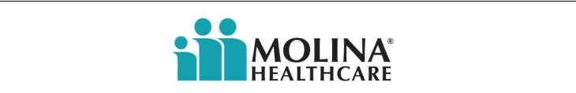

MOLINA HEALTHCARE, INC.

(Exact name of registrant as specified in its charter)

Delaware | 13-4204626
(State or other jurisdiction of | (I.R.S. Employer
incorporation or organization) | Identification No.)
200 Oceangate, Suite 100
Long Beach, California | 90802
(Address of principal executive offices) | (Zip Code)

(562) 435-3666

(Registrant’s telephone number, including area code)

Securities registered pursuant to Section 12(b) of the Act:

Title of each class | Trading Symbol(s) | Name of each exchange on which registered
Common Stock, $0.001 Par Value | MOH | New York Stock Exchange

Indicate by check mark whether the registrant (1) has filed all reports required to be filed by Section 13 or 15(d) of the Securities Exchange Act of 1934 during the preceding 12 months (or for such shorter period that the registrant was required to file such reports), and (2) has been subject to such filing requirements for the past 90 days. Yes ☒ No ☐

Indicate by check mark whether the registrant has submitted electronically every Interactive Data File required to be submitted pursuant to Rule 405 of Regulation S-T during the preceding 12 months (or for such shorter period that the registrant was required to submit such files). Yes ☒ No ☐

Indicate by check mark whether the registrant is a large accelerated filer, an accelerated filer, a non-accelerated filer, a smaller reporting company, or an emerging growth company. See the definitions of “large accelerated filer,” “accelerated filer,” “smaller reporting company,” and “emerging growth company” in Rule 12b-2 of the Exchange Act.

Large Accelerated Filer ☒ Accelerated Filer ☐ Non-Accelerated Filer ☐ Smaller reporting company ☐ Emerging growth company ☐

If an emerging growth company, indicate by check mark if the registrant has elected not to use the extended transition period for complying with any new or revised financial accounting standards provided pursuant to Section 13(a) of the Exchange Act. ☐

Indicate by check mark whether the registrant is a shell company (as defined in Rule 12b-2 of the Exchange Act). Yes ☐ No ☒

The number of shares of the issuer’s Common Stock, $0.001 par value, outstanding as of October 21, 2022, was approximately 58,400,000.

Table of Contents

MOLINA HEALTHCARE, INC. FORM 10-Q

FOR THE QUARTERLY PERIOD ENDED SEPTEMBER 30, 2022

TABLE OF CONTENTS

ITEM NUMBER |  |  |  |  |  |  |  |  |  | Page
 |  |  |  |  |  |  |  |  | PART I
1. | Financial Statements |  |  |  |  |  |  |  |  | 3
2. | Management’s Discussion and Analysis of Financial Condition and Results of Operations |  |  |  |  |  |  |  |  |  |  | 20
3. | Quantitative and Qualitative Disclosures About Market Risk |  |  |  |  |  |  |  |  |  |  | 34
4. | Controls and Procedures |  |  |  |  |  |  |  |  | 34
 |  |  |  |  |  |  |  |  | PART II
1. | Legal Proceedings |  |  |  |  |  |  |  |  |  |  | 34
1A. | Risk Factors |  |  |  |  |  |  |  |  | 34
2. | Unregistered Sales of Equity Securities and Use of Proceeds |  |  |  |  |  |  |  |  |  |  | 35
3. | Defaults Upon Senior Securities |  |  |  |  |  |  |  |  | Not Applicable.
4. | Mine Safety Disclosures |  |  |  |  |  |  |  |  | Not Applicable.
5. | Other Information |  |  |  |  |  |  |  |  | Not Applicable.
6. | Exhibits |  |  |  |  |  |  |  |  | 36
 | Signatures |  |  |  |  |  |  |  |  | 37

Table of Contents

CONSOLIDATED STATEMENTS OF INCOME

 | Three Months Ended September 30, |  |  |  |  |  |  | Nine Months Ended September 30,
 | 2022 |  |  | 2021 |  |  |  | 2022 |  |  | 2021
 |  |  |  | (Dollars in millions, except per-share amounts)
 |  |  |  |  | (Unaudited)
Revenue:
Premium revenue | $ | 7,636 |  | $ | 6,800 |  | $ | 22,966 |  | $ | 19,689
Premium tax revenue |  | 223 |  |  | 204 |  |  | 646 |  |  | 576
Investment income |  | 49 |  |  | 20 |  |  | 82 |  |  | 39
Other revenue |  | 19 |  |  | 16 |  |  | 57 |  |  | 58
Total revenue |  | 7,927 |  |  | 7,040 |  |  | 23,751 |  |  | 20,362
Operating expenses:
Medical care costs |  | 6,748 |  |  | 6,049 |  |  | 20,183 |  |  | 17,342
General and administrative expenses |  | 560 |  |  | 532 |  |  | 1,682 |  |  | 1,489
Premium tax expenses |  | 223 |  |  | 204 |  |  | 646 |  |  | 576
Depreciation and amortization |  | 45 |  |  | 32 |  |  | 129 |  |  | 96
Other |  | 16 |  |  | 2 |  |  | 43 |  |  | 30
Total operating expenses |  | 7,592 |  |  | 6,819 |  |  | 22,683 |  |  | 19,533
Operating income |  | 335 |  |  | 221 |  |  | 1,068 |  |  | 829
Other expenses, net:
Interest expense |  | 28 |  |  | 30 |  |  | 83 |  |  | 90
Total other expenses, net |  | 28 |  |  | 30 |  |  | 83 |  |  | 90
Income before income tax expense |  | 307 |  |  | 191 |  |  | 985 |  |  | 739
Income tax expense |  | 77 |  |  | 48 |  |  | 249 |  |  | 183
Net income | $ | 230 |  | $ | 143 |  | $ | 736 |  | $ | 556
Net income per share - Basic | $ | 4.00 |  | $ | 2.49 |  | $ | 12.74 |  | $ | 9.63
Net income per share - Diluted | $ | 3.95 |  | $ | 2.46 |  | $ | 12.58 |  | $ | 9.51

CONSOLIDATED STATEMENTS OF COMPREHENSIVE INCOME

 | Three Months Ended September 30, |  |  |  |  |  |  | Nine Months Ended September 30,
 | 2022 |  |  | 2021 |  |  |  | 2022 |  |  | 2021
 |  |  |  |  | (In millions)
 |  |  |  |  | (Unaudited)
Net income | $ | 230 |  | $ | 143 |  | $ | 736 |  | $ | 556
Other comprehensive loss:
Unrealized investment loss |  | (75) |  |  | (13) |  |  | (237) |  |  | (27)
Less: effect of income taxes |  | (18) |  |  | (4) |  |  | (57) |  |  | (7)
Other comprehensive loss, net of tax |  | (57) |  |  | (9) |  |  | (180) |  |  | (20)
Comprehensive income | $ | 173 |  | $ | 134 |  | $ | 556 |  | $ | 536

See accompanying notes.

Molina Healthcare, Inc. September 30, 2022 Form 10-Q | 3

Table of Contents

CONSOLIDATED BALANCE SHEETS

September 30, |  | December 31,
2022 |  | 2021

Current assets:

Cash and cash equivalents

Investments

Receivables

Prepaid expenses and other current assets Total current assets
Property, equipment, and capitalized software, net

Goodwill, and intangible assets, net

Restricted investments

Deferred income taxes

Other assets

Total assets

 |  | (Dollars in millions,
 |  | except per-share amounts)
 |  | (Unaudited)
ASSETS
$ |  | 4,242 |  | $ | 4,438
 |  | 3,639 |  |  | 3,202
 |  | 2,220 |  |  | 2,177
 |  | 391 |  |  | 247
 |  | 10,492 |  |  | 10,064
 |  | 412 |  |  | 396
 |  | 1,263 |  |  | 1,252
 |  | 242 |  |  | 212
 |  | 198 |  |  | 106
 |  | 186 |  |  | 179
$ |  | 12,793 |  | $ | 12,209

LIABILITIES AND STOCKHOLDERS’ EQUITY

Current liabilities:
Medical claims and benefits payable | $ | 3,622 |  | $ | 3,363
Amounts due government agencies |  | 2,139 |  |  | 2,472
Accounts payable, accrued liabilities and other |  | 818 |  |  | 842
Deferred revenue |  | 663 |  |  | 370
Total current liabilities |  | 7,242 |  |  | 7,047
Long-term debt |  | 2,175 |  |  | 2,173
Finance lease liabilities |  | 217 |  |  | 219
Other long-term liabilities |  | 118 |  |  | 140
Total liabilities |  | 9,752 |  |  | 9,579
Stockholders’ equity:
Common stock, $0.001 par value, 150 million shares authorized; outstanding: 58 million shares at September 30, 2022 and December 31, |  | — |  |  | —
2021 |  |  |  |  | —
Preferred stock, $0.001 par value; 20 million shares authorized, no shares issued and outstanding |  | — |  |  | —
Additional paid-in capital |  | 289 |  |  | 236
Accumulated other comprehensive loss |  | (185) |  |  | (5)
Retained earnings |  | 2,937 |  |  | 2,399
Total stockholders’ equity |  | 3,041 |  |  | 2,630
Total liabilities and stockholders’ equity | $ | 12,793 |  | $ | 12,209

See accompanying notes.

Molina Healthcare, Inc. September 30, 2022 Form 10-Q | 4

Table of Contents

CONSOLIDATED STATEMENTS OF STOCKHOLDERS’ EQUITY

 |  |  |  |  |  |  |  |  |  |  |  |  |  |  | Accumulated
 |  | Common Stock |  |  |  |  |  |  |  |  |  | Additional |  |  | Other
 |  |  |  |  |  |  |  |  |  |  |  | Paid-in |  |  | Comprehensive |  |  |  |  | Retained
 |  | Outstanding |  |  |  |  | Amount |  |  |  |  |  |  |  | Comprehensive |  |  |  |  |  |  |  |  |  | Total
 |  |  |  |  |  |  |  |  |  |  |  | Capital |  |  | Loss |  |  |  |  | Earnings
 |  |  |  |  |  |  |  |  |  |  |  |  |  | (In millions)
 |  |  |  |  |  |  |  |  |  |  |  |  |  | (Unaudited)
Balance at December 31, 2021 |  | 58 |  |  |  | $ | — |  |  |  | $ | 236 |  | $ |  | (5) |  |  | $ | 2,399 |  |  |  | $ | 2,630
Net income |  | — |  |  |  |  | — |  |  |  |  | — |  |  |  | — |  |  |  | 258 |  |  |  |  | 258
Other comprehensive loss, net |  | — |  |  |  |  | — |  |  |  |  | — |  |  |  | (76) |  |  |  | — |  |  |  |  | (76)
Share-based compensation |  | 1 |  |  |  |  | — |  |  |  |  | (18) |  |  |  | — |  |  |  | — |  |  |  |  | (18)
Balance at March 31, 2022 |  | 59 |  |  |  |  | — |  |  |  |  | 218 |  |  |  | (81) |  |  |  | 2,657 |  |  |  |  | 2,794
Net income |  | — |  |  |  |  | — |  |  |  |  | — |  |  |  | — |  |  |  | 248 |  |  |  |  | 248
Common stock purchases |  | (1) |  |  |  |  | — |  |  |  |  | (2) |  |  |  | — |  |  |  | (198) |  |  |  |  | (200)
Other comprehensive loss, net |  | — |  |  |  |  | — |  |  |  |  | — |  |  |  | (47) |  |  |  | — |  |  |  |  | (47)
Share-based compensation |  | — |  |  |  |  | — |  |  |  |  | 35 |  |  |  | — |  |  |  | — |  |  |  |  | 35
Balance at June 30, 2022 |  | 58 |  |  |  |  | — |  |  |  |  | 251 |  |  |  | (128) |  |  |  | 2,707 |  |  |  |  | 2,830
Net income |  | — |  |  |  |  | — |  |  |  |  | — |  |  |  | — |  |  |  | 230 |  |  |  |  | 230
Other comprehensive loss, net |  | — |  |  |  |  | — |  |  |  |  | — |  |  |  | (57) |  |  |  | — |  |  |  |  | (57)
Share-based compensation |  | — |  |  |  |  | — |  |  |  |  | 38 |  |  |  | — |  |  |  | — |  |  |  |  | 38
Balance at September 30, 2022 |  | 58 |  |  |  | $ | — |  |  |  | $ | 289 |  | $ |  | (185) |  |  | $ | 2,937 |  |  |  | $ | 3,041
 |  |  |  |  |  |  |  |  |  |  |  |  |  |  | Accumulated
 |  | Common Stock |  |  |  |  |  |  |  |  |  | Additional |  |  | Other
 |  |  |  |  |  |  |  |  |  |  |  | Paid-in |  |  | Comprehensive |  |  |  |  | Retained
 |  | Outstanding |  |  |  |  | Amount |  |  |  |  |  |  |  | Comprehensive |  |  |  |  |  |  |  |  |  | Total
 |  | Outstanding |  |  |  |  | Amount |  |  |  |  | Capital |  |  | Income (Loss) |  |  |  |  | Earnings |  |  |  |  | Total
 |  |  |  |  |  |  |  |  |  |  |  |  |  | (In millions)
 |  |  |  |  |  |  |  |  |  |  |  |  |  | (Unaudited)
Balance at December 31, 2020 |  | 59 |  |  |  | $ | — |  |  |  | $ | 199 |  | $ |  | 37 |  |  | $ | 1,860 |  |  |  | $ | 2,096
Net income |  | — |  |  |  |  | — |  |  |  |  | — |  |  |  | — |  |  |  | 228 |  |  |  |  | 228
Common stock purchases |  | (1) |  |  |  |  | — |  |  |  |  | (2) |  |  |  | — |  |  |  | (120) |  |  |  |  | (122)
Other comprehensive loss, net |  | — |  |  |  |  | — |  |  |  |  | — |  |  |  | (11) |  |  |  | — |  |  |  |  | (11)
Share-based compensation |  | — |  |  |  |  | — |  |  |  |  | (27) |  |  |  | — |  |  |  | — |  |  |  |  | (27)
Balance at March 31, 2021 |  | 58 |  |  |  |  | — |  |  |  |  | 170 |  |  |  | 26 |  |  |  | 1,968 |  |  |  |  | 2,164
Net income |  | — |  |  |  |  | — |  |  |  |  | — |  |  |  | — |  |  |  | 185 |  |  |  |  | 185
Share-based compensation |  | — |  |  |  |  | — |  |  |  |  | 21 |  |  |  | — |  |  |  | — |  |  |  |  | 21
Balance at June 30, 2021 |  | 58 |  |  |  |  | — |  |  |  |  | 191 |  |  |  | 26 |  |  |  | 2,153 |  |  |  |  | 2,370
Net income |  | — |  |  |  |  | — |  |  |  |  | — |  |  |  | — |  |  |  | 143 |  |  |  |  | 143
Other comprehensive loss, net |  | — |  |  |  |  | — |  |  |  |  | — |  |  |  | (9) |  |  |  | — |  |  |  |  | (9)
Share-based compensation |  | — |  |  |  |  | — |  |  |  |  | 14 |  |  |  | — |  |  |  | — |  |  |  |  | 14
Balance at September 30, 2021 |  | 58 |  |  |  | $ | — |  |  |  | $ | 205 |  | $ |  | 17 |  |  | $ | 2,296 |  |  |  | $ | 2,518

See accompanying notes.

Molina Healthcare, Inc. September 30, 2022 Form 10-Q | 5

Table of Contents

CONSOLIDATED STATEMENTS OF CASH FLOWS

 | Nine Months Ended September 30,
 | 2022 |  |  | 2021
 |  | (In millions)
 |  | (Unaudited)
Operating activities:
Net income | $ | 736 |  | $ | 556
Adjustments to reconcile net income to net cash provided by operating activities:
Depreciation and amortization |  | 129 |  |  | 96
Deferred income taxes |  | (35) |  |  | (8)
Share-based compensation |  | 80 |  |  | 49
Other, net |  | (3) |  |  | 9
Changes in operating assets and liabilities:
Receivables |  | (15) |  |  | (247)
Prepaid expenses and other current assets |  | (110) |  |  | (43)
Medical claims and benefits payable |  | 251 |  |  | 522
Amounts due government agencies |  | (360) |  |  | 810
Accounts payable, accrued liabilities and other |  | (40) |  |  | 129
Deferred revenue |  | 293 |  |  | (374)
Income taxes |  | 59 |  |  | 23
Net cash provided by operating activities |  | 985 |  |  | 1,522
Investing activities:
Purchases of investments |  | (1,764) |  |  | (2,018)
Proceeds from sales and maturities of investments |  | 1,082 |  |  | 965
Net cash paid in business combinations |  | (134) |  |  | —
Purchases of property, equipment and capitalized software |  | (81) |  |  | (56)
Other, net |  | (41) |  |  | 3
Net cash used in investing activities |  | (938) |  |  | (1,106)
Financing activities:
Common stock purchases |  | (200) |  |  | (128)
Common stock withheld to settle employee tax obligations |  | (53) |  |  | (52)
Contingent consideration liabilities settled |  | (20) |  |  | (20)
Other, net |  | 15 |  |  | (4)
Net cash used in financing activities |  | (258) |  |  | (204)
Net (decrease) increase in cash, cash equivalents, and restricted cash and cash equivalents |  | (211) |  |  | 212
Cash, cash equivalents, and restricted cash and cash equivalents at beginning of period |  | 4,506 |  |  | 4,223
Cash, cash equivalents, and restricted cash and cash equivalents at end of period | $ | 4,295 |  | $ | 4,435

Molina Healthcare, Inc. September 30, 2022 Form 10-Q | 6

Table of Contents

NOTES TO CONSOLIDATED FINANCIAL STATEMENTS (UNAUDITED)

SEPTEMBER 30, 2022

- Organization and Basis of Presentation

Organization and Operations

Molina Healthcare, Inc. provides managed healthcare services under the Medicaid and Medicare programs, and through the state insurance marketplaces (the “Marketplace”). We currently have four reportable segments consisting of: 1) Medicaid; 2) Medicare; 3) Marketplace; and 4) Other. Our reportable segments are consistent with how we currently manage the business and view the markets we serve.

As of September 30, 2022, we served approximately 5.2 million members eligible for government-sponsored healthcare programs, located across 19 states.

Our state Medicaid contracts typically have terms of three to five years, contain renewal options exercisable by the state Medicaid agency, and allow either the state or the health plan to terminate the contract with or without cause. Such contracts are subject to risk of loss in states that issue requests for proposal (“RFPs”) open to competitive bidding by other health plans. If one of our health plans is not a successful responsive bidder to a state RFP, its contract may not be renewed.

In addition to contract renewal, our state Medicaid contracts may be periodically amended to include or exclude certain health benefits (such as pharmacy services, behavioral health services, or long-term care services); populations such as the aged, blind or disabled (“ABD”); and regions or service areas.

Recent Developments

New York Acquisition—Medicaid. On October 1, 2022, we closed on our acquisition of the Medicaid Managed Long Term Care business of AgeWell New York. See Note 4, “Business Combinations,” for further information.

Nebraska Procurement—Medicaid. In September 2022, we announced that our Nebraska health plan had been selected by the Nebraska Department of Health and Human Services (DHHS) to provide health care services to Nebraskans under the state’s Medicaid managed care program. The new five-year contract is expected to begin on January 1, 2024, and may be extended for an additional two-years.

Iowa Procurement—Medicaid. In August 2022, we announced that our Iowa health plan had been notified by the Iowa Department of Health and Human Services (HHS) of its intent to award a Medicaid managed care contract pursuant to the Request for Proposal issued by HHS on February 17, 2022. The new four-year contract is expected to begin on July 1, 2023, and may be extended for an additional four years.

California Procurement—Medicaid. In August 2022, we announced that our California health plan had been notified by the California Department of Health Care Services of its intent to award a Medi-Cal contract in each of Los Angeles, Riverside, San Bernardino, Sacramento, and San Diego Counties. The five Medi-Cal contracts are expected to commence on January 1, 2024, which enables us to continue serving Medi-Cal members in our existing counties and expand footprint with the addition of the Los Angeles County contract.

Mississippi Procurement—Medicaid. In August 2022, we announced that our Mississippi health plan had been notified by the Mississippi Division of Medicaid (DOM) of its intent to award a Medicaid Coordinated Care Contract for its Mississippi Coordinated Access Program and Mississippi Children’s Health Insurance Program pursuant to the Request for Qualifications issued by DOM on December 10, 2021. The four-year contract is expected to begin on July 1, 2023, and may be extended for an additional two years. The award enables us to continue serving Medicaid members across the state.

Wisconsin Acquisition — Medicaid and Medicare. On July 13, 2022, we announced a definitive agreement to acquire substantially all the assets of My Choice Wisconsin (“MCW”). The purchase price for the transaction is approximately $ 150 million, net of expected tax benefits and required regulatory capital, which we intend to fund with cash on hand. The transaction is subject to receipt of applicable federal and state regulatory approvals, and the satisfaction of other customary closing conditions. We currently expect the transaction to close in early 2023.

Texas Procurement—Medicaid. In March 2022, the Texas Health and Human Services Commission posted the ABD program (known in Texas as STAR+PLUS) RFP. We submitted our proposal in June 2022 to continue serving STAR+PLUS members, with awards estimated to be announced in the first quarter of 2023, and start of operations in February 2024. Further, in October 2022, the draft RFP was posted for the TANF and CHIP programs (known as

Molina Healthcare, Inc. September 30, 2022 Form 10-Q | 7

Table of Contents

the STAR & CHIP programs, and both existing contracts for us), with awards expected in late Q4 2023 or early Q1 2024 and the start of operations in late Q4 2024 or early Q1 2025.

Nevada Procurement—Medicaid. Our new contract in Clark and Washoe Counties commenced on January 1, 2022, and offers health coverage to TANF, CHIP and Medicaid Expansion beneficiaries. This new contract is four years with a potential two-year extension.

Texas Acquisition—Medicaid and Medicare. On January 1, 2022, we closed on our acquisition of Cigna Corporation’s Texas Medicaid and Medicare-Medicaid Plan (“MMP”) contracts, along with certain operating assets. See Note 4, “Business Combinations,” for further information.

Consolidation and Interim Financial Information

The consolidated financial statements include the accounts of Molina Healthcare, Inc., and its subsidiaries. In the opinion of management, these financial statements reflect all normal recurring adjustments, which are considered necessary for a fair presentation of the results as of the dates and for the interim periods presented. All significant intercompany balances and transactions have been eliminated. The consolidated results of operations for the nine months ended September 30, 2022 are not necessarily indicative of the results for the entire year ending December 31, 2022.

The unaudited consolidated interim financial statements have been prepared under the assumption that users of the interim financial data have either read or have access to our audited consolidated financial statements for the fiscal year ended December 31, 2021. Accordingly, certain disclosures that would substantially duplicate the disclosures contained in our December 31, 2021, audited consolidated financial statements have been omitted. These unaudited consolidated interim financial statements should be read in conjunction with our audited consolidated financial statements for the fiscal year ended December 31, 2021.

Use of Estimates

The preparation of consolidated financial statements in conformity with U.S. generally accepted accounting principles (“GAAP”) requires management to make estimates and assumptions that affect the reported amounts of assets and liabilities. Estimates also affect the reported amounts of revenues and expenses during the reporting period. Actual results could differ from these estimates.

- Significant Accounting Policies

Cash and Cash Equivalents

Cash and cash equivalents consist of cash and short-term, highly liquid investments that are both readily convertible into known amounts of cash and have a maturity of three months or less on the date of purchase. The following table provides a reconciliation of cash and cash equivalents, and restricted cash and cash equivalents reported within the accompanying consolidated balance sheets that sum to the total of the same such amounts presented in the accompanying consolidated statements of cash flows. The restricted cash and cash equivalents presented below are included in “Restricted investments” in the accompanying consolidated balance sheets.

 |  | September 30,
 | 2022 |  |  |  | 2021
 |  | (In millions)
Cash and cash equivalents | $ | 4,242 |  | $ | 4,357
Restricted cash and cash equivalents |  | 53 |  |  | 78
Total cash, cash equivalents, and restricted cash and cash equivalents presented in the consolidated statements of cash flows | $ | 4,295 |  | $ | 4,435

Molina Healthcare, Inc. September 30, 2022 Form 10-Q | 8

Table of Contents

Receivables

Receivables consist primarily of premium amounts due from government agencies, which are subject to potential retroactive adjustments. Because substantially all of our receivable amounts are readily determinable and substantially all of our creditors are governmental authorities, our allowance for credit losses is insignificant. Any amounts determined to be uncollectible are charged to expense when such determination is made.
 |  | September 30, |  |  | December 31,
 |  | 2022 |  |  | 2021
 |  | (In millions)
Government receivables | $ | 1,545 |  | $ | 1,566
Pharmacy rebate receivables |  | 290 |  |  | 276
Other |  | 385 |  |  | 335
Total | $ | 2,220 |  | $ | 2,177

Premium Revenue Recognition and Amounts Due Government Agencies

Premium revenue is generated from our contracts with state and federal agencies, in connection with our participation in the Medicaid, Medicare, and Marketplace programs. Premium revenue is generally received based on per member per month (“PMPM”) rates established in advance of the periods covered. These premium revenues are recognized in the month that members are entitled to receive healthcare services, and premiums collected in advance are deferred. State Medicaid programs and the federal Medicare program periodically adjust premium rates.

Certain components of premium revenue are subject to accounting estimates and are described in further detail below, and in our 2021 Annual Report on Form 10-K, Note 2, “Significant Accounting Policies,” under “Contractual Provisions That May Adjust or Limit Revenue or Profit,” and “Quality Incentives.”

Contractual Provisions That May Adjust or Limit Revenue or Profit

Many of our contracts contain provisions that may adjust or limit revenue or profit, as described below. Consequently, we recognize premium revenue as it is earned under such provisions. Liabilities accrued for premiums to be returned under such provisions are reported in the aggregate as “Amounts due government agencies,” in the accompanying consolidated balance sheets.

The following table sets forth amounts due government agencies, categorized by program:

 |  | September 30, |  |  | December 31,
 |  | 2022 |  |  | 2021
 |  | (In millions)
Medicaid program:
Minimum MLR and profit sharing | $ | 1,091 |  | $ | 1,016
Other |  | 617 |  |  | 263
Medicare program:
Minimum MLR and profit sharing |  | 100 |  |  | 101
Risk adjustment and Part D risk sharing |  | 74 |  |  | 89
Other |  | 23 |  |  | 35
Marketplace program:
Risk adjustment |  | 179 |  |  | 902
Minimum MLR |  | 4 |  |  | 18
Other |  | 51 |  |  | 48
Total amounts due government agencies | $ | 2,139 |  | $ | 2,472

Medicaid Program

Minimum MLR and Retroactive Premium Adjustments. State Medicaid programs periodically adjust premium rates on a retroactive basis. In these cases, we adjust our premium revenue in the period in which we determine that the adjustment is probable and reasonably estimable, based on our best estimate of the ultimate premium we expect to realize for the period being adjusted.

Molina Healthcare, Inc. September 30, 2022 Form 10-Q | 9

Table of Contents

Beginning in 2020, various states enacted temporary risk corridors in response to the reduced demand for medical services stemming from COVID-19, which have resulted in a reduction of our medical margin. In some cases, these risk corridors were retroactive to earlier periods in 2020, or as early as the beginning of the states’ fiscal years in 2019. Since the second quarter of 2020, we have recognized risk corridors that we believe to be probable, and where the ultimate premium amount is reasonably estimable. For the three and nine months ended September 30, 2022, we recognized approximately $ 34 million and $156 million, respectively, related to such risk corridors, primarily in the Medicaid segment, compared to $17 million and $183 million, respectively, recognized in the three and nine months ended September 30, 2021. The decrease is due to the elimination of several of the COVID-19 risk corridors.

It is possible that certain states could change the structure of existing risk corridors, implement new risk corridors in the future or discontinue existing risk corridors. Due to these uncertainties, the ultimate outcomes could differ materially from our estimates as a result of changes in facts or further developments, which could have an adverse effect on our consolidated financial position, results of operations, or cash flows.

Marketplace Program

Risk Adjustment. Under this program, our health plans’ composite risk scores are compared with the overall average risk score for the relevant state and market pool. Generally, our health plans will make a risk adjustment payment into the pool if their composite risk scores are below the average risk score (risk adjustment payable), and will receive a risk adjustment payment from the pool if their composite risk scores are above the average risk score (risk adjustment receivable). We estimate our ultimate premium based on insurance policy year-to-date experience, and recognize estimated premiums relating to the risk adjustment program as an adjustment to premium revenue in our consolidated statements of income. As of September 30, 2022, Marketplace risk adjustment payables amounted to $179 million and related receivables amounted to $94 million, for a net payable of $85 million. As of December 31, 2021, Marketplace risk adjustment payables amounted to $902 million and related receivables amounted to $7 million, for a net payable of $895 million.

Concentrations of Credit Risk

Financial instruments that potentially subject us to concentrations of credit risk consist primarily of cash and cash equivalents, investments, receivables, and restricted investments. Our investments and a portion of our cash equivalents are managed by professional portfolio managers operating under documented investment guidelines. Our portfolio managers must obtain our prior approval before selling investments where the loss position of those investments exceeds certain levels. Our investments consist primarily of investment-grade debt securities with final maturities of less than 15 years, or less than 15 years average life for structured securities. Restricted investments are invested principally in cash, cash equivalents, and U.S. Treasury securities. Concentration of credit risk with respect to accounts receivable is limited because our payors consist principally of the federal government, and governments of each state in which our health plan subsidiaries operate.

Income Taxes

The provision for income taxes is determined using an estimated annual effective tax rate, which generally differs from the U.S. federal statutory rate primarily because of foreign and state taxes, and nondeductible expenses such as certain compensation and other general and administrative expenses.

The effective tax rate may be subject to fluctuations during the year as new information is obtained. Such information may affect the assumptions used to estimate the annual effective tax rate, including projected pretax earnings, the mix of pretax earnings in the various tax jurisdictions in which we operate, valuation allowances against deferred tax assets, the recognition or the reversal of the recognition of tax benefits related to uncertain tax positions, and changes in or the interpretation of tax laws in jurisdictions where we conduct business. We recognize deferred tax assets and liabilities for temporary differences between the financial reporting basis and the tax basis of our assets and liabilities, along with net operating loss and tax credit carryovers.

Recent Accounting Pronouncements

Recent accounting pronouncements issued by the FASB (including its Emerging Issues Task Force), the American Institute of Certified Public Accountants, and the Securities and Exchange Commission (“SEC”) did not have, nor does management expect such pronouncements to have, a significant impact on our present or future consolidated financial statements.

Molina Healthcare, Inc. September 30, 2022 Form 10-Q | 10

Table of Contents

3. Net Income Per Share

The following table sets forth the calculation of basic and diluted net income per share:

 | Three Months Ended September 30, |  |  |  |  |  |  | Nine Months Ended September 30,
 | 2022 |  |  |  | 2021 |  |  | 2022 |  |  | 2021
 |  |  |  |  | (In millions, except net income per share)
Numerator:
Net income | $ | 230 |  | $ | 143 |  | $ | 736 |  | $ | 556
Denominator:
Shares outstanding at the beginning of the period |  | 57.6 |  |  | 57.8 |  |  | 57.9 |  |  | 58.0
Weighted-average number of shares issued:
Stock-based compensation |  | — |  |  | — |  |  | 0.2 |  |  | 0.3
Stock purchases |  | — |  |  | — |  |  | (0.3) |  |  | (0.5)
Denominator for basic net income per share |  | 57.6 |  |  | 57.8 |  |  | 57.8 |  |  | 57.8
Effect of dilutive securities: ⁽¹⁾
Stock-based compensation |  | 0.7 |  |  | 0.7 |  |  | 0.7 |  |  | 0.7
Denominator for diluted net income per share |  | 58.3 |  |  | 58.5 |  |  | 58.5 |  |  | 58.5
Net income per share - Basic ⁽²⁾ | $ | 4.00 |  | $ | 2.49 |  | $ | 12.74 |  | $ | 9.63
Net income per share - Diluted ⁽²⁾ | $ | 3.95 |  | $ | 2.46 |  | $ | 12.58 |  | $ | 9.51

______________________________

- The dilutive effect of all potentially dilutive common shares is calculated using the treasury stock method.

- Source data for calculations in thousands.

4. Business Combinations

AgeWell. As described in Note 1, “Organization and Basis of Presentation,” we announced this acquisition closed on October 1, 2022. Because the closing date fell on a weekend, the $134 million purchase price was paid on September 30, 2022 and was recorded to prepaid expenses and other assets. Such amounts are reported in investing activities in the accompanying consolidated statements of cash flows. The initial accounting for this transaction is incomplete.

Cigna. On January 1, 2022, we closed on our acquisition of Cigna Corporation’s Texas Medicaid and Medicare-Medicaid Plan contracts, along with certain operating assets, for purchase consideration of approximately $60 million. We acquired membership and a provider network with a preliminary fair value of approximately $36 million. We allocated the remaining $24 million of purchase consideration to goodwill, primarily in the Medicaid segment, which relates to future economic benefits arising from expected synergies from the use of our existing infrastructure to support the added membership, and from the assembled workforce. The goodwill is deductible for income tax purposes.

Affinity. On October 25, 2021, we closed on our acquisition of substantially all of the assets of Affinity Health Plan, Inc., a Medicaid health plan in New York, for initial purchase consideration of approximately $176 million. In the nine months ended September 30, 2022, we recorded various measurement period adjustments, including an increase of

$8 million to “Medical claims and benefits payable,” and an increase of $1 million to “Receivables” net of “Amounts due government agencies.” In the aggregate, we recorded a net increase of $7 million to goodwill for these measurement period adjustments and various purchase price adjustments.

5. Fair Value Measurements

We consider the carrying amounts of current assets and current liabilities to approximate their fair values because of the relatively short period of time between the origination of these instruments and their expected realization or payment. For our financial instruments measured at fair value on a recurring basis, we prioritize the inputs used in measuring fair value according to the three-tier fair value hierarchy. For a description of the methods and assumptions used to: a) estimate the fair value; and b) determine the classification according to the fair value

Molina Healthcare, Inc. September 30, 2022 Form 10-Q | 11

Table of Contents

hierarchy for each financial instrument, refer to our 2021 Annual Report on Form 10-K, Note 5, “Fair Value Measurements.”

The net changes in fair value of Level 3 financial instruments are reported in “Other” operating expenses in our consolidated statements of income. In the nine months ended September 30, 2022 and 2021, we recognized a loss of $4 million and $3 million, respectively, for the increase in the fair value of the contingent consideration liabilities described below.

Our financial instruments measured at fair value on a recurring basis at September 30, 2022, were as follows:

 |  |  |  |  |  |  | Observable Inputs |  |  |  |  |  | Directly or Indirectly |  |  |  | Unobservable Inputs
 |  |  |  |  |  |  | Observable Inputs |  |  |  |  |  | Observable Inputs |  |  |  | Unobservable Inputs
 |  | Total |  |  |  |  | (Level 1) |  |  |  |  |  | (Level 2) |  |  |  | (Level 3)
 |  |  |  |  |  |  |  | (In millions)
Corporate debt securities | $ |  | 2,283 |  | $ |  |  | — |  | $ |  |  | 2,283 |  |  | $ | —
Mortgage-backed securities |  |  | 743 |  |  |  |  | — |  |  |  |  | 743 |  |  |  | —
Asset-backed securities |  |  | 303 |  |  |  |  | — |  |  |  |  | 303 |  |  |  | —
Municipal securities |  |  | 148 |  |  |  |  | — |  |  |  |  | 148 |  |  |  | —
U.S. Treasury notes |  |  | 116 |  |  |  |  | — |  |  |  |  | 116 |  |  |  | —
Other |  |  | 46 |  |  |  |  | — |  |  |  |  | 46 |  |  |  | —
Total assets | $ |  | 3,639 |  | $ |  |  | — |  | $ |  |  | 3,639 |  |  | $ | —
Contingent consideration liabilities |  | $ | 8 |  |  |  | $ | — |  |  |  | $ | — |  |  | $ | 8
Total liabilities |  | $ | 8 |  |  |  | $ | — |  |  |  | $ | — |  |  | $ | 8
Our financial instruments measured at fair value on a recurring basis at December 31, 2021, were as follows:
 |  |  |  |  |  |  | Observable Inputs |  |  |  |  |  | Directly or Indirectly |  |  |  | Unobservable Inputs
 |  |  |  |  |  |  | Observable Inputs |  |  |  |  |  | Observable Inputs |  |  |  | Unobservable Inputs
 |  | Total |  |  |  |  | (Level 1) |  |  |  |  |  | (Level 2) |  |  |  | (Level 3)
 |  |  |  |  |  |  | (In millions)
Corporate debt securities | $ |  | 1,833 |  | $ |  |  | — |  | $ |  |  | 1,833 |  |  | $ | —
Mortgage-backed securities |  |  | 614 |  |  |  |  | — |  |  |  |  | 614 |  |  |  | —
Asset-backed securities |  |  | 247 |  |  |  |  | — |  |  |  |  | 247 |  |  |  | —
Municipal securities |  |  | 123 |  |  |  |  | — |  |  |  |  | 123 |  |  |  | —
U.S. Treasury notes |  |  | 353 |  |  |  |  | — |  |  |  |  | 353 |  |  |  | —
Other |  |  | 32 |  |  |  |  | — |  |  |  |  | 32 |  |  |  | —
Total assets | $ |  | 3,202 |  | $ |  |  | — |  | $ |  |  | 3,202 |  |  | $ | —
Contingent consideration liabilities | $ |  | 47 |  |  | $ |  | — |  |  | $ |  | — |  |  | $ | 47
Total liabilities | $ |  | 47 |  | $ |  |  | — |  | $ |  |  | — |  |  | $ | 47

Contingent Consideration Liabilities

Our Level 3 financial instruments at September 30, 2022 are comprised solely of contingent consideration liabilities of $8 million, in connection with our 2020 acquisition of certain assets of Passport Health Plan, Inc., a Medicaid health plan in Kentucky. Such liabilities are recorded at fair value on a recurring basis. In the nine months ended September 30, 2022, the estimated fair value of contingent purchase consideration increased by approximately $4 million, relating to an operating income guarantee.

In the nine months ended September 30, 2022, we paid the seller $43 million, of which $23 million was for the remaining half of the consideration due for minimum member enrollment targets and $20 million was for the first payment of the consideration due for the operating income guarantee. For the amounts paid in the nine months ended September 30, 2022, $20 million has been presented in “Financing activities” in the accompanying consolidated statements of cash flows, with the balance reflected in “Operating activities.” The remaining balance of

Molina Healthcare, Inc. September 30, 2022 Form 10-Q | 12

Table of Contents

the liabilities is reported in “Accounts payable, accrued liabilities and other” in the accompanying consolidated balance sheets.

Fair Value Measurements – Disclosure Only

The carrying amounts and estimated fair values of our notes payable are classified as Level 2 financial instruments. Fair value for these securities is determined using a market approach based on quoted market prices for similar securities in active markets or quoted prices for identical securities in inactive markets.

 |  | September 30, 2022 |  |  |  |  |  | December 31, 2021
 | Carrying |  |  |  | Fair Value |  |  | Carrying |  |  | Fair Value
 | Amount |  |  |  | Fair Value |  |  | Amount |  |  | Fair Value
 |  |  |  |  | (In millions)
4.375% Notes due 2028 | $ | 792 |  | $ | 715 |  | $ | 791 |  | $ | 829
3.875% Notes due 2030 |  | 642 |  |  | 541 |  |  | 642 |  |  | 675
3.875% Notes due 2032 |  | 741 |  |  | 612 |  |  | 740 |  |  | 760
Total | $ | 2,175 |  | $ | 1,868 |  | $ | 2,173 |  | $ | 2,264

- Investments

Available-for-Sale

We consider all of our investments classified as current assets to be available-for-sale. The following tables summarize our current investments as of the dates indicated:

 |  |  |  |  | September 30, 2022
 |  |  |  |  | Gross Unrealized
 |  | Amortized Cost |  |  | Gains |  | Losses |  |  |  | Estimated Fair Value
 |  |  |  |  | (In millions)
Corporate debt securities | $ | 2,431 |  | $ | — |  | $ | 148 |  | $ | 2,283
Mortgage-backed securities |  | 804 |  |  | — |  |  | 61 |  |  | 743
Asset-backed securities |  | 322 |  |  | — |  |  | 19 |  |  | 303
Municipal securities |  | 159 |  |  | — |  |  | 11 |  |  | 148
U.S. Treasury notes |  | 117 |  |  | — |  |  | 1 |  |  | 116
Other |  | 49 |  |  | — |  |  | 3 |  |  | 46
Total | $ | 3,882 |  | $ | — |  | $ | 243 |  | $ | 3,639
 |  |  |  |  | December 31, 2021
 |  |  |  |  | Gross Unrealized
 |  | Amortized Cost |  |  | Gains |  | Losses |  |  |  | Estimated Fair Value
 |  |  |  |  | (In millions)
Corporate debt securities | $ | 1,836 |  | $ | 9 |  | $ | 12 |  | $ | 1,833
Mortgage-backed securities |  | 616 |  |  | 2 |  |  | 4 |  |  | 614
Asset-backed securities |  | 248 |  |  | — |  |  | 1 |  |  | 247
Municipal securities |  | 123 |  |  | 1 |  |  | 1 |  |  | 123
U.S. Treasury notes |  | 353 |  |  | — |  |  | — |  |  | 353
Other |  | 32 |  |  | — |  |  | — |  |  | 32
Total | $ | 3,208 |  | $ | 12 |  | $ | 18 |  | $ | 3,202

Molina Healthcare, Inc. September 30, 2022 Form 10-Q | 13

Table of Contents

The contractual maturities of our current investments as of September 30, 2022 are summarized below:

 |  | Amortized Cost |  |  | Estimated
 |  | Amortized Cost |  |  | Fair Value
 |  | (In millions)
Due in one year or less | $ | 378 |  | $ | 374
Due after one year through five years |  | 2,330 |  |  | 2,186
Due after five years through ten years |  | 390 |  |  | 364
Due after ten years |  | 784 |  |  | 715
Total | $ | 3,882 |  | $ | 3,639

Gross realized gains and losses from sales of available-for-sale securities are calculated under the specific identification method and are included in investment income. Gross realized investment gains were insignificant for the three and nine months ended September 30, 2022, respectively. Gross realized investment gains amounted to $6 million and $7 million for the three and nine months ended September 30, 2021, respectively. Gross realized investment losses were insignificant for the three and nine months ended September 30, 2022, and 2021.

We have determined that unrealized losses at September 30, 2022, and December 31, 2021, primarily resulted from fluctuating interest rates, rather than a deterioration of the creditworthiness of the issuers. Therefore, we determined that an allowance for credit losses was not necessary. So long as we maintain the intent and ability to hold these securities to maturity, we are unlikely to experience losses. In the event that we dispose of these securities before maturity, we expect that realized losses, if any, will be insignificant.

The following table segregates those available-for-sale investments that have been in a continuous loss position for less than 12 months, and those that have been in a continuous loss position for 12 months or more as of September 30, 2022:

 |  |  | In a Continuous Loss Position |  |  |  |  |  |  |  |  | In a Continuous Loss Position
 |  |  |  |  | for Less than 12 Months |  |  |  |  |  |  |  |  | for 12 Months or More
 | Estimated |  |  |  |  | Unrealized |  |  | Total Number of |  | Estimated |  |  |  | Unrealized |  |  | Total Number of
 | Fair |  |  |  |  |  |  |  |  |  | Fair |  |  |  |  |  |  | Total Number of
 | Value |  |  |  |  | Losses |  |  | Positions |  | Value |  |  |  | Losses |  |  | Positions
 |  |  |  |  |  |  |  |  | (Dollars in millions)
Corporate debt securities | $ | 1,764 | $ |  |  | 103 |  |  | 909 |  | $ | 433 |  | $ | 45 |  |  | 167
Mortgage-backed securities |  | 555 |  |  |  | 36 |  |  | 282 |  |  | 188 |  |  | 25 |  |  | 75
Asset-backed securities |  | 242 |  |  |  | 13 |  |  | 128 |  |  | 56 |  |  | 6 |  |  | 28
Municipal securities |  | 106 |  |  |  | 7 |  |  | 110 |  |  | 31 |  |  | 4 |  |  | 35
U.S. Treasury notes |  | 116 |  |  |  | 1 |  |  | 8 |  |  | — |  |  | — |  |  | —
Other |  | 32 |  |  |  | 3 |  |  | 20 |  |  | — |  |  | — |  |  | —
Total | $ | 2,815 | $ |  |  | 163 |  |  | 1,457 |  | $ | 708 |  | $ | 80 |  |  | 305

The following table segregates those available-for-sale investments that have been in a continuous loss position for less than 12 months, and those that have been in a continuous loss position for 12 months or more as of December 31, 2021:

 |  | In a Continuous Loss Position |  |  |  |  |  |  |  |  | In a Continuous Loss Position
 |  |  |  | for Less than 12 Months |  |  |  |  |  |  |  |  | for 12 Months or More
 | Estimated |  |  |  | Unrealized |  |  | Total Number of |  | Estimated |  |  |  | Unrealized |  |  | Total Number of
 | Fair |  |  |  |  |  |  |  |  | Fair |  |  |  |  |  |  | Total Number of
 | Value |  |  |  | Losses |  |  | Positions |  | Value |  |  |  | Losses |  |  | Positions
 |  |  |  |  |  |  |  | (Dollars in millions)
Corporate debt securities | $ | 1,063 |  | $ | 12 |  |  | 395 |  | $ | — |  | $ | — |  |  | —
Mortgage-backed securities |  | 408 |  |  | 4 |  |  | 146 |  |  | — |  |  | — |  |  | —
Asset-backed securities |  | 166 |  |  | 1 |  |  | 75 |  |  | — |  |  | — |  |  | —
Municipal securities |  | 69 |  |  | 1 |  |  | 61 |  |  | — |  |  | — |  |  | —
Total | $ | 1,706 |  | $ | 18 |  |  | 677 |  | $ | — |  | $ | — |  |  | —

Molina Healthcare, Inc. September 30, 2022 Form 10-Q | 14

Table of Contents

Restricted Investments Held-to-Maturity

Pursuant to the regulations governing our state health plan subsidiaries, we maintain statutory deposits and deposits required by government authorities primarily in cash, cash equivalents, U.S. Treasury securities, and corporate debt securities. We also maintain restricted investments as protection against the insolvency of certain capitated providers. The use of these funds is limited as required by regulations in the various states in which we operate, or as needed in the event of insolvency of capitated providers. Therefore, such investments are reported as “Restricted investments” in the accompanying consolidated balance sheets.

We have the ability to hold these restricted investments until maturity and, as a result, we would not expect the value of these investments to decline significantly due to a sudden change in market interest rates. Our held-to-maturity restricted investments are carried at amortized cost, which approximates fair value. Such investments amounted to $242 million at September 30, 2022, of which $201 million will mature in one year or less, $37 million will mature in one through five years, and $4 million will mature after five years.

7. Medical Claims and Benefits Payable

The following table provides the details of our medical claims and benefits payable as of the dates indicated:

 | September 30, |  |  |  | December 31,
 | 2022 |  |  |  | 2021
 |  | (In millions)
Claims incurred but not paid (“IBNP”) | $ | 2,553 |  | $ | 2,486
Pharmacy payable |  | 241 |  |  | 219
Capitation payable |  | 90 |  |  | 82
Other |  | 738 |  |  | 576
Total | $ | 3,622 |  | $ | 3,363

“Other” medical claims and benefits payable include amounts payable to certain providers for which we act as an intermediary on behalf of various government agencies without assuming financial risk. Such receipts and payments do not impact our consolidated statements of income. Non-risk provider payables amounted to $317 million and $226 million as of September 30, 2022, and December 31, 2021, respectively.

The following tables present the components of the change in our medical claims and benefits payable for the periods indicated. The amounts presented for “Components of medical care costs related to: Prior years” represent the amount by which our original estimate of medical claims and benefits payable at the beginning of the year varied from the actual liabilities, based on information (principally the payment of claims) developed since those liabilities were first reported.

 |  |  |  | Nine Months Ended September 30, 2022
 | Medicaid |  |  | Medicare |  |  | Marketplace |  |  |  | Consolidated
 |  |  |  |  | (In millions)
Medical claims and benefits payable, beginning balance | $ | 2,580 |  | $ | 404 |  | $ | 379 |  | $ | 3,363
Components of medical care costs related to:
Current year |  | 16,520 |  |  | 2,525 |  |  | 1,476 |  |  | 20,521
Prior years |  | (282) |  |  | (38) |  |  | (18) |  |  | (338)
Total medical care costs |  | 16,238 |  |  | 2,487 |  |  | 1,458 |  |  | 20,183
Payments for medical care costs related to:
Current year |  | 14,133 |  |  | 2,103 |  |  | 1,302 |  |  | 17,538
Prior years |  | 1,861 |  |  | 337 |  |  | 283 |  |  | 2,481
Total paid |  | 15,994 |  |  | 2,440 |  |  | 1,585 |  |  | 20,019
Acquired balances, net of post-acquisition adjustments |  | 8 |  |  | — |  |  | — |  |  | 8
Change in non-risk and other provider payables |  | 91 |  |  | (4) |  |  | — |  |  | 87
Medical claims and benefits payable, ending balance | $ | 2,923 |  | $ | 447 |  | $ | 252 |  | $ | 3,622

Molina Healthcare, Inc. September 30, 2022 Form 10-Q | 15

Table of Contents

 |  |  |  | Nine Months Ended September 30, 2021
 | Medicaid |  |  | Medicare |  |  | Marketplace |  |  |  | Consolidated
 |  |  |  |  | (In millions)
Medical claims and benefits payable, beginning balance | $ | 2,129 |  | $ | 392 |  | $ | 175 |  | $ | 2,696
Components of medical care costs related to:
Current year |  | 13,491 |  |  | 2,195 |  |  | 1,872 |  |  | 17,558
Prior years |  | (158) |  |  | (36) |  |  | (22) |  |  | (216)
Total medical care costs |  | 13,333 |  |  | 2,159 |  |  | 1,850 |  |  | 17,342
Payments for medical care costs related to:
Current year |  | 11,530 |  |  | 1,816 |  |  | 1,534 |  |  | 14,880
Prior years |  | 1,538 |  |  | 340 |  |  | 130 |  |  | 2,008
Total paid |  | 13,068 |  |  | 2,156 |  |  | 1,664 |  |  | 16,888
Acquired balances, net of post-acquisition adjustments |  | (19) |  |  | (8) |  |  | — |  |  | (27)
Change in non-risk and other provider payables |  | 68 |  |  | — |  |  | — |  |  | 68
Medical claims and benefits payable, ending balance | $ | 2,443 |  | $ | 387 |  | $ | 361 |  | $ | 3,191

Our estimates of medical claims and benefits payable recorded at December 31, 2021, and 2020 developed favorably by approximately $338 million and $216 million as of September 30, 2022, and 2021, respectively.

The favorable prior year development recognized in the nine months ended September 30, 2022 was primarily due to lower than expected utilization of medical services by our members and improved operating performance. Consequently, the ultimate costs recognized in 2022, as claims payments were processed, were lower than our estimates in 2021.

8. Debt

All our debt is held at the parent, which is reported in the Other segment. The following table summarizes our outstanding debt obligations, all of which are non-current as of the dates reported below:

 | September 30, |  |  |  | December 31,
 | 2022 |  |  |  | 2021
 |  | (In millions)
Non-current long-term debt:
4.375% Notes due 2028 | $ | 800 |  | $ | 800
3.875% Notes due 2030 |  | 650 |  |  | 650
3.875% Notes due 2032 |  | 750 |  |  | 750
Deferred debt issuance costs |  | (25) |  |  | (27)
Total | $ | 2,175 |  | $ | 2,173

Credit Agreement

We are party to a credit agreement (the “Credit Agreement”) which includes a revolving credit facility (“Credit Facility”) of $1.0 billion, among other provisions. The Credit Agreement has a term of five years, and all amounts outstanding will be due and payable on June 8, 2025. Borrowings under the Credit Agreement bear interest based, at our election, on a base rate or other defined rate, plus in each case, the applicable margin. In addition to interest payable on the principal amount of indebtedness outstanding from time to time under the Credit Agreement, we are required to pay a quarterly commitment fee.

The Credit Agreement contains customary non-financial and financial covenants. As of September 30, 2022, we were in compliance with all financial and non-financial covenants under the Credit Agreement. As of September 30, 2022, no amounts were outstanding under the Credit Facility.

Senior Notes

Our senior notes are described below. Each of these notes are senior unsecured obligations of Molina and rank equally in right of payment with all existing and future senior debt, and senior to all existing and future subordinated

Molina Healthcare, Inc. September 30, 2022 Form 10-Q | 16

Table of Contents

debt of Molina. In addition, each of the indentures governing the senior notes contain customary non-financial covenants and change of control provisions. As of September 30, 2022, we were in compliance with all non-financial covenants in the indentures governing the senior notes.

The indentures governing the senior notes contain cross-default provisions that are triggered upon default by us or any of our subsidiaries on any indebtedness in excess of the amount specified in the applicable indenture.

4.375% Notes due 2028. We had $800 million aggregate principal amount of senior notes (the “4.375% Notes”) outstanding as of September 30, 2022, which are due June 15,

2028, unless earlier redeemed. Interest, at a rate of 4.375% per annum, is payable semiannually in arrears on June 15 and December 15.

3.875% Notes due 2030. We had $ 650 million aggregate principal amount of senior notes (the “3.875% Notes due 2030”) outstanding as of September 30, 2022, which are due November 15, 2030, unless earlier redeemed. Interest, at a rate of 3.875% per annum, is payable semiannually in arrears on May 15 and November 15.

3.875% Notes due 2032. We had $750 million aggregate principal amount of senior notes (the “3.875% Notes due 2032”) outstanding as of September 30, 2022, which are due May

15, 2032, unless earlier redeemed. Interest, at a rate of 3.875% per annum, is payable semiannually in arrears on May 15 and November 15.

9. Stockholders' Equity

In September 2021, our board of directors authorized the purchase of up to $500 million, in the aggregate, of our common stock. This new program, which superseded the stock purchase program approved by our board of directors in September 2020, is funded with cash on hand and extends through December 31, 2022. The exact timing and amount of any repurchase is determined by management based on market conditions and share price, in addition to other factors, and subject to the restrictions relating to volume, price, and timing under applicable law. Under this program, pursuant to a Rule 10b5-1 trading plan, we purchased approximately 658,000 shares for $200 million in the second quarter of 2022 (average cost of $304.13 per share).

10. Segments

We currently have four reportable segments consisting of: 1) Medicaid; 2) Medicare; 3) Marketplace; and 4) Other. Our reportable segments are consistent with how we currently manage the business and view the markets we serve.

The Medicaid, Medicare, and Marketplace segments represent the government-funded or sponsored programs under which we offer managed healthcare services. The Other segment, which is insignificant to our consolidated results of operations, includes certain corporate amounts not associated with or allocated to the Medicaid, Medicare, or Marketplace segments. Additionally, the Other segment includes service revenues and service costs associated with the long-term services and supports consultative services we provide in Wisconsin.

The key metrics used to assess the performance of our Medicaid, Medicare, and Marketplace segments are premium revenue, medical margin and medical care ratio (“MCR”). MCR represents the amount of medical care costs as a percentage of premium revenue. Therefore, the underlying medical margin, or the amount earned by the Medicaid, Medicare, and Marketplace segments after medical costs are deducted from premium revenue, represents the most important measure of earnings reviewed by management, and is used by our chief executive officer to review results, assess performance, and allocate resources. The key metric used to assess the performance of our Other segment is service margin. The service margin is equal to service revenue minus cost of service revenue. We do not report total assets by segment because this is not a metric used to assess segment performance or allocate resources.

Molina Healthcare, Inc. September 30, 2022 Form 10-Q | 17

Table of Contents

The following table presents total revenue by segment. Inter-segment revenue was insignificant for all periods presented.

 | Three Months Ended September 30, |  |  |  |  |  |  | Nine Months Ended September 30,
 | 2022 |  |  | 2021 |  |  |  | 2022 |  |  | 2021
 |  |  |  |  | (In millions)
Total revenue:
Medicaid | $ | 6,380 |  | $ | 5,354 |  | $ | 19,091 |  | $ | 15,583
Medicare |  | 955 |  |  | 875 |  |  | 2,867 |  |  | 2,502
Marketplace |  | 575 |  |  | 793 |  |  | 1,740 |  |  | 2,224
Other |  | 17 |  |  | 18 |  |  | 53 |  |  | 53
Total | $ | 7,927 |  | $ | 7,040 |  | $ | 23,751 |  | $ | 20,362

The following table reconciles margin by segment to consolidated income before income taxes.

 | Three Months Ended September 30, |  |  |  |  |  |  | Nine Months Ended September 30,
 | 2022 |  |  | 2021 |  |  |  | 2022 |  |  | 2021
 |  |  |  |  | (In millions)
Margin:
Medicaid | $ | 703 |  | $ | 532 |  | $ | 2,168 |  | $ | 1,687
Medicare |  | 108 |  |  | 151 |  |  | 360 |  |  | 329
Marketplace |  | 77 |  |  | 68 |  |  | 255 |  |  | 331
Other |  | 2 |  |  | 4 |  |  | 8 |  |  | 11
Total margin |  | 890 |  |  | 755 |  |  | 2,791 |  |  | 2,358
Add: other operating revenues ⁽¹⁾ |  | 274 |  |  | 222 |  |  | 732 |  |  | 620
Less: other operating expenses ⁽²⁾ |  | (829) |  |  | (756) |  |  | (2,455) |  |  | (2,149)
Operating income |  | 335 |  |  | 221 |  |  | 1,068 |  |  | 829
Other expenses, net |  | 28 |  |  | 30 |  |  | 83 |  |  | 90
Income before income tax expense | $ | 307 |  | $ | 191 |  | $ | 985 |  | $ | 739

______________________

- Other operating revenues include premium tax revenue, investment income, and other revenue.

- Other operating expenses include general and administrative expenses, premium tax expenses, depreciation and amortization, and other operating expenses.

- Commitments and Contingencies

COVID-19 Pandemic

We continue to monitor and assess the estimated operating and financial impact of the COVID-19 pandemic on our business and, as it evolves, we continue to process, assemble, and assess member utilization information. We believe that our cash resources, borrowing capacity available under the Credit Agreement, and cash flow generated from operations will be sufficient to withstand the financial impact of the pandemic, and will enable us to continue to support our operations, regulatory requirements, debt repayment obligations, and capital expenditures for the foreseeable future.

Legal Proceedings

The healthcare industry is subject to numerous laws and regulations of federal, state, and local governments. Compliance with these laws and regulations can be subject to government review and interpretation, as well as regulatory actions unknown and unasserted at this time. Penalties associated with violations of these laws and regulations include significant fines and penalties, exclusion from participating in publicly funded programs, the repayment of previously billed and collected revenues and reputational damage.

We are involved in legal actions in the ordinary course of business including, but not limited to, various employment claims, vendor disputes and provider claims. Some of these legal actions seek monetary damages, including claims for punitive damages, which may not be covered by insurance. We review legal matters and update our estimates of

Molina Healthcare, Inc. September 30, 2022 Form 10-Q | 18

Table of Contents

reasonably possible losses and related disclosures, as necessary. We have accrued liabilities for legal matters for which we deem the loss to be both probable and reasonably estimable. These liability estimates could change as a result of further developments of the matters. The outcome of legal actions is inherently uncertain. An adverse determination in one or more of these pending matters could have an adverse effect on our consolidated financial position, results of operations, or cash flows.

Kentucky RFP. On September 4, 2020, Anthem Kentucky Managed Care Plan, Inc. brought an action in Franklin County Circuit Court against the Kentucky Finance and Administration Cabinet, the Kentucky Cabinet for Health and Family Services, and all of the five winning bidder health plans, including our Kentucky health plan. On September 9, 2022, the Court of Appeal ruled, among other things, that the Circuit Court should not have invalidated the 2020 procurement and thus should not have awarded a contract to Anthem. Anthem filed a petition for rehearing with the Kentucky Court of Appeals and will likely seek review by the Kentucky Supreme Court. Pending further Court order, our Kentucky health plan will continue to operate for the foreseeable future under its current Medicaid contract.

Puerto Rico. On August 13, 2021, Molina Healthcare of Puerto Rico, Inc. (“MHPR”) filed a complaint against the Puerto Rico Health Insurance Administration (“ASES”), asserting, among other claims, breach of contract. On September 13, 2021, ASES filed a counterclaim and a third-party complaint against MHPR and the Company. This matter remains subject to significant additional proceedings, and no prediction can be made as to the outcome.

Molina Healthcare, Inc. September 30, 2022 Form 10-Q | 19

Table of Contents

MANAGEMENT’S DISCUSSION AND ANALYSIS OF FINANCIAL CONDITION AND RESULTS OF OPERATIONS (“MD&A”)

FORWARD-LOOKING STATEMENTS

This quarterly report on Form 10-Q contains forward-looking statements regarding our business, financial condition, and results of operations within the meaning of Section 27A of the Securities Act of 1933, or Securities Act, and Section 21E of the Securities Exchange Act of 1934, or Securities Exchange Act. Many of the forward-looking statements are located under the heading “Management’s Discussion and Analysis of Financial Condition and Results of Operations.” Forward-looking statements provide current expectations of future events based on certain assumptions and include any statement that does not directly relate to any historical or current fact. Forward-looking statements can also be identified by words such as “guidance,” “future,” “anticipates,” “believes,” “estimates,” “expects,” “growth,” “intends,” “plans,” “predicts,” “projects,” “will,” “would,” “could,” “can,” “may,” and similar terms. Readers are cautioned not to place undue reliance on any forward-looking statements, as forward-looking statements are not guarantees of future performance and the Company’s actual results may differ significantly due to numerous known and unknown risks and uncertainties. Those known risks and uncertainties include, but are not limited to, the risk factors identified in the section titled “Risk Factors” in our 2021 Annual Report on Form 10-K, including without limitation the following:

- the impact of the COVID-19 pandemic and its associated or indirect effects on our business, operations, and financial results, including without limitation the duration of the Public Health Emergency Declaration (“PHE”) and associated suspension in redeterminations, and the potential impact on our workforce or contractors of federal or state vaccine mandates;

- significant budget pressures on state governments from diminished tax revenues incidental to the COVID-19 pandemic and their efforts to reduce rates or limit rate increases, to impose profit caps or risk corridors, or to recoup previously paid premium amounts on a retroactive basis;
- the numerous political, judicial, and market-based uncertainties associated with the Affordable Care Act (the “ACA”);

- the market dynamics surrounding the ACA Marketplaces, including issues impacting enrollment, risk adjustment estimates and results, the potential for disproportionate enrollment of higher acuity members, and the discontinuation of premium tax credits;
- the outcome of the legal proceedings in Kentucky with regard to the Medicaid contract award to our Kentucky health plan and our acquisition of certain assets of Passport;

- the success of our efforts to retain existing or awarded government contracts, including our awarded contracts in California, Iowa, and Nebraska, and the success of any bid submissions in response to requests for proposal, including our contracts in Texas;
- subsequent adjustments to reported premium revenue based upon subsequent developments or new information, including changes to estimated amounts payable or receivable related to Marketplace risk adjustment;
- our ability to consummate, integrate, and realize benefits from acquisitions, including the completed acquisitions of Magellan Complete Care, Passport, Affinity, the Medicaid assets of Cigna in Texas, AgeWell New York and the announced acquisition of My Choice Wisconsin;
- effective management of our medical costs;

- our ability to predict with a reasonable degree of accuracy utilization rates, including utilization rates associated with COVID-19;

- cyber-attacks, ransomware attacks, or other privacy or data security incidents resulting in an inadvertent unauthorized disclosure of protected information;

- the ability to manage our operations, including maintaining and creating adequate internal systems and controls relating to authorizations, approvals, provider payments, and the overall success of our care management initiatives;
- our receipt of adequate premium rates to support increasing pharmacy costs, including costs associated with specialty drugs and costs resulting from formulary changes that allow the option of higher-priced non-generic drugs;
- our ability to operate profitably in an environment where the trend in premium rate increases lags behind the trend in increasing medical costs;

- the interpretation and implementation of federal or state medical cost expenditure floors, administrative cost and profit ceilings, premium stabilization programs, profit-sharing arrangements, and risk adjustment provisions and requirements;
- our estimates of amounts owed for such cost expenditure floors, administrative cost and profit ceilings, premium stabilization programs, profit-sharing arrangements, and risk adjustment provisions and requirements;

Molina Healthcare, Inc. September 30, 2022 Form 10-Q | 20

Table of Contents

- the Medicaid expansion medical cost corridor, and any other retroactive adjustment to revenue where methodologies and procedures are subject to interpretation or dependent upon information about the health status of participants other than Molina members;
- the interpretation and implementation of at-risk premium rules and state contract performance requirements regarding the achievement of certain quality measures, and our ability to recognize revenue amounts associated therewith;
- the success and renewal of our duals demonstration programs in California, Illinois, Michigan, Ohio, South Carolina, and Texas;

- the accurate estimation of incurred but not reported or paid medical costs across our health plans;

- efforts by states to recoup previously paid and recognized premium amounts;
- changes in our annual effective tax rate, due to federal and/or state legislation, or changes in our mix of earnings and other factors;

- complications, member confusion, eligibility redeterminations, or enrollment backlogs related to the renewal of Medicaid coverage;

- fraud, waste and abuse matters, government audits or reviews, comment letters, or potential investigations, and any fine, sanction, enrollment freeze, corrective action plan, monitoring program, or premium recovery that may result therefrom;
- our exit from Puerto Rico, including the payment in full of our outstanding accounts receivable, the effective run-out of claims, the return of our capital, and the outcome of the claims filed against our Puerto Rico health plan and us by the Puerto Rico Health Insurance Administration, or ASES;
- changes with respect to our provider contracts and the loss of providers;

- approval by state regulators of dividends and distributions by our health plan subsidiaries;

- changes in funding under our contracts as a result of regulatory changes, programmatic adjustments, or other reforms;

- high dollar claims related to catastrophic illness;

- the resolution, favorable or unfavorable, of litigation, arbitration, or administrative proceedings;

- the relatively small number of states in which we operate health plans, including the greater scale and revenues of our California, Ohio, Texas, and Washington health plans;

- the failure to comply with the financial or other covenants in our credit agreement or the indentures governing our outstanding notes;
- the availability of adequate financing on acceptable terms to fund and capitalize our expansion and growth, repay our outstanding indebtedness at maturity, and meet our general liquidity needs;
- the sufficiency of funds on hand to pay the amounts due upon maturity of our outstanding notes;

- the failure of a state in which we operate to renew its federal Medicaid waiver;

- changes generally affecting the managed care industry;

- increases in government surcharges, taxes, and assessments;

- the unexpected loss of the leadership of one or more of our senior executives; and

- increasing competition and consolidation in the Medicaid industry.

Each of the terms “Molina Healthcare, Inc.” “Molina Healthcare,” “Company,” “we,” “our,” and “us,” as used herein, refers collectively to Molina Healthcare, Inc. and its wholly owned subsidiaries, unless otherwise stated. The Company assumes no obligation to revise or update any forward-looking statements for any reason, except as required by law.

Readers should refer to the section entitled “Risk Factors” in our 2021 Annual Report on Form 10-K, for a discussion of certain risk factors that could materially affect our business, financial condition, cash flows, or results of operations. Given these risks and uncertainties, we can give no assurance that any results or events projected or contemplated by our forward-looking statements will in fact occur.

This Quarterly Report on Form 10 -Q and the following discussion of our financial condition and results of operations should be read in conjunction with the accompanying consolidated financial statements and the notes to those statements appearing elsewhere in this report, and the audited financial statements and Management’s Discussion and Analysis appearing in our 2021 Annual Report on Form 10-K.

Molina Healthcare, Inc. September 30, 2022 Form 10-Q | 21

Table of Contents

OVERVIEW

Molina Healthcare, Inc., a FORTUNE 500 company (currently ranked 125), provides managed healthcare services under the Medicaid and Medicare programs, and through the state insurance marketplaces (the “Marketplace”). We served approximately 5.2 million members as of September 30, 2022, located across 19 states.

THIRD QUARTER 2022 HIGHLIGHTS

We reported net income of $230 million, or $3.95 per diluted share, for the third quarter of 2022, which reflected the following:

- Membership increase of 337,000, or 7%, compared with September 30, 2021, and a 57,000 sequential increase compared to June 30, 2022;

- Premium revenue of $7.6 billion increased 12% compared with the third quarter of 2021, reflecting the impact of acquisitions, increased organic membership in Medicaid and Medicare, partially offset by the impact of expected attrition in Marketplace membership;
- Consolidated medical care ratio (“MCR”) was 88.4%, compared with 88.9% for the third quarter of 2021;

- General and administrative expense (“G&A”) ratio of 7.1%, which compared with 7.5% in the third quarter of 2021, reflecting the benefits of scale produced by our increase in revenue and disciplined cost management; and
- After-tax margin of 2.9%, which was in line with our expectations.

We note the following factors impacting the 2022 third quarter financial results:

- The net effect of COVID decreased net income by approximately $0.59 per diluted share and increased the MCR by 60 basis points in the third quarter of 2022. The net effect of COVID decreased net income by approximately $1.00 per diluted share and increased the MCR by 110 basis points in the third quarter of 2021; and
- Higher net investment income that was mainly driven by recent Federal Reserve interest rate increases.

Molina Healthcare, Inc. September 30, 2022 Form 10-Q | 22

Table of Contents

CONSOLIDATED FINANCIAL SUMMARY

 | Three Months Ended September 30, |  |  |  |  |  |  | Nine Months Ended September 30,
 | 2022 |  |  |  | 2021 |  |  | 2022 |  |  | 2021
 |  |  |  |  | (In millions, except per-share amounts)
Premium revenue | $ | 7,636 |  | $ | 6,800 |  | $ | 22,966 |  | $ | 19,689
Less: medical care costs |  | 6,748 |  |  | 6,049 |  |  | 20,183 |  |  | 17,342
Medical margin |  | 888 |  |  | 751 |  |  | 2,783 |  |  | 2,347
MCR ⁽¹⁾ |  | 88.4 % |  |  | 88.9 % |  |  | 87.9 % |  |  | 88.1 %
Other revenues:
Premium tax revenue |  | 223 |  |  | 204 |  |  | 646 |  |  | 576
Investment income |  | 49 |  |  | 20 |  |  | 82 |  |  | 39
Other revenue |  | 19 |  |  | 16 |  |  | 57 |  |  | 58
General and administrative expenses |  | 560 |  |  | 532 |  |  | 1,682 |  |  | 1,489
G&A ratio ⁽²⁾ |  | 7.1 % |  |  | 7.5 % |  |  | 7.1 % |  |  | 7.3 %
Premium tax expenses |  | 223 |  |  | 204 |  |  | 646 |  |  | 576
Depreciation and amortization |  | 45 |  |  | 32 |  |  | 129 |  |  | 96
Other |  | 16 |  |  | 2 |  |  | 43 |  |  | 30
Operating income |  | 335 |  |  | 221 |  |  | 1,068 |  |  | 829
Interest expense |  | 28 |  |  | 30 |  |  | 83 |  |  | 90
Income before income tax expense |  | 307 |  |  | 191 |  |  | 985 |  |  | 739
Income tax expense |  | 77 |  |  | 48 |  |  | 249 |  |  | 183
Net income | $ | 230 |  | $ | 143 |  | $ | 736 |  | $ | 556
Net income per share – Diluted | $ | 3.95 |  | $ | 2.46 |  | $ | 12.58 |  | $ | 9.51
Diluted weighted average shares outstanding |  | 58.3 |  |  | 58.5 |  |  | 58.5 |  |  | 58.5
Other Key Statistics
Ending membership |  | 5.2 |  |  | 4.8 |  |  | 5.2 |  |  | 4.8
Effective income tax rate |  | 24.9 % |  |  | 24.8 % |  |  | 25.2 % |  |  | 24.7 %
After-tax margin ⁽³⁾ |  | 2.9 % |  |  | 2.0 % |  |  | 3.1 % |  |  | 2.7 %

________________________

- MCR represents medical care costs as a percentage of premium revenue.

- G&A ratio represents general and administrative expenses as a percentage of total revenue.

- After-tax margin represents net income as a percentage of total revenue.

CONSOLIDATED RESULTS

NET INCOME AND OPERATING INCOME

Net income in the third quarter of 2022 amounted to $230 million, or $3.95 per diluted share, compared with $ 143 million, or $2.46 per diluted share, in the third quarter of 2021. The 61% increase in net income is consistent with the improvement in operating income, which increased to $335 million in the third quarter of 2022, compared with $221 million in the third quarter of 2021.

Net income in the nine months ended September 30, 2022 amounted to $736 million, or $12.58 per diluted share, compared with $556 million, or $9.51 per diluted share, in the nine months ended September 30, 2021. The 32% increase in net income is consistent with the improvement in operating income of $1,068 million in the nine months ended September 30, 2022, compared with $829 million in the nine months ended September 30, 2021.

The improvement in operating income for both periods was mainly due to membership growth and higher premium revenues, and a decrease in MCR for the three and nine months ended September 30, 2022 compared to the prior year periods.

Molina Healthcare, Inc. September 30, 2022 Form 10-Q | 23

Table of Contents

Net income per share in the third quarter and nine months ended September 30, 2022 was favorably impacted by the reduction in common shares outstanding as a result of our share repurchases in the second quarter of 2022. See further discussion in “Liquidity and Financial Condition,” below.

PREMIUM REVENUE

Premium revenue increased $836 million, or 12%, in the third quarter of 2022, when compared with the third quarter of 2021, and increased $3.3 billion, or 17%, in the nine months ended September 30, 2022, when compared with the nine months ended September 30, 2021. The higher premium revenue reflects the impact of acquisitions, increased organic membership in the Medicaid and Medicare segments partially offset by a decline in the Marketplace segment.

MEDICAL CARE RATIO

The consolidated MCR in the third quarter of 2022 decreased to 88.4%, compared with 88.9% in the third quarter of 2021, or 50 basis points. The improvement mainly relates to our Medicaid and Marketplace segments, partially offset by an increase in the Medicare segment. The results reflect a favorable year-over-year change in the net effect of COVID, which impacted all of our segments and increased the consolidated MCR by approximately 60 basis points in the third quarter of 2022, compared to approximately 110 basis points in the third quarter of 2021. The year-over-year change in the net effect of COVID mainly reflects lower COVID inpatient costs, partially offset by lower COVID-related utilization curtailment.

The consolidated MCR in the nine months ended September 30, 2022 decreased to 87.9%, compared with 88.1% MCR for the nine months ended September 30, 2021, or 20 basis points. Similar to the quarter-to-date consolidated MCR, net effect of COVID impacted each period; however, the results were varied by segment. See further explanation in “Segment Financial Performance,” below.

The prior year reserve development in the third quarter and nine months ended September 30, 2022 was favorable, and its impact on earnings was partially absorbed by the COVID-related risk corridors.

PREMIUM TAX REVENUE AND EXPENSES

The premium tax ratio (premium tax expense as a percentage of premium revenue plus premium tax revenue) was 2.8% and 2.9% for the third quarter of 2022 and 2021, respectively, and 2.7% and 2.8% for the nine months ended September 30, 2022 and 2021, respectively. The current year ratio decrease was mainly due to changes in business mix.

INVESTMENT INCOME

Investment income increased to $49 million in the third quarter of 2022, compared with $20 million in the third quarter of 2021, and increased to $82 million in the nine months ended September 30, 2022, compared with $39 million in the nine months ended September 30, 2021.The improvement in both periods was driven by recent increases in market interest rates and higher invested assets. Additionally, investment yields were lower in the first half of 2021 due to a temporary allocation in shorter-term invested assets due to the COVID-19 pandemic, which was rescinded in the second quarter of 2021.

OTHER REVENUE

Other revenue increased to $19 million in the third quarter of 2022, compared with $16 million in the third quarter of 2021, and decreased to $57 million in the nine months ended September 30, 2022, compared with $ 58 million in the nine months ended September 30, 2021. Other revenue mainly includes service revenue associated with long-term services and supports consultative services we provide in Wisconsin.

G&A EXPENSES

The G&A expense ratio decreased to 7.1% in the third quarter of 2022, compared with 7.5% in the third quarter of 2021. The G&A expense ratio was 7.1% in the nine months ended September 30, 2022, compared with 7.3% in the nine months ended September 30, 2021, which reflects the benefits of scale produced by our increase in revenue and disciplined cost management.

DEPRECIATION AND AMORTIZATION

Depreciation and amortization increased to $45 million in the third quarter of 2022, compared with $32 million in the third quarter of 2021, and increased to $129 million in the nine months ended September 30, 2022, compared with $96 million in the nine months ended September 30, 2021. The increases in both periods were due primarily to amortization associated with acquisitions completed in the fourth quarter of 2021 and the first quarter of 2022.

Molina Healthcare, Inc. September 30, 2022 Form 10-Q | 24

Table of Contents

OTHER OPERATING EXPENSES

Other operating expenses increased to $16 million in the third quarter of 2022, compared with $2 million in the third quarter of 2021, and increased to $43 million in the nine months ended September 30, 2022, compared with $ 30 million in the nine months ended September 30, 2021. Other operating expenses mainly includes service costs associated with long-term services and supports consultative services we provide in Wisconsin, as noted above.

INTEREST EXPENSE

Interest expense decreased to $28 million in the third quarter of 2022, compared with $30 million in the third quarter of 2021, and to $83 million in the nine months ended September 30, 2022, compared with $90 million in the nine months ended September 30, 2021. The decrease resulted from our early redemption of $700 million aggregate principal amount of our 5.375% senior notes due 2022 in the fourth quarter of 2021, partially offset by interest related to the private offering of the 3.875% Notes due 2032 in the same period.

INCOME TAXES

Income tax expense amounted to $ 77 million in the third quarter of 2022, or 24.9% of pretax income, compared with income tax expense of $48 million, or 24.8% of pretax income in the third quarter of 2021. Income tax expense amounted to $249 million in the nine months ended September 30, 2022, or 25.2% of pretax income, compared with income tax expense of $183 million, or 24.7% of pretax income in the nine months ended September 30, 2021. The difference in the effective tax rate is primarily due to an increase in nondeductible expenses and differences in discrete tax benefits recognized in the respective periods.

TRENDS AND UNCERTAINTIES

COVID-19 PANDEMIC

As the COVID-19 pandemic continues to evolve, its ongoing impact to our business, results of operations, financial condition, and cash flows is uncertain and difficult to predict.

Specific trends and uncertainties related to our Medicaid, Medicare, and Marketplace segments follow.

Federal Economic Stabilization and Other Programs

Effective October 13, 2022, the Biden Administration extended the PHE for another 90 days and it will remain in effect until January 11, 2023, unless extended.

Due to the uncertainty as to the duration and breadth of the pandemic, we are unable to reasonably estimate the ultimate impact of the economic stabilization and other programs to our business, financial condition, and operating results.

Operations

Enrollment and Premium Revenue

Excluding acquisitions and our exit from Puerto Rico, we added over 750,000 new Medicaid members since March 31, 2020, when we first began to report on the impacts of the pandemic. We believe this membership increase was mainly due to the suspension of redeterminations for Medicaid eligibility. We expect Medicaid enrollment to continue to benefit from the extension of the PHE period, and the associated pause on membership redeterminations, at least through mid-January 2023.

Beginning in 2020, various states enacted temporary risk corridors in response to the reduced demand for medical services stemming from COVID-19, which have resulted in a reduction of our medical margin. The current rate environment is stable and rational. We continue to believe that the risk-sharing corridors previously introduced are related to the declared PHE and will likely be eliminated as the COVID pandemic subsides. However, the risk corridors continue to contribute an added level of variability to our results of operations. In the three and nine months ended September 30, 2022, we recognized approximately $34 million and $156 million, respectively, for the impact of these risk corridors, compared to $17 million and $183 million, respectively, recognized in the three and nine months ended September 30, 2021. The decrease in 2022 is due to the elimination of most of the COVID-19 risk corridors.

It is possible that certain states could change the structure of existing risk corridors, implement new risk corridors in the future or discontinue existing risk corridors. Due to these uncertainties, the ultimate outcomes could differ materially from our estimates as a result of changes in facts or further developments, which could have an adverse effect on our consolidated financial position, results of operations, or cash flows.

Molina Healthcare, Inc. September 30, 2022 Form 10-Q | 25

Table of Contents

Medical Care Costs

We expect continued uncertainty regarding utilization trends as the pandemic continues. The speed and extent to which utilization rebounds will be greatly impacted by the economy and consumer behavior, provider capacity, and the potential resurgence of COVID-19 infection rates. We believe that some portion of the utilization curtailment experienced in the nine months ended September 30, 2022 is likely the result of service deferrals, and so these services will likely be provided to members over the remainder of the year.

Capital and Financial Resources

We continue to monitor and assess the estimated operating and financial impact of the COVID-19 pandemic on our business and, as it evolves, we continue to process, assemble, and assess member utilization information. We believe that our cash resources, borrowing capacity available under the Credit Agreement, and cash flow generated from operations will be sufficient to withstand the financial impact of the pandemic, and will enable us to continue to support our operations, regulatory requirements, debt repayment obligations, and capital expenditures for the foreseeable future. Refer to “Liquidity and Financial Condition” below for further discussion of our capital and financial resources.

OTHER RECENT DEVELOPMENTS

New York Acquisition—Medicaid. On October 1, 2022, we closed on our acquisition of the Medicaid Managed Long Term Care business of AgeWell New York.

Nebraska Procurement—Medicaid. In September 2022, we announced that our Nebraska health plan had been selected by the Nebraska Department of Health and Human Services (DHHS) to provide health care services to Nebraskans under the state’s Medicaid managed care program. The new five-year contract is expected to begin on January 1, 2024, and may be extended for an additional two-years.

Iowa Procurement—Medicaid. In August 2022, we announced that our Iowa health plan had been notified by the Iowa Department of Health and Human Services (HHS) of its intent to award a Medicaid managed care contract pursuant to the Request for Proposal issued by HHS on February 17, 2022. The new four-year contract is expected to begin on July 1, 2023, and may be extended for an additional four years.

California Procurement—Medicaid. In August 2022, we announced that our California health plan had been notified by the California Department of Health Care Services of its intent to award a Medi-Cal contract in each of Los Angeles, Riverside, San Bernardino, Sacramento, and San Diego Counties. The 5 Medi-Cal contracts are expected to commence on January 1, 2024, which enables us to continue serving Medi-Cal members in our existing counties and expand footprint with the addition of the Los Angeles County contract.

Wisconsin Acquisition — Medicaid and Medicare. On July 13, 2022, we announced a definitive agreement to acquire substantially all the assets of My Choice Wisconsin (“MCW”). The purchase price for the transaction is approximately $ 150 million, net of expected tax benefits and required regulatory capital, which we intend to fund with cash on hand. The transaction is subject to receipt of applicable federal and state regulatory approvals, and the satisfaction of other customary closing conditions. We currently expect the transaction to close in early 2023.

Mississippi Procurement—Medicaid. In August 2022, we announced that our Mississippi health plan had been notified by the Mississippi Division of Medicaid (DOM) of its intent to award a Medicaid Coordinated Care Contract for its Mississippi Coordinated Access Program and Mississippi Children’s Health Insurance Program pursuant to the Request for Qualifications issued by DOM on December 10, 2021. The four-year contract is expected to begin on July 1, 2023, and may be extended for an additional two years. The award enables us to continue serving Medicaid members across the state.

Texas Procurement—Medicaid. In March 2022, the Texas Health and Human Services Commission posted the ABD program (known in Texas as STAR+PLUS) RFP. We submitted our proposal in June 2022 to continue serving STAR+PLUS members, with awards estimated to be announced in the first quarter of 2023, and start of operations in February 2024. Further, in October 2022, the draft RFP was posted for the TANF and CHIP programs (known as the STAR & CHIP programs, and both existing contracts for us), with awards expected in late Q4 2023 or early Q1 2024 and the start of operations in late Q4 2024 or early Q1 2025.

Nevada Procurement—Medicaid. Our new contract in Clark and Washoe Counties commenced on January 1, 2022, and offers health coverage to TANF, CHIP and Medicaid Expansion beneficiaries. This new contract is four years with a potential two-year extension.

Texas Acquisition—Medicaid and Medicare. On January 1, 2022, we closed on our acquisition of Cigna Corporation’s Texas Medicaid and Medicare-Medicaid Plan (“MMP”) contracts, along with certain operating assets.

Molina Healthcare, Inc. September 30, 2022 Form 10-Q | 26

Table of Contents

Marketplace Enrollment. We expect to end 2022 with approximately 315,000 members, reflecting normal attrition over the remainder of the year and limited special enrollment period growth based on revised eligibility rules and our product design and distribution strategy.

Infosys. On September 29, 2022, we amended each of the master service agreements governing our relationship with our managed information technology (“IT”) services provider, Infosys Limited (collectively, the “Infosys Agreements”). Significant changes to the Infosys Agreements include (i) the extension of the expiration date of each Infosys Agreement to September 30, 2029 (extended from prior expiration dates in 2024), (ii) expansions in the scope of certain support services, and (iii) changes to the pricing model for certain services. As a result of these changes, we expect improvements in certain service level objectives, as well as a reduction in our IT spend.

Pharmacy. We have entered into an early renewal of our long-standing pharmacy benefit management (“PBM”) agreement with CVS Caremark (“Caremark”). Under the renewal, Caremark will continue to be the exclusive PBM provider to us and our health plan subsidiaries through December 31, 2026. The renewal includes improvements to network rates and administrative costs as well as improved terms around performance standards. Caremark’s services to Molina include, among other things, pharmacy network management, mail order, specialty pharmacy, pharmacy claims processing, and pharmaceutical rebate management.

Real Estate. We intend to move permanently to a remote work environment, a model we have been working under successfully for over two years. As a result, we expect to complete a plan to reduce our real estate footprint by the end of the year, which we expect will yield substantial and sustainable G&A expense savings.

For a discussion of additional segment trends, uncertainties and other developments, refer to our 2021 Annual Report on Form 10-K, “Item 1. Business—Our Business,” and “— Legislative and Political Environment.”

REPORTABLE SEGMENTS

As of September 30, 2022, we served approximately 5.2 million members eligible for Medicaid, Medicare, and other government-sponsored healthcare programs for low-income families and individuals, including Marketplace members, most of whom receive government premium subsidies.

We currently have four reportable segments consisting of: 1) Medicaid; 2) Medicare; 3) Marketplace; and 4) Other.

The Medicaid, Medicare, and Marketplace segments represent the government-funded or sponsored programs under which we offer managed healthcare services. The Other segment, which is insignificant to our consolidated results of operations, includes certain corporate amounts not associated with or allocated to the Medicaid, Medicare, or Marketplace segments. Additionally, the Other segment includes service revenues and service costs associated with the long-term services and supports consultative services we provide in Wisconsin.

HOW WE ASSESS PERFORMANCE

We derive our revenues primarily from health insurance premiums. Our primary customers are state Medicaid agencies and the federal government.

The key metrics used to assess the performance of our Medicaid, Medicare, and Marketplace segments are premium revenue, medical margin and medical care ratio (“MCR”). MCR represents the amount of medical care costs as a percentage of premium revenue. Therefore, the underlying medical margin, or the amount earned by the Medicaid, Medicare, and Marketplace segments after medical costs are deducted from premium revenue, represents the most important measure of earnings reviewed by management, and is used by our chief executive officer to review results, assess performance, and allocate resources. The key metric used to assess the performance of our Other segment is service margin. The service margin is equal to service revenue minus cost of service revenue.

Management’s discussion and analysis of the change in medical margin is discussed below under “Segment Financial Performance.” For more information, see Notes to Consolidated Financial Statements, Note 10, “Segments.”

Molina Healthcare, Inc. September 30, 2022 Form 10-Q | 27

Table of Contents

SEGMENT MEMBERSHIP

The following table sets forth our membership by segment as of the dates indicated:

 | September 30, |  | December 31, |  | September 30,
 | 2022 |  | 2021 |  | 2021
Medicaid | 4,667,000 |  | 4,329,000 |  | 3,981,000
Medicare | 155,000 |  | 142,000 |  | 138,000
Marketplace | 353,000 |  | 728,000 |  | 719,000
Total | 5,175,000 |  | 5,199,000 |  | 4,838,000

SEGMENT FINANCIAL PERFORMANCE

The following tables summarize premium revenue, medical margin, and MCR by segment for the periods indicated (dollars in millions):

 |  |  |  |  |  |  |  |  |  |  | Three Months Ended September 30,
 |  |  |  |  |  |  | 2022 |  |  |  |  |  |  |  |  |  |  |  |  | 2021
 |  |  | Premium |  |  |  | Medical |  |  |  | MCR |  |  |  |  | Premium |  |  |  | Medical |  | MCR
 |  |  | Revenue |  |  |  | Margin |  |  |  | MCR |  |  |  |  | Revenue |  |  |  | Margin |  | MCR
Medicaid | $ |  | 6,125 |  | $ |  | 703 | 88.5 % |  |  |  |  |  | $ |  | 5,146 |  |  | $ | 532 | 89.6 %
Medicare |  |  | 947 |  |  |  | 108 | 88.7 |  |  |  |  |  |  |  | 875 |  |  |  | 151 | 82.8
Marketplace |  |  | 564 |  |  |  | 77 | 86.3 |  |  |  |  |  |  |  | 779 |  |  |  | 68 | 91.3
Total | $ |  | 7,636 |  | $ |  | 888 | 88.4 % |  |  |  |  |  | $ |  | 6,800 |  |  | $ | 751 | 88.9 %
 |  |  |  |  |  |  |  |  |  |  | Nine Months Ended September 30,
 |  |  |  |  |  |  | 2022 |  |  |  |  |  |  |  |  |  |  |  |  | 2021
 |  |  | Premium |  |  |  | Medical |  |  |  | MCR |  |  |  |  | Premium |  |  |  | Medical |  | MCR
 |  |  | Revenue |  |  |  | Margin |  |  |  |  |  |  |  |  | Revenue |  |  |  | Margin |  | MCR
Medicaid | $ |  | 18,406 |  | $ |  | 2,168 | 88.2 % |  |  |  |  |  | $ |  | 15,020 |  |  | $ | 1,687 | 88.8 %
Medicare |  |  | 2,847 |  |  |  | 360 | 87.4 |  |  |  |  |  |  |  | 2,488 |  |  |  | 329 | 86.8
Marketplace |  |  | 1,713 |  |  |  | 255 |  | 85.1 |  |  |  |  |  |  | 2,181 |  |  |  | 331 | 84.8
Total | $ |  | 22,966 |  | $ |  | 2,783 | 87.9 % |  |  |  |  |  | $ |  | 19,689 |  |  | $ | 2,347 | 88.1 %

Medicaid

Medicaid premium revenue increased $979 million, or 19% in the third quarter of 2022, when compared with the third quarter of 2021. Medicaid premium revenue increased $3.4 billion, or 23% in the nine months ended September 30, 2022, when compared with the nine months ended September 30, 2021. The increases in both periods were mainly due to organic membership growth, including our entry into Nevada, the impact from the Affinity and Cigna acquisitions that closed in the fourth quarter of 2021 and in January 2022, respectively, and state directed payments in our Texas health plan. The organic membership growth was across several states, driven mainly by the extension of the PHE period and the associated suspension of membership redeterminations due to COVID-19.

As described above in “Trends and Uncertainties,” we recognized approximately $34 million and $156 million in the third quarter and nine months ended September 30, 2022, respectively, for the impact of risk corridors enacted in several states since the second quarter of 2020, in response to the lower utilization of medical services resulting from COVID-

- We recognized approximately $17 million and $183 million, respectively, for the impact of such risk corridors in the third quarter and nine months ended September 30, 2021. The decrease was due to the elimination of most of the COVID-19 risk corridors.

The medical margin in our Medicaid program increased $171 million, or 32%, in the third quarter of 2022 when compared with the third quarter of 2021, and increased $481 million, or 29%, in the nine months ended September 30, 2022 when compared with the nine months ended September 30, 2021. The increase in margin in both periods was driven by the increased membership growth and premium revenues discussed above and the MCR decrease discussed below.

The Medicaid MCR decreased 110 basis points to 88.5% in the third quarter of 2022, from 89.6% in the third quarter of 2021, and decreased 60 basis points to 88.2% in the nine months ended September 30, 2022, from 88.8% in the

Molina Healthcare, Inc. September 30, 2022 Form 10-Q | 28

Table of Contents

nine months ended September 30, 2021. The decrease for both periods is mainly attributable to medical cost management, lower utilization and the year-over-year change in the net effect of COVID, partially offset by the impact of state directed payments in our Texas health plan. The year-over-year change in the net effect of COVID for the third quarter of 2022 reflects lower COVID inpatient costs, partially offset by lower COVID-related utilization curtailment. The 2022 Medicaid MCR is at the lower end of our long-term target despite the net effect of COVID and other impacts.

Medicare

Medicare premium revenue increased $72 million, or 8%, in the third quarter of 2022 compared to the third quarter of 2021, and increased $359 million, or 14%, in the nine months ended September 30, 2022 compared to the nine months ended September 30, 2021. The increase was primarily due to the impact of product expansion and organic membership growth in existing states, partially offset by lower premium revenue PMPM from the change in business mix.

The medical margin for Medicare decreased $43 million in the third quarter of 2022, and increased $31 million in the nine months ended September 30, 2022, when compared to the same periods in 2021. The decrease in the third quarter is due to the increase in MCR discussed below, partially offset by the increase in premium revenues. The year-over-year increase for the nine months is mainly due to the increase in premium revenues, partially offset by the increase in the MCR discussed below.

The Medicare MCR increased to 88.7% in the third quarter of 2022, from 82.8% in the third quarter of 2021, or 590 basis points. The Medicare MCR increased to 87.4% in the nine months ended September 30, 2022, compared to 86.8% in the nine months ended September 30, 2021, or 60 basis points. The MCR increase in both periods was primarily driven by the year-over-year change in the net effect of COVID. COVID-related utilization curtailment and corridor adjustments drove a lower MCR for the 2021 periods. Additionally, the increase in MCR was driven by higher non-COVID utilization, partially offset by higher risk scores that more closely reflect the acuity of our membership, and strong medical cost management. The 2022 year-to-date Medicare MCR is in line with our long-term target.

Marketplace

Marketplace premium revenue decreased $215 million in the third quarter of 2022 compared to the third quarter of 2021, and decreased $ 468 million in the nine months ended September 30, 2022 compared to the nine months ended September 30, 2021. The decrease in both periods was mainly due to expected attrition of membership, partially offset by an increase in premium revenue PMPM. Our Marketplace membership as of September 30, 2022, amounted to 353,000 members, representing a decrease of 366,000 members compared to September 30, 2021. The increase in premium revenue PMPM is consistent with the product and pricing strategy, reflecting an increase of members in the silver metal tier and a decrease of members in the bronze metal tier, partially offset by an increase in the 2021 risk adjustment payable that was finalized in June 2022.

The Marketplace medical margin increased $9 million in the third quarter of 2022 when compared with the third quarter of 2021, and decreased $76 million in the nine months ended September 30, 2022 when compared with the nine months ended September 30, 2021. The improvement in the third quarter is due mainly to the decrease in MCR discussed below, partially offset by the decrease in premium revenue. The decrease in year to date results is primarily due to the net decrease in membership and premiums, and the increase in the MCR described below.

The Marketplace MCR decreased to 86.3% in the third quarter of 2022, compared to 91.3% in the third quarter of 2021, or 500 basis points, and increased to 85.1% in the nine months ended September 30, 2022, compared to 84.8% in the nine months ended September 30, 2021, or 30 basis points. The decrease in MCR for the third quarter was driven mainly by the year-over-year change in the net effect of COVID, partially offset by changes in membership mix that includes higher acuity members. The increase for the nine-month period reflects changes in membership mix that includes higher acuity members and the unfavorable change in the 2021 risk adjustment payable recognized in the second quarter of 2022, partially offset by the year-over-year change in the net effect of COVID. We are also incurring less MCR seasonality relative to the prior year, due to the lower deductibles in the silver metal tier product.

Other

The Other segment includes service revenues and costs associated with long-term services and supports consultative services we provide in Wisconsin, and also includes certain corporate amounts not allocated to the Medicaid, Medicare, or Marketplace segments. Such amounts were immaterial to our consolidated results of operations for the third quarters of and nine months ended September 30, 2022 and 2021, respectively.

Molina Healthcare, Inc. September 30, 2022 Form 10-Q | 29

Table of Contents

LIQUIDITY AND FINANCIAL CONDITION

LIQUIDITY

We manage our cash, investments, and capital structure to meet the short- and long-term obligations of our business while maintaining liquidity and financial flexibility. We forecast, analyze, and monitor our cash flows to enable prudent investment management and financing within the confines of our financial strategy.

We maintain liquidity at two levels: 1) the regulated health plan subsidiaries; and 2) the parent company. Our regulated subsidiaries generate significant cash flows from premium revenue, which is generally received a short time before related healthcare services are paid. Premium revenue is our primary source of liquidity. Thus, any decline in the receipt of premium revenue, and our profitability, could have a negative impact on our liquidity. In the first half of 2022, we did not experience noticeable delays to, or changes in, the timing or level of premium receipts as a result of the COVID-19 pandemic, but there can be no assurances that we will not experience such delays in the future. See further discussion below in “Future Sources and Uses of Liquidity—Future Uses—Potential Impact of COVID-19 Pandemic.”

A majority of the assets held by our regulated health plan subsidiaries is in the form of cash, cash equivalents, and investments. When available and as permitted by applicable regulations, cash in excess of the capital needs of our regulated health plan subsidiaries is generally paid in the form of dividends to our parent company to be used for general corporate purposes. In the third quarter and nine months ended September 30, 2022, the parent company received $120 million and $ 400 million, respectively, in dividends and return of capital from the regulated health plan subsidiaries. See further discussion of dividends below in “Future Sources and Uses of Liquidity—Future Sources.”

The parent company may also contribute capital to the regulated health plan subsidiaries to satisfy minimum statutory net worth requirements, including funding for newer health plans. In the third quarter and nine months ended September 30, 2022, the parent company contributed capital of $116 million and $145 million, respectively, to the regulated health plan subsidiaries.

Cash, cash equivalents and investments at the parent company amounted to $298 million and $348 million as of September 30, 2022, and December 31, 2021, respectively. The decrease as of September 30, 2022, was primarily due to our share repurchase program and the timing of corporate payments and capital contributions to regulated health plan subsidiaries, partially offset by dividends received from regulated health plan subsidiaries.

Investments

After considering expected cash flows from operating activities, we generally invest cash of regulated subsidiaries that exceeds our expected short-term obligations in longer term, investment-grade, and marketable debt securities to improve our overall investment return. These investments are made pursuant to board-approved investment policies which conform to applicable state laws and regulations.

Our investment policies are designed to provide liquidity, preserve capital, and maximize total return on invested assets, all in a manner consistent with state requirements that prescribe the types of instruments in which our subsidiaries may invest. These investment policies require that our investments have final maturities of less than 15 years, or less than 15 years average life for structured securities. Professional portfolio managers operating under documented guidelines manage our investments and a portion of our cash equivalents. Our portfolio managers must obtain our prior approval before selling investments where the loss position of those investments exceeds certain levels.

We believe that the risks of the COVID-19 pandemic, as they relate to our investments, are minimal. The overall rating of our portfolio remains strong and is rated A+. Our investment policy has directives in conjunction with state guidelines to minimize risks and exposures in volatile markets. Additionally, our portfolio managers assist us in navigating volatility in the capital markets.

Our restricted investments are invested principally in cash, cash equivalents, U.S. Treasury securities, and corporate debt securities; we have the ability to hold such restricted investments until maturity. All of our unrestricted investments are classified as current assets.

Molina Healthcare, Inc. September 30, 2022 Form 10-Q | 30

Table of Contents

Cash Flow Activities

Our cash flows are summarized as follows:

 |  | Nine Months Ended September 30,
 | 2022 |  |  |  | 2021 |  |  | Change
 |  |  |  |  | (In millions)
Net cash provided by operating activities | $ | 985 |  | $ | 1,522 |  | $ | (537)
Net cash used in investing activities |  | (938) |  |  | (1,106) |  |  | 168
Net cash used in financing activities |  | (258) |  |  | (204) |  |  | (54)
Net (decrease) increase in cash, cash equivalents, and restricted cash and cash equivalents | $ | (211) |  | $ | 212 |  | $ | (423)

Operating Activities

We typically receive capitation payments monthly, in advance of payments for medical claims; however, government payors may adjust their payment schedules, positively or negatively impacting our reported cash flows from operating activities in any given period. For example, government payors may delay our premium payments, or they may prepay the following month’s premium payment.

Net cash provided by operations for the nine months ended September 30, 2022 was $985 million, compared with $1,522 million in the nine months ended September 30, 2021.

The $537 million decrease in cash flow was due to the net impact of timing differences in government receivables and payables and partially offset by an increase in net earnings.

Investing Activities

Net cash used in investing activities was $938 million in the nine months ended September 30, 2022, compared with $1,106 million used in investing activities in the nine months ended September 30, 2021, an increase in cash flow of $168 million. This increase in cash flow was primarily due to the net activity of proceeds and purchases of investments partially, offset by funding of the AgeWell acquisition, in the nine months ended September 30, 2022.

Financing Activities

Net cash used in financing activities was $258 million in the nine months ended September 30, 2022, compared with $204 million used in the nine months ended September 30, 2021, a decrease in cash flow of $ 54 million. In the nine months ended September 30, 2022, financing cash outflows included common stock purchases of $200 million and $53 million for common stock withheld to settle employee tax obligations. In the nine months ended September 30, 2021, financing cash outflows included common stock purchases of $128 million and $ 52 million for common stock withheld to settle employee tax obligations. Additionally, we paid $20 million in each of the nine months ended September 30, 2022 and 2021 to settle contingent consideration liabilities relating to our Kentucky Passport acquisition that closed in 2020.

FINANCIAL CONDITION

We believe that our cash resources, borrowing capacity available under the Credit Agreement as discussed further below in “Future Sources and Uses of Liquidity—Future Sources,” and internally generated funds will be sufficient to support our operations, regulatory requirements, debt repayment obligations and capital expenditures for at least the next 12 months.

On a consolidated basis, at September 30, 2022, our working capital was $3.3 billion, compared with $3.0 billion at December 31, 2021. At September 30, 2022, our cash and investments amounted to $8.1 billion, compared with $7.9 billion at December 31, 2021.

Regulatory Capital and Dividend Restrictions

Each of our regulated, wholly owned subsidiaries must maintain a minimum amount of statutory capital determined by statute or regulations. Such statutes, regulations and capital requirements also restrict the timing, payment and amount of dividends and other distributions, loans or advances that may be paid to us as the sole stockholder. To the extent our subsidiaries must comply with these regulations, they may not have the financial flexibility to transfer funds to us. Based upon current statutes and regulations, the minimum capital and surplus requirement for these subsidiaries was estimated to be approximately $2.2 billion at September 30, 2022, compared with $2.1 billion at December 31, 2021. The aggregate capital and surplus of our regulated, wholly owned subsidiaries was in excess of these minimum capital requirements as of both dates.

Molina Healthcare, Inc. September 30, 2022 Form 10-Q | 31

Table of Contents

Under applicable regulatory requirements, the amount of dividends that may be paid by our regulated, wholly owned subsidiaries without prior approval by regulatory authorities as of September 30, 2022, was approximately $170 million in the aggregate. These subsidiaries may pay dividends over this amount, but only after approval is granted by the regulatory authorities.

Based on our cash and investments balances as of September 30, 2022, management believes that our regulated, wholly owned subsidiaries remain well capitalized and exceed their regulatory minimum requirements. We have the ability, and have committed to provide, additional capital to each of our health plans as necessary to ensure compliance with statutory capital and surplus requirements.

Debt Ratings

Each of our senior notes is rated “BB-” by Standard & Poor’s, and “Ba3” by Moody’s Investor Service, Inc. A downgrade in our ratings could adversely affect our borrowing capacity and increase our future borrowing costs.

Financial Covenants

The Credit Agreement contains customary non-financial and financial covenants, including a net leverage ratio and an interest coverage ratio. Such ratios are computed as defined by the terms of the Credit Agreement.

In addition, the indentures governing each of our outstanding senior notes contain cross-default provisions that are triggered upon default by us or any of our subsidiaries on any indebtedness in excess of the amount specified in the applicable indenture. As of September 30, 2022, we were in compliance with all financial and non-financial covenants under the Credit Agreement and the indentures governing our senior notes.

FUTURE SOURCES AND USES OF LIQUIDITY

Future Sources

Our regulated subsidiaries generate significant cash flows from premium revenue, which is generally received a short time before related healthcare services are paid. Premium revenue is our primary source of liquidity. Thus, any decline in the receipt of premium revenue, and our profitability, could have a negative impact on our liquidity.

Potential Impact of COVID-19 Pandemic. Excluding acquisitions and our exit from Puerto Rico, we added over 750,000 new Medicaid members since March 31, 2020, when we first began to report on the impacts of the pandemic. We believe this membership increase was mainly due to the suspension of redeterminations for Medicaid eligibility. We expect Medicaid enrollment to continue to benefit from the extension of the PHE period, and the associated pause on membership redeterminations, at least through mid-January 2023.

Dividends from Subsidiaries. When available and as permitted by applicable regulations, cash in excess of the capital needs of our regulated health plans is generally paid in the form of dividends to our unregulated parent company to be used for general corporate purposes. As a result of the COVID-19 pandemic, state regulators could further restrict the ability of our regulated health plan subsidiaries to pay dividends to the parent company, which would reduce the liquidity of the parent company.

Credit Agreement Borrowing Capacity. As of September 30, 2022, we had available borrowing capacity of $1 billion under the revolving credit facility of our Credit Agreement. In addition, the Credit Agreement provides for a $15 million swingline sub-facility and a $100 million letter of credit sub-facility, as well as incremental term loans available to finance certain acquisitions up to $500 million, plus an unlimited amount of such term loans as long as our consolidated net leverage ratio is not greater than a defined maximum. See further discussion in the Notes to Consolidated Financial Statements, Note 8, “Debt.”

Future Uses

Common Stock Purchases. In September 2021, our board of directors authorized the purchase of up to $ 500 million, in the aggregate, of our common stock. This new program, which superseded the stock purchase program approved by our board of directors in September 2020, is funded with cash on hand and extends through December 31, 2022. The exact timing and amount of any repurchase is determined by management based on market conditions and share price, in addition to other factors, and subject to the restrictions relating to volume, price, and timing under applicable law. As of October 26, 2022, $300 million remained available to purchase our common stock under this program through December 31, 2022.

Molina Healthcare, Inc. September 30, 2022 Form 10-Q | 32

Table of Contents

Acquisitions. On July 13, 2022, we announced a definitive agreement to acquire substantially all the assets of My Choice Wisconsin (“MCW”). The purchase price for the transaction is approximately $ 150 million, net of expected tax benefits and required regulatory capital, which we intend to fund with cash on hand. The transaction is subject to receipt of applicable federal and state regulatory approvals, and the satisfaction of other customary closing conditions. We currently expect the transaction to close in early 2023.

Potential Impact of COVID-19 Pandemic. As described above in “Trends and Uncertainties,” we have been subject to Medicaid risk corridors as a result of the pandemic. Beginning in 2020, various states enacted temporary risk corridors in response to the reduced demand for medical services stemming from COVID-19, which have resulted in a reduction of our medical margin. In some cases, these risk corridors were retroactive to earlier periods in 2020, or as early as the beginning of the states’ fiscal years in 2019. Since the second quarter of 2020, we have recognized risk corridors that we believe to be probable, and where the ultimate premium amount is reasonably estimable. For the three and nine months ended September 30, 2022, we recognized approximately $34 million and $156 million, respectively, related to such risk corridors, primarily in the Medicaid segment.

It is possible that certain states could change the structure of existing risk corridors, implement new risk corridors in the future or discontinue existing risk corridors. Due to these uncertainties, the ultimate outcomes could differ materially from our estimates as a result of changes in facts or further developments, which could have an adverse effect on our consolidated financial position, results of operations, or cash flows.

Regulatory Capital Requirements. We have the ability, and have committed to provide, additional capital to each of our health plans as necessary to ensure compliance with statutory capital and surplus requirements.

CONTRACTUAL OBLIGATIONS

A summary of future obligations under our various contractual obligations and commitments as of December 31, 2021, was disclosed in our 2021 Annual Report on Form 10-K.

There were no significant changes to our contractual obligations and commitments outside the ordinary course of business during the nine months ended September 30, 2022.

CRITICAL ACCOUNTING ESTIMATES

When we prepare our consolidated financial statements, we use estimates based on assumptions that may affect reported amounts and disclosures; actual results could differ from these estimates. Our critical accounting estimates relate to:

- Medical claims and benefits payable. Refer to Notes to Consolidated Financial Statements, Note 7, “Medical Claims and Benefits Payable,” for a table that presents the components of the change in medical claims and benefits payable, and for additional information regarding the factors used to determine our changes in estimates for all periods presented in the accompanying consolidated financial statements. Other than the discussion as noted above, in the nine months ended September 30, 2022 there were no significant changes to our disclosure reported in “Critical Accounting Estimates” in our 2021 Annual Report on Form 10-K.

- Contractual provisions that may adjust or limit revenue or profit. For a discussion of this topic, including amounts recorded in our consolidated financial statements, refer to Notes to Consolidated Financial Statements, Note 2, “Significant Accounting Policies.”

- Quality incentives. In the nine months ended September 30, 2022, there were no significant changes to our disclosure reported in “Critical Accounting Estimates” in our 2021 Annual Report on Form 10-K.

- Business combinations, goodwill, and intangible assets, net. In the nine months ended September 30, 2022, there were no significant changes to our disclosure reported in “Critical Accounting Estimates” in our 2021 Annual Report on Form 10-K.

Molina Healthcare, Inc. September 30, 2022 Form 10-Q | 33

Table of Contents

QUANTITATIVE AND QUALITATIVE DISCLOSURES ABOUT MARKET RISK

Our earnings and financial position are exposed to financial market risk relating to changes in interest rates, and the resulting impact on investment income and interest expense.

Substantially all of our investments and restricted investments are subject to interest rate risk and will decrease in value if market interest rates increase. Assuming a hypothetical and immediate 1% increase in market interest rates at September 30, 2022, the fair value of our fixed income investments would decrease by approximately $85 million. Declines in interest rates over time will reduce our investment income.

For further information on fair value measurements and our investment portfolio, please refer to Notes to Consolidated Financial Statements, Note 5, “Fair Value Measurements,” and Note 6, “Investments.”

Borrowings under the Credit Agreement bear interest based, at our election, on a base rate or other defined rate, plus in each case, the applicable margin. For further information, see Notes to Consolidated Financial Statements, Note 8, “Debt.”

CONTROLS AND PROCEDURES

Evaluation of Disclosure Controls and Procedures. Our management, with the participation of our chief executive officer and our chief financial officer, has concluded, based upon its evaluation as of the end of the period covered by this report, that the Company’s “disclosure controls and procedures” (as defined in Rules 13a-15(e) and 15d-15(e) under the Securities Exchange Act), are effective to ensure that information required to be disclosed in the reports that we file or submit under the Securities Exchange Act is recorded, processed, summarized, and reported within the time periods specified in the SEC’s rules and forms.

Changes in Internal Control Over Financial Reporting. There were no changes in our internal control over financial reporting during the nine months ended September 30, 2022, that materially affected, or are reasonably likely to materially affect, our internal controls over financial reporting.

LEGAL PROCEEDINGS

For information regarding legal proceedings, see Notes to Consolidated Financial Statements, Note 11, “Commitments and Contingencies.”

RISK FACTORS

Certain risks may have a material adverse effect on our business, financial condition, cash flows, results of operations, or stock price, and you should carefully consider them before making an investment decision with respect to our securities. In addition to the other information set forth in this report, you should carefully consider the risk factors discussed under the caption “Risk Factors,” in our 2021 Annual Report on Form 10-K. The risk factors described in our 2021 Annual Report on Form 10-K are not the only risks that we face. Additional risks and uncertainties not currently known to us or that we currently deem to be immaterial may also materially adversely affect our business, financial condition, cash flows, results of operations, or stock price.

Molina Healthcare, Inc. September 30, 2022 Form 10-Q | 34

Table of Contents

UNREGISTERED SALES OF EQUITY SECURITIES AND USE OF PROCEEDS

ISSUER PURCHASES OF EQUITY SECURITIES

Purchases of common stock made by us, or on our behalf, during the third quarter of 2022, including shares withheld by us to satisfy our employees’ income tax obligations, are set forth below:

 |  |  |  |  |  | Total Number of Shares
 |  |  |  |  |  | Purchased as Part of |  |  | Approximate Dollar Value
 | Total Number |  |  |  |  | Publicly
 | Total Number |  | Average Price Paid per |  |  | Announced |  |  |  | of Shares that May Yet
 | of Shares |  |  |  |  | Plans or |  |  | Be Purchased Under the
 | Purchased ⁽¹⁾ |  | Share |  |  | Programs |  |  |  | Plans or Programs ⁽²⁾
July 1 - July 31 | 2,000 | $ |  | 282.90 |  |  | — | $ |  | 300,000,000
August 1 - August 31 | — | $ |  | — |  |  | — | $ |  | 300,000,000
September 1 - September 30 | — | $ |  | — |  |  | — | $ |  | 300,000,000
Total | 2,000 | $ |  | 282.90 |  |  | —

_______________________

- During the third quarter of 2022, we withheld approximately 2,000 shares of common stock, to settle employee income tax obligations, for releases of awards granted under the Molina Healthcare, Inc. 2019 Equity Incentive Plan.
- For further information on our stock repurchase programs, refer to the accompanying Notes to Financial Statements, Note 9, “Stockholders' Equity.”

Molina Healthcare, Inc. September 30, 2022 Form 10-Q | 35

Table of Contents

INDEX TO EXHIBITS

Exhibit No. |  |  | Title |  |  |  |  |  |  |  |  | Method of Filing
+10.1 |  |  | Change Request #7 to the Master Services Agreement dated February 4, 2019, by and between |  |  |  |  |  |  |  |  | Filed herewith.
 |  |  | Molina Healthcare, Inc. and Infosys Limited
31.1 |  |  | Section 302 Certification of Chief Executive Officer |  |  |  |  |  |  |  |  | Filed herewith.
31.2 |  |  | Section 302 Certification of Chief Financial Officer |  |  |  |  |  |  |  |  | Filed herewith.
32.1 |  |  | Certification of Chief Executive Officer pursuant to 18 U.S.C. Section 1350, as adopted pursuant to |  |  |  |  |  |  |  |  | Filed herewith.
 |  |  | Section 906 of the Sarbanes-Oxley Act of 2002.
32.2 |  |  | Certification of Chief Financial Officer pursuant to 18 U.S.C. Section 1350, as adopted pursuant to |  |  |  |  |  |  |  |  | Filed herewith.
 |  |  | Section 906 of the Sarbanes-Oxley Act of 2002.
101.INS |  |  | Inline XBRL Taxonomy Instance Document - the instance document does not appear in the |  |  |  |  |  |  |  |  | Filed herewith.
 |  |  | Interactive Data File because its XBRL tags are embedded within the inline XBRL document.
101.SCH |  |  | Inline XBRL Taxonomy Extension Schema Document. |  |  |  |  |  |  |  |  | Filed herewith.
101.CAL |  |  | Inline XBRL Taxonomy Extension Calculation Linkbase Document. |  |  |  |  |  |  |  |  | Filed herewith.
101.DEF |  |  | Inline XBRL Taxonomy Extension Definition Linkbase Document. |  |  |  |  |  |  |  |  | Filed herewith.
101.LAB |  |  | Inline XBRL Taxonomy Extension Label Linkbase Document. |  |  |  |  |  |  |  |  | Filed herewith.
101.PRE |  |  | Inline XBRL Taxonomy Extension Presentation Linkbase Document |  |  |  |  |  |  |  |  | Filed herewith.
104 |  |  | Cover Page Interactive Data file (formatted as Inline XBRL and embedded within Exhibit 101) |  |  |  |  |  |  |  |  | Filed herewith.

- Pursuant to Item 601(b)(10) of Regulation S-K, portions of this exhibit have been excluded because the information is not material and is the type that the registrant treats as confidential. The location of the redacted confidential information is indicated in the exhibit as “[redacted]”.

Molina Healthcare, Inc. September 30, 2022 Form 10-Q | 36

Table of Contents

SIGNATURES

Pursuant to the requirements of the Securities Exchange Act of 1934, the registrant has duly caused this report to be signed on its behalf by the undersigned thereunto duly authorized.

MOLINA HEALTHCARE, INC.

(Registrant)

Dated: October 27, 2022 /s/ JOSEPH M. ZUBRETSKY

Joseph M. Zubretsky

Chief Executive Officer

(Principal Executive Officer)

Dated: October 27, 2022 /s/ MARK L. KEIM

Mark L. Keim

Chief Financial Officer and Treasurer

(Principal Financial Officer)

Molina Healthcare, Inc. September 30, 2022 Form 10-Q | 37

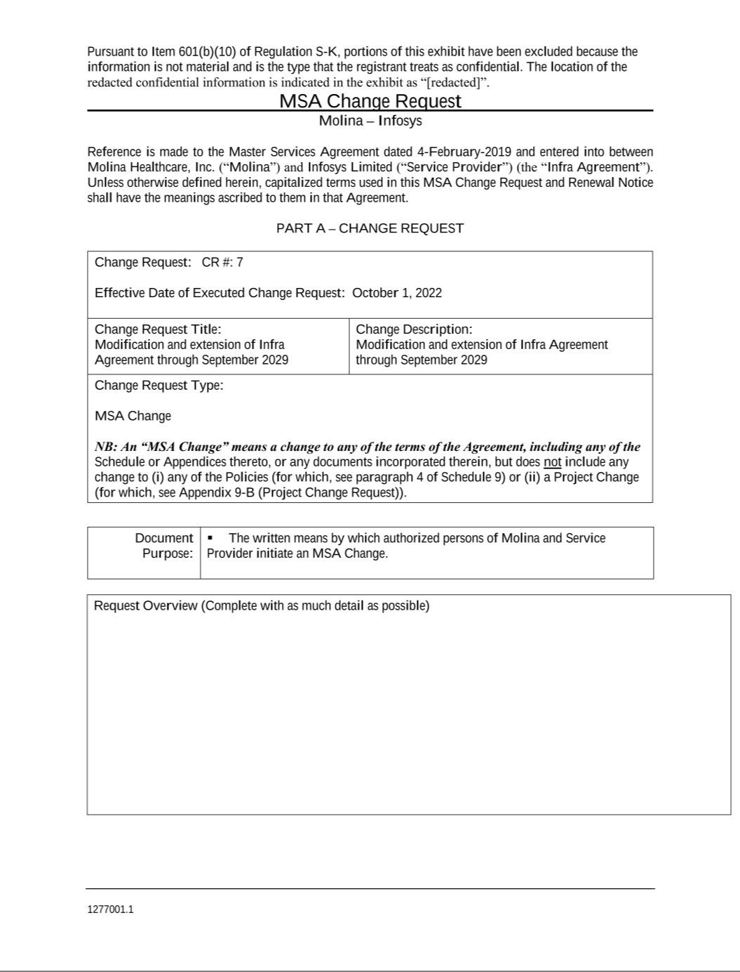

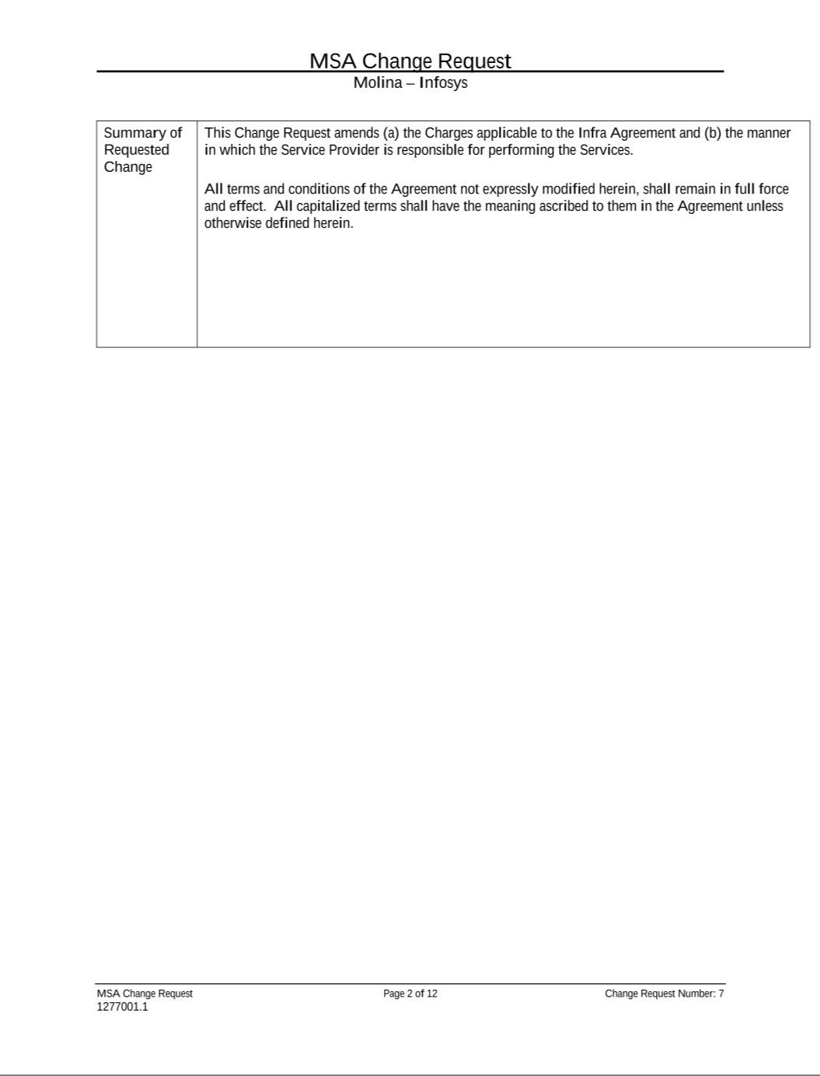

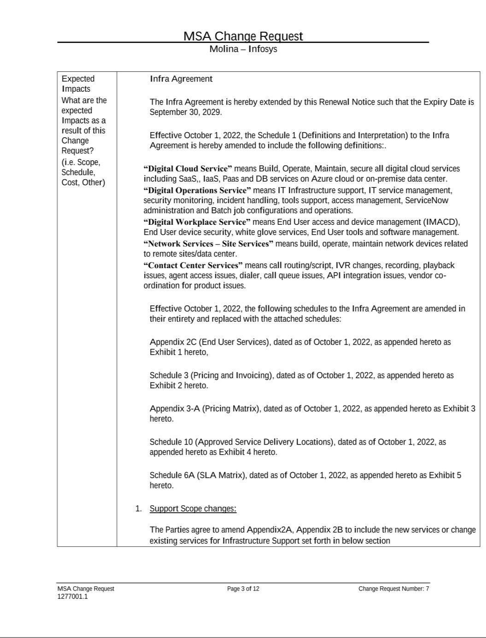

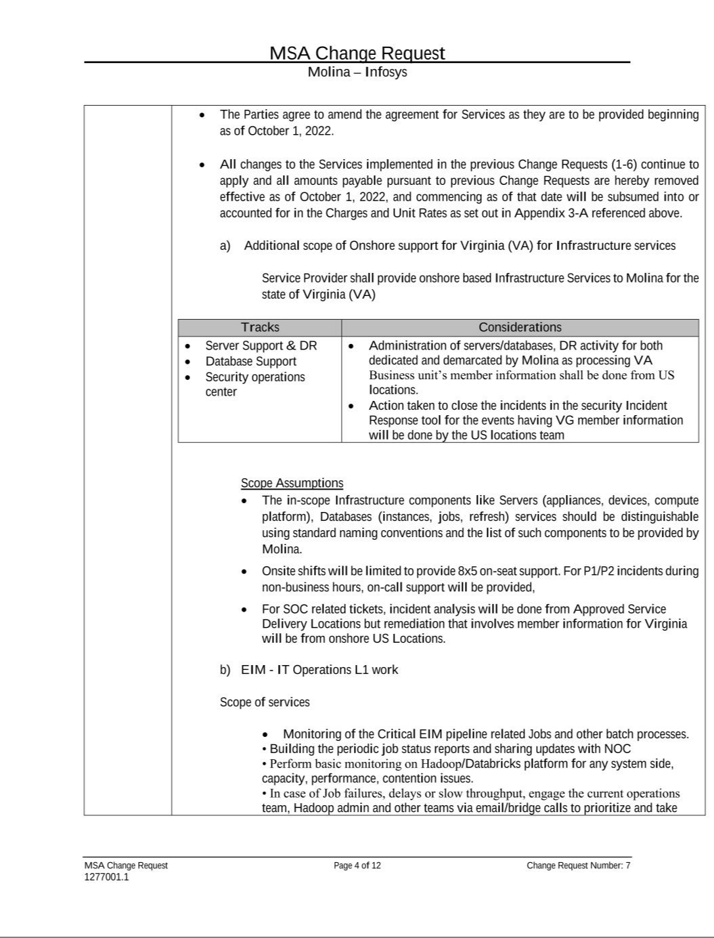

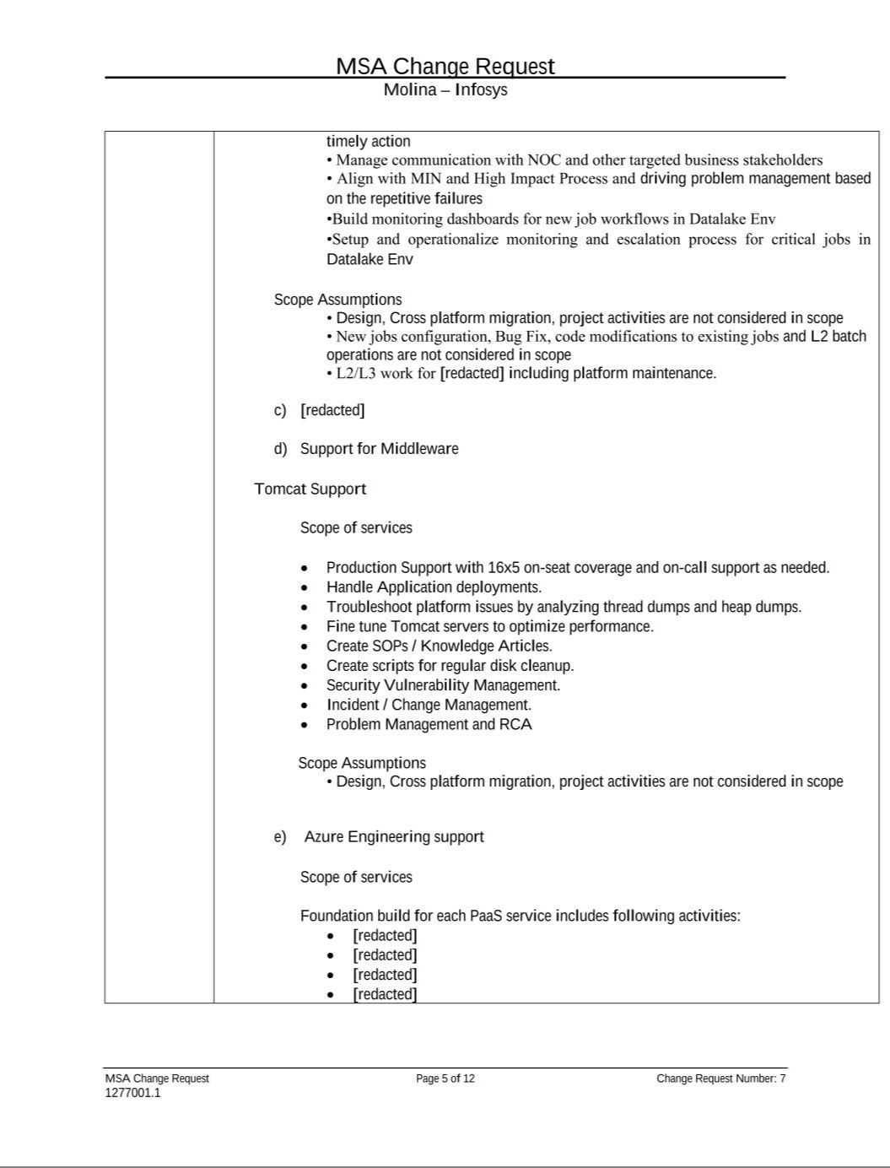

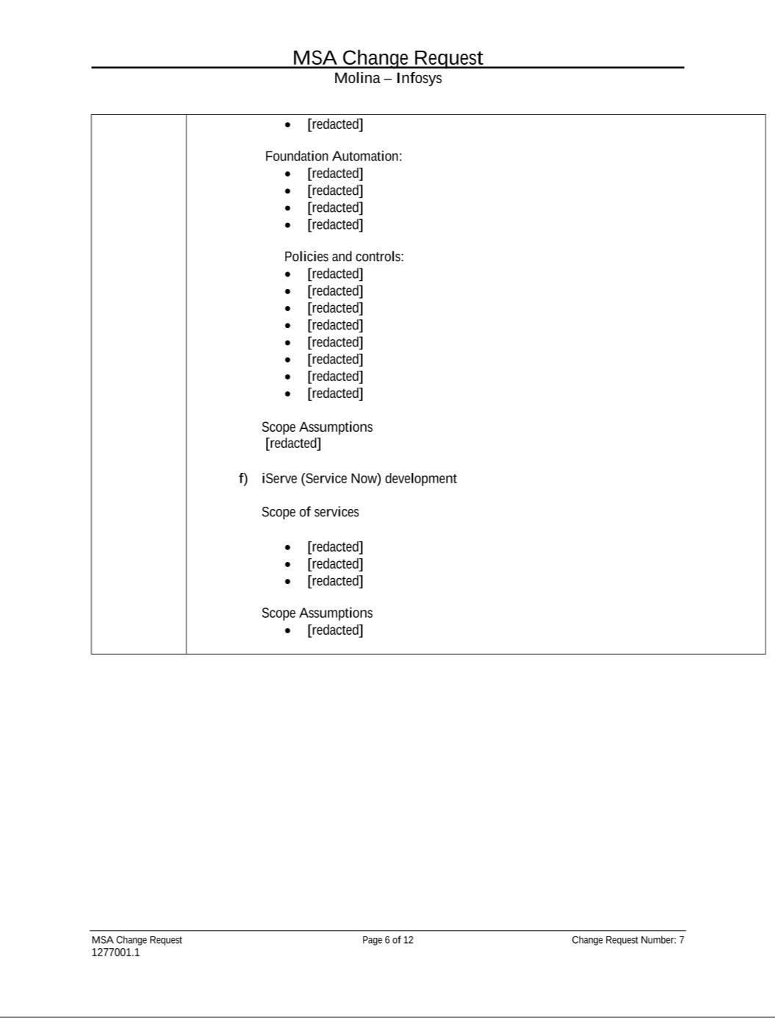

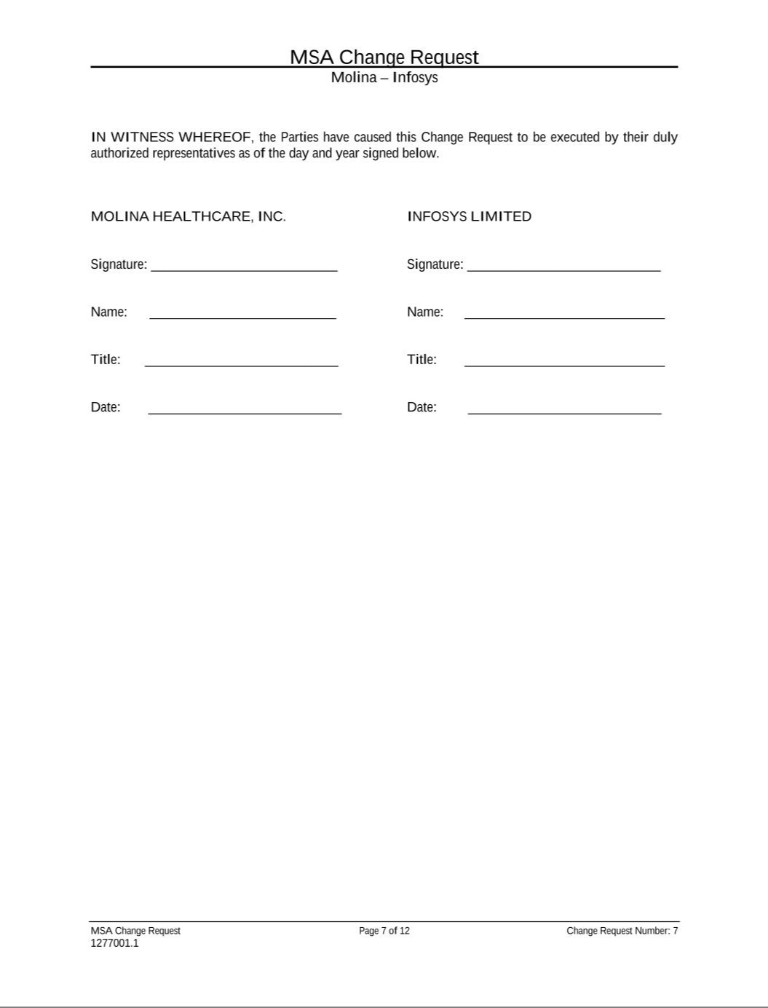

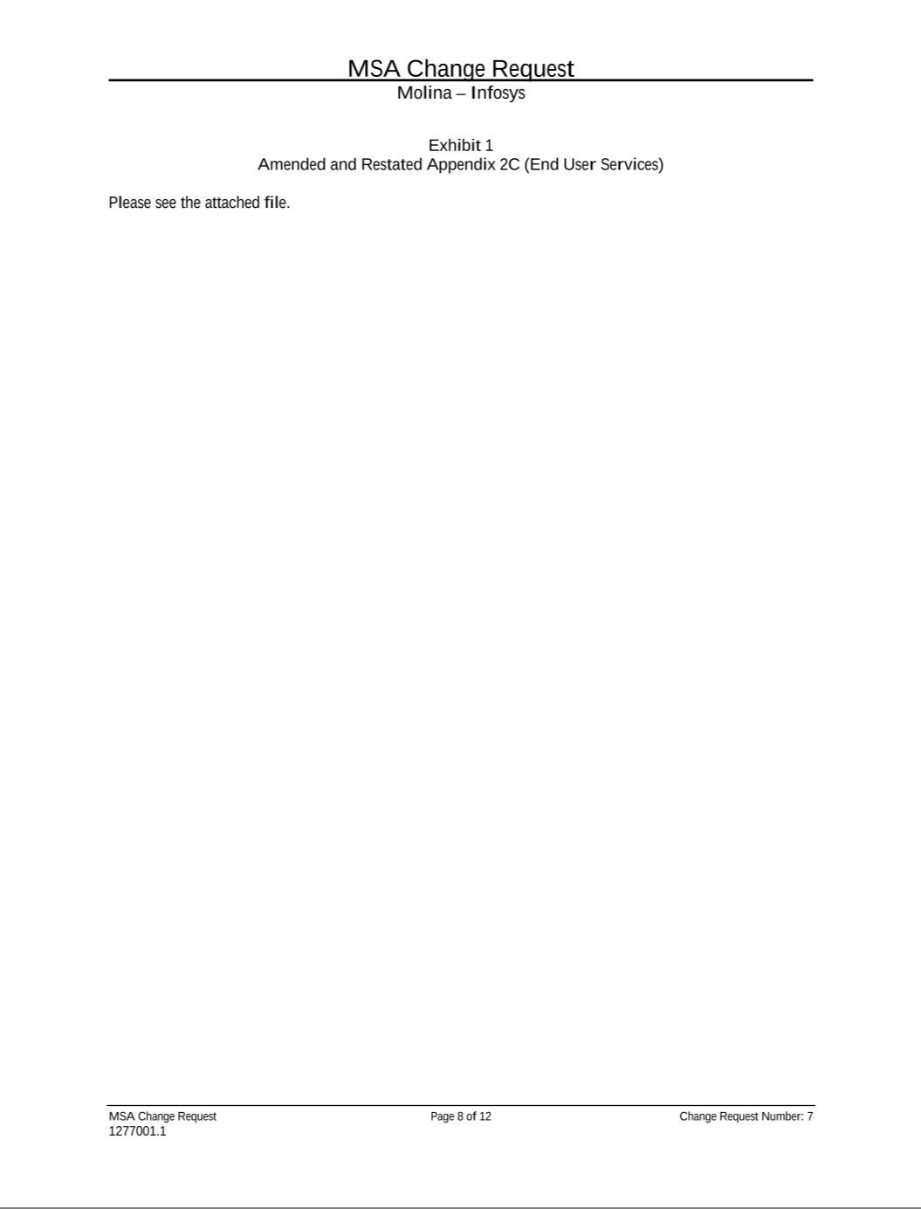

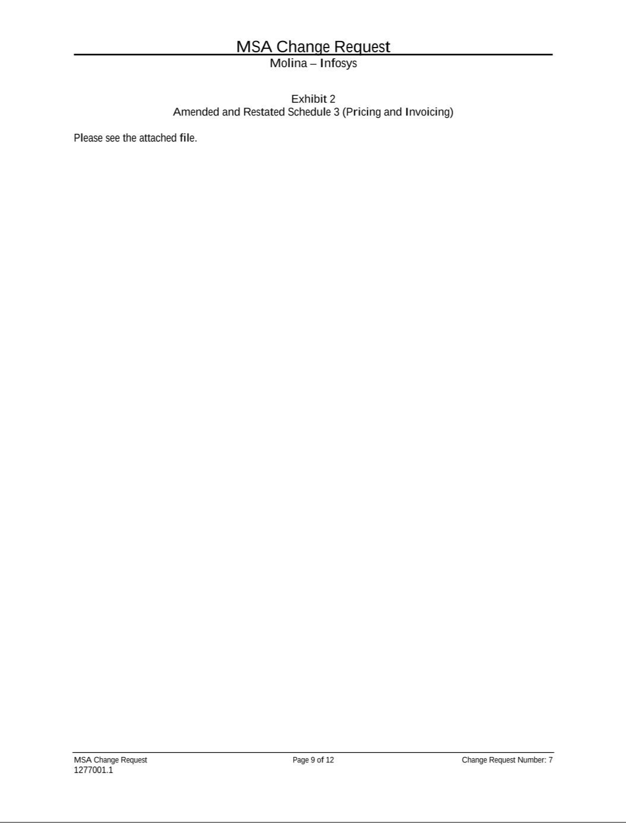

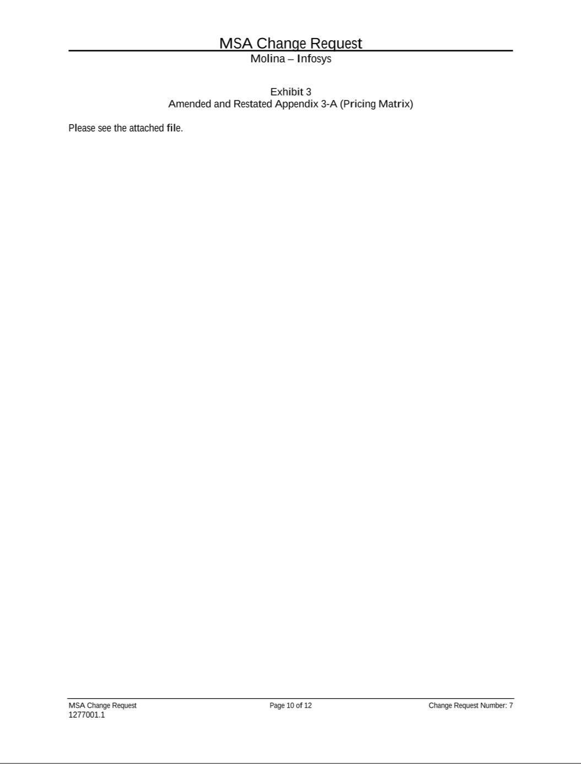

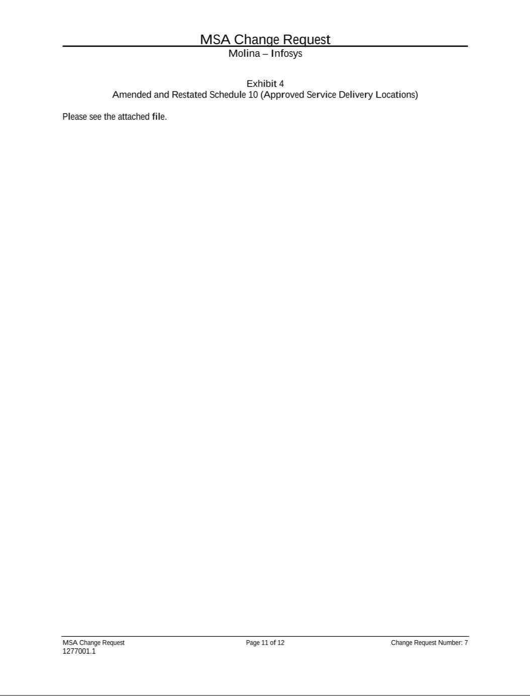

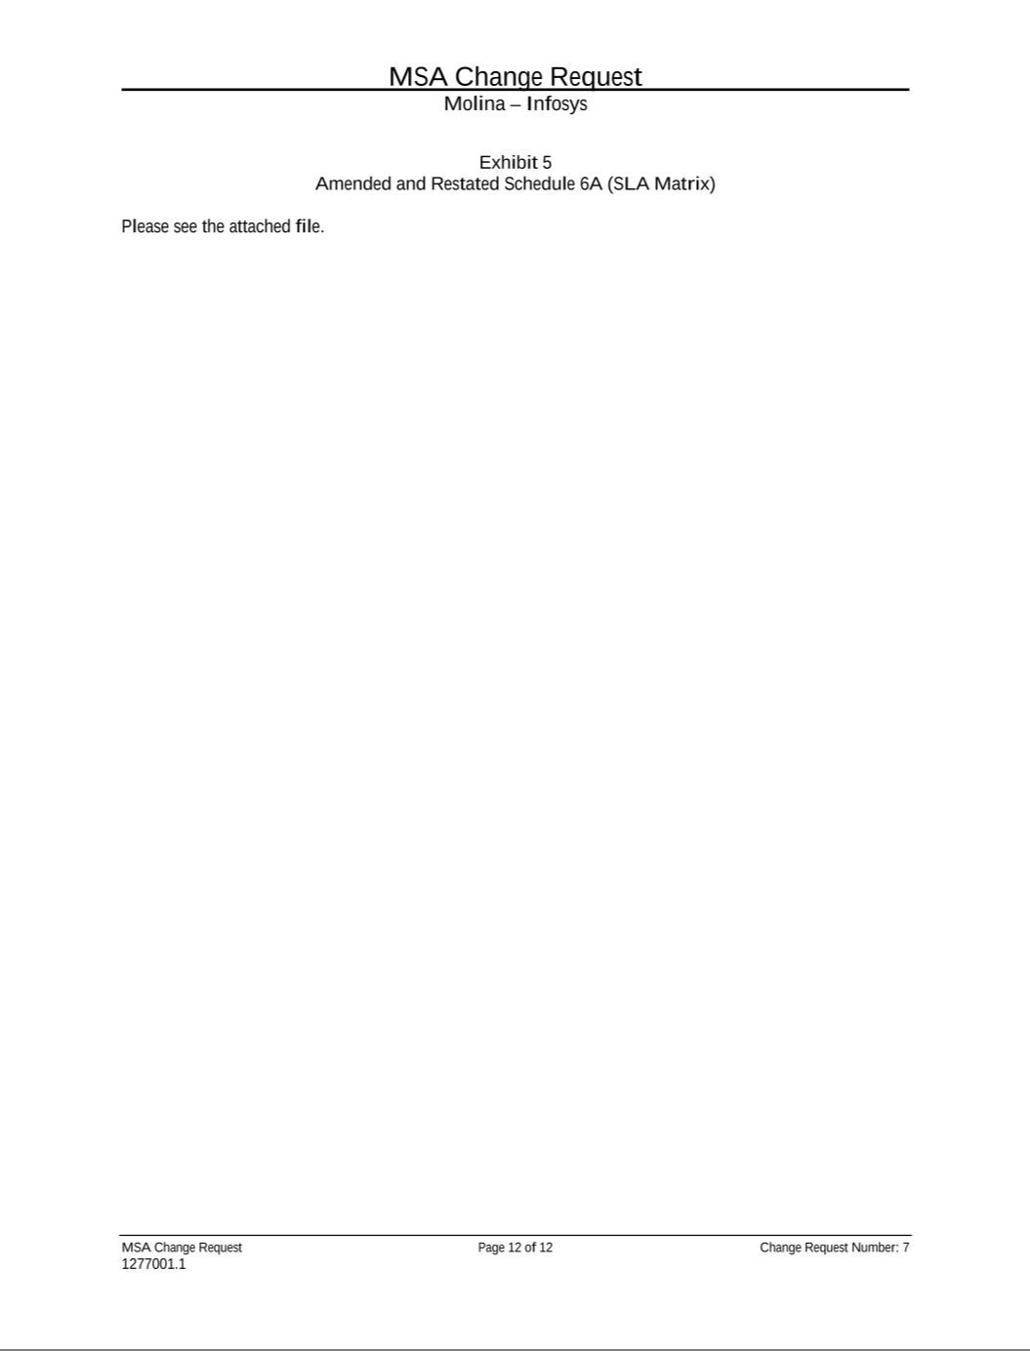

EXHIBIT 31.1

CERTIFICATION PURSUANT TO

RULES 13a-14(a)/15d-14(a)

UNDER THE SECURITIES EXCHANGE

ACT OF 1934, AS AMENDED

I, Joseph M. Zubretsky, certify that:

- I have reviewed the report on Form 10-Q for the period ended September 30, 2022, of Molina Healthcare, Inc.;

- Based on my knowledge, the report does not contain any untrue statement of a material fact or omit to state a material fact necessary in order to make the statements made, in light of the circumstances under which such statements were made, not misleading with respect to the period covered by the report;

- Based on my knowledge, the financial statements, and other financial information included in the report, fairly present in all material respects the financial condition, results of operations and cash flows of the registrant as of, and for, the periods presented in the report;

- The registrant's other certifying officers and I are responsible for establishing and maintaining disclosure controls and procedures (as defined in Rule 13a-15(e) and 15d-15(e) of the Securities Exchange Act of 1934, as amended), and internal control over financial reporting (as defined in Rules 13a-15(f) and 15d-15(f) of the Securities Exchange Act of 1934, as amended), for the registrant and have:

  - Designed such disclosure controls and procedures, or caused such disclosure controls and procedures to be designed under our supervision, to ensure that material information relating to the registrant, including its consolidated subsidiaries, is made known to us by others within those entities, particularly during the period for which this report is being prepared;

  - Designed such internal control over financial reporting, or caused such internal control over financial reporting to be designed under our supervision, to provide reasonable assurance regarding the reliability of financial reporting and the preparation of financial statements for external purposes in accordance with generally accepted accounting principles;

  - Evaluated the effectiveness of the registrant’s disclosure controls and procedures and presented in the report our conclusions about the effectiveness of the disclosure controls and procedures, as of the end of the period covered by the report based on such evaluation; and

  - Disclosed in the report any change in the registrant’s internal control over financial reporting that occurred during the registrant’s most recent fiscal quarter (the registrant’s fourth fiscal quarter in the case of an annual report) that has materially affected, or is reasonably likely to materially affect, the registrant’s internal control over financial reporting; and

- The registrant's other certifying officers and I have disclosed, based on our most recent evaluation of internal control over financial reporting, to the registrant’s auditors and to the audit committee of the registrant’s board of directors (or persons performing the equivalent functions):

  - All significant deficiencies and material weaknesses in the design or operation of internal control over financial reporting which are reasonably likely to adversely affect the registrant’s ability to record, process, summarize and report financial information; and

  - Any fraud, whether or not material, that involves management or other employees who have a significant role in the registrant’s internal control over financial

reporting.

Dated: October 27, 2022 /s/ Joseph M. Zubretsky

Joseph M. Zubretsky

Chief Executive Officer, President and Director

EXHIBIT 31.2

CERTIFICATION PURSUANT TO

RULES 13a-14(a)/15d-14(a)

UNDER THE SECURITIES EXCHANGE

ACT OF 1934, AS AMENDED

I, Mark L. Keim, certify that:

- I have reviewed the report on Form 10-Q for the period ended September 30, 2022, of Molina Healthcare, Inc.;

- Based on my knowledge, the report does not contain any untrue statement of a material fact or omit to state a material fact necessary in order to make the statements made, in light of the circumstances under which such statements were made, not misleading with respect to the period covered by the report;

- Based on my knowledge, the financial statements, and other financial information included in the report, fairly present in all material respects the financial condition, results of operations and cash flows of the registrant as of, and for, the periods presented in the report;

- The registrant’s other certifying officers and I are responsible for establishing and maintaining disclosure controls and procedures (as defined in Rule 13a-15(e) and 15d-15(e) of the Securities Exchange Act of 1934, as amended), and internal control over financial reporting (as defined in Rules 13a-15(f) and 15d-15(f) of the Securities Exchange Act of 1934, as amended), for the registrant and have:

  - Designed such disclosure controls and procedures, or caused such disclosure controls and procedures to be designed under our supervision, to ensure that material information relating to the registrant, including its consolidated subsidiaries, is made known to us by others within those entities, particularly during the period for which this report is being prepared;

  - Designed such internal control over financial reporting, or caused such internal control over financial reporting to be designed under our supervision, to provide reasonable assurance regarding the reliability of financial reporting and the preparation of financial statements for external purposes in accordance with generally accepted accounting principles;

  - Evaluated the effectiveness of the registrant’s disclosure controls and procedures and presented in the report our conclusions about the effectiveness of the disclosure controls and procedures, as of the end of the period covered by the report based on such evaluation; and

  - Disclosed in the report any change in the registrant’s internal control over financial reporting that occurred during the registrant’s most recent fiscal quarter (the registrant’s fourth fiscal quarter in the case of an annual report) that has materially affected, or is reasonably likely to materially affect, the registrant’s internal control over financial reporting; and

- The registrant’s other certifying officers and I have disclosed, based on our most recent evaluation of internal control over financial reporting, to the registrant’s auditors and to the audit committee of the registrant’s board of directors (or persons performing the equivalent functions):

  - All significant deficiencies and material weaknesses in the design or operation of internal control over financial reporting which are reasonably likely to adversely affect the registrant’s ability to record, process, summarize and report financial information; and

  - Any fraud, whether or not material, that involves management or other employees who have a significant role in the registrant’s internal control over financial

reporting.

Dated: October 27, 2022 /s/ Mark L. Keim

Mark L. Keim

Chief Financial Officer and Treasurer

EXHIBIT 32.1

CERTIFICATE PURSUANT TO

18 U.S.C. SECTION 1350,

AS ADOPTED PURSUANT TO

SECTION 906 OF THE SARBANES-OXLEY ACT OF 2002

In connection with the report of Molina Healthcare, Inc. (the “Company”) on Form 10-Q for the period ended September 30, 2022 (the “Report”), I, Joseph M. Zubretsky, Chief Executive Officer of the Company, certify, pursuant to 18 U.S.C. Section 1350, as adopted pursuant to Section 906 of the Sarbanes-Oxley Act of 2002, that:

- The Report fully complies with the requirements of Section 13(a) or 15(d) of the Securities Exchange Act of 1934, as amended; and

- The information contained in the Report fairly presents, in all material respects, the financial condition and results of operations of the Company.

Dated: October 27, 2022 /s/ Joseph M. Zubretsky

Joseph M. Zubretsky

Chief Executive Officer, President and Director

EXHIBIT 32.2

CERTIFICATE PURSUANT TO

18 U.S.C. SECTION 1350,

AS ADOPTED PURSUANT TO

SECTION 906 OF THE SARBANES-OXLEY ACT OF 2002

In connection with the report of Molina Healthcare, Inc. (the “Company”) on Form 10 -Q for the period ended September 30, 2022 (the “Report”), I, Mark L. Keim, Chief Financial Officer of the Company, certify, pursuant to 18 U.S.C. Section 1350, as adopted pursuant to Section 906 of the Sarbanes-Oxley Act of 2002, that:

- The Report fully complies with the requirements of Section 13(a) or 15(d) of the Securities Exchange Act of 1934, as amended; and

- The information contained in the Report fairly presents, in all material respects, the financial condition and results of operations of the Company.

Dated: October 27, 2022 /s/ Mark L. Keim

Mark L. Keim

Chief Financial Officer and Treasurer

