Table of Contents

UNITED STATES

SECURITIES AND EXCHANGE COMMISSION

Washington, D.C. 20549

FORM 10-Q

(Mark One)

- QUARTERLY REPORT PURSUANT TO SECTION 13 OR 15(d) OF THE SECURITIES EXCHANGE ACT OF 1934

For the quarterly period ended June 30, 2019

OR

- TRANSITION REPORT PURSUANT TO SECTION 13 OR 15(d) OF THE SECURITIES EXCHANGE ACT OF 1934

For the transition period from to

Commission file number: 001-31719


MOLINA HEALTHCARE, INC.

(Exact name of registrant as specified in its charter)

Delaware |  |  |  |  | 13-4204626
(State or other jurisdiction of incorporation or organization) |  |  |  |  | (I.R.S. Employer Identification No.)
200 Oceangate, Suite 100
Long Beach, California |  |  |  |  | 90802
(Address of principal executive offices) |  |  | (562) 435-3666 |  |  | (Zip Code)
 |  |  | (Registrant’s telephone number, including area code)
Securities registered pursuant to Section 12(b) of the Act:
Title of each class |  |  | Trading Symbol(s) |  | Name of each exchange on which registered
Common Stock, $0.001 Par Value |  |  | MOH |  | New York Stock Exchange

Indicate by check mark whether the registrant (1) has filed all reports required to be filed by Section 13 or 15(d) of the Securities Exchange Act of 1934 during the preceding 12 months (or for such shorter period that the registrant was required to file such reports), and (2) has been subject to such filing requirements for the past 90 days. Yes ☒ No ☐

Indicate by check mark whether the registrant has submitted electronically and posted on its corporate Web site, if any, every Interactive Data File required to be submitted and posted pursuant to Rule 405 of Regulation S-T during the preceding 12 months (or for such shorter period that the registrant was required to submit and post such files). Yes ☒ No ☐

Indicate by check mark whether the registrant is a large accelerated filer, an accelerated filer, a non-accelerated filer, a smaller reporting company, or emerging growth company. See the definitions of “large accelerated filer,” “accelerated filer,” “smaller reporting company,” and “emerging growth company” in Rule 12b-2 of the Exchange Act.

Large Accelerated Filer ☒ Accelerated Filer ☐ Non-Accelerated Filer ☐ (do not check if a smaller reporting company)

Smaller reporting company ☐ Emerging growth company ☐

If an emerging growth company, indicate by check mark if the registrant has elected not to use the extended transition period for complying with any new or revised financial accounting standards provided pursuant to Section13(a) of the Exchange Act. ☐

Indicate by check mark whether the registrant is a shell company (as defined in Rule 12b-2 of the Exchange Act). Yes ☐ No ☒

The number of shares of the issuer’s Common Stock, $0.001 par value, outstanding as of July 26, 2019, was approximately 62,711,000.

Table of Contents

MOLINA HEALTHCARE, INC. FORM 10-Q

FOR THE QUARTERLY PERIOD ENDED June 30, 2019

TABLE OF CONTENTS

ITEM NUMBER |  |  |  |  |  |  |  |  |  | Page
PART I - Financial Information
1. | Financial Statements |  |  |  |  |  |  |  |  |  |  | 3
2. | Management’s Discussion and Analysis of Financial Condition and Results of Operations |  |  |  |  |  |  |  |  | 28
3. | Quantitative and Qualitative Disclosures About Market Risk |  |  |  |  |  |  |  |  | 48
4. | Controls and Procedures |  |  |  |  |  |  |  |  | 49
Part II - Other Information
1. | Legal Proceedings |  |  |  |  |  |  |  |  | 49
1A. | Risk Factors |  |  |  |  |  |  |  |  | 49
2. | Unregistered Sales of Equity Securities and Use of Proceeds |  |  |  |  |  |  |  |  | 49
3. | Defaults Upon Senior Securities |  |  |  |  |  |  |  |  | Not Applicable.
4. | Mine Safety Disclosures |  |  |  |  |  |  |  |  | Not Applicable.
5. | Other Information |  |  |  |  |  |  |  |  | Not Applicable.
6. | Exhibits |  |  |  |  |  |  |  |  | 50
 | Signatures |  |  |  |  |  |  |  |  | 51

Table of Contents

CONSOLIDATED STATEMENTS OF INCOME

 | Three Months Ended June 30, |  |  |  |  |  |  | Six Months Ended June 30,
 | 2019 |  |  | 2018 |  |  |  | 2019 |  |  | 2018
 |  |  |  | (In millions, except per-share amounts)
 |  |  |  |  | (Unaudited)
Revenue:
Premium revenue | $ | 4,049 |  | $ | 4,514 |  | $ | 8,001 |  | $ | 8,837
Premium tax revenue |  | 110 |  |  | 106 |  |  | 248 |  |  | 210
Health insurer fees reimbursed |  | — |  |  | 104 |  |  | — |  |  | 165
Service revenue |  | — |  |  | 127 |  |  | — |  |  | 261
Investment income and other revenue |  | 34 |  |  | 32 |  |  | 63 |  |  | 56
Total revenue |  | 4,193 |  |  | 4,883 |  |  | 8,312 |  |  | 9,529
Operating expenses:
Medical care costs |  | 3,466 |  |  | 3,850 |  |  | 6,837 |  |  | 7,572
General and administrative expenses |  | 328 |  |  | 335 |  |  | 630 |  |  | 687
Premium tax expenses |  | 110 |  |  | 106 |  |  | 248 |  |  | 210
Health insurer fees |  | — |  |  | 99 |  |  | — |  |  | 174
Depreciation and amortization |  | 22 |  |  | 25 |  |  | 47 |  |  | 51
Restructuring costs |  | 2 |  |  | 8 |  |  | 5 |  |  | 33
Cost of service revenue |  | — |  |  | 118 |  |  | — |  |  | 238
Total operating expenses |  | 3,928 |  |  | 4,541 |  |  | 7,767 |  |  | 8,965
Operating income |  | 265 |  |  | 342 |  |  | 545 |  |  | 564
Other expenses, net:
Interest expense |  | 22 |  |  | 32 |  |  | 45 |  |  | 65
Other (income) expenses, net |  | (14) |  |  | 5 |  |  | (17) |  |  | 15
Total other expenses, net |  | 8 |  |  | 37 |  |  | 28 |  |  | 80
Income before income tax expense |  | 257 |  |  | 305 |  |  | 517 |  |  | 484
Income tax expense |  | 61 |  |  | 103 |  |  | 123 |  |  | 175
Net income | $ | 196 |  | $ | 202 |  | $ | 394 |  | $ | 309
Net income per share:
Basic | $ | 3.15 |  | $ | 3.29 |  | $ | 6.34 |  | $ | 5.10
Diluted | $ | 3.06 |  | $ | 3.02 |  | $ | 6.04 |  | $ | 4.68
CONSOLIDATED STATEMENTS OF COMPREHENSIVE INCOME
 | Three Months Ended June 30, |  |  |  |  |  |  | Six Months Ended June 30,
 | 2019 |  |  | 2018 |  |  |  | 2019 |  |  | 2018
 |  |  |  |  | (In millions)
 |  |  |  |  | (Unaudited)
Net income | $ | 196 |  | $ | 202 |  | $ | 394 |  | $ | 309
Other comprehensive income (loss):
Unrealized investment income (loss) |  | 10 |  |  | 1 |  |  | 17 |  |  | (6)
Less: effect of income taxes |  | 2 |  |  | — |  |  | 4 |  |  | (1)
Other comprehensive income (loss), net of tax |  | 8 |  |  | 1 |  |  | 13 |  |  | (5)
Comprehensive income | $ | 204 |  | $ | 203 |  | $ | 407 |  | $ | 304

See accompanying notes.

Molina Healthcare, Inc. June 30, 2019 Form 10-Q | 3

Table of Contents

CONSOLIDATED BALANCE SHEETS

 | June 30, |  |  | December 31,
 | 2019 |  |  | 2018
 |  | (Dollars in millions,
 | except per-share amounts)
 | (Unaudited)
ASSETS
Current assets:
Cash and cash equivalents | $ | 2,253 |  | $ | 2,826
Investments |  | 2,070 |  |  | 1,681
Receivables |  | 1,239 |  |  | 1,330
Prepaid expenses and other current assets |  | 132 |  |  | 149
Derivative asset |  | 169 |  |  | 476
Total current assets |  | 5,863 |  |  | 6,462
Property, equipment, and capitalized software, net |  | 373 |  |  | 241
Goodwill and intangible assets, net |  | 180 |  |  | 190
Restricted investments |  | 98 |  |  | 120
Deferred income taxes |  | 70 |  |  | 117
Other assets |  | 106 |  |  | 24
 | $ | 6,690 |  | $ | 7,154
LIABILITIES AND STOCKHOLDERS’ EQUITY
Current liabilities:
Medical claims and benefits payable | $ | 1,767 |  | $ | 1,961
Amounts due government agencies |  | 984 |  |  | 967
Accounts payable and accrued liabilities |  | 373 |  |  | 390
Deferred revenue |  | 30 |  |  | 211
Current portion of long-term debt |  | 65 |  |  | 241
Derivative liability |  | 169 |  |  | 476
Total current liabilities |  | 3,388 |  |  | 4,246
Long-term debt |  | 1,241 |  |  | 1,020
Finance lease liabilities |  | 232 |  |  | 197
Other long-term liabilities |  | 93 |  |  | 44
Total liabilities |  | 4,954 |  |  | 5,507
Stockholders’ equity:
Common stock, $0.001 par value, 150 million shares authorized; outstanding: 63 million shares at June 30, 2019, and 62 million shares at
December 31, 2018 |  | — |  |  | —
Preferred stock, $0.001 par value; 20 million shares authorized, no shares issued and outstanding |  | — |  |  | —
Additional paid-in capital |  | 240 |  |  | 643
Accumulated other comprehensive income (loss) |  | 5 |  |  | (8)
Retained earnings |  | 1,491 |  |  | 1,012
Total stockholders’ equity |  | 1,736 |  |  | 1,647
 | $ | 6,690 |  | $ | 7,154

See accompanying notes.

Molina Healthcare, Inc. June 30, 2019 Form 10-Q | 4

Table of Contents

CONSOLIDATED STATEMENTS OF STOCKHOLDERS’ EQUITY

 | Common Stock |  |  |  |  |  |  |  |  | Accumulated
 |  |  |  |  |  |  | Additional |  |  | Other
 |  |  |  |  |  |  | Paid-in |  |  | Comprehensive |  |  |  | Retained
 | Outstanding |  |  | Amount |  |  | Capital |  |  | Income |  |  |  | Earnings |  |  | Total
 |  |  |  |  |  |  |  | (In millions)
 |  |  |  |  |  |  |  | (Unaudited)
Balance at December 31, 2018 | 62 |  | $ | — |  | $ | 643 | $ |  |  | (8) |  | $ | 1,012 |  | $ | 1,647
Net income | — |  |  | — |  |  | — |  |  |  | — |  |  | 198 |  |  | 198
Adoption of new accounting standard | — |  |  | — |  |  | — |  |  |  | — |  |  | 85 |  |  | 85
Partial termination of 1.125% Warrants | — |  |  | — |  |  | (103) |  |  |  | — |  |  | — |  |  | (103)
Other comprehensive income, net | — |  |  | — |  |  | — |  |  |  | 5 |  |  | — |  |  | 5
Share-based compensation | 1 |  |  | — |  |  | 3 |  |  |  | — |  |  | — |  |  | 3
Balance at March 31, 2019 | 63 |  |  | — |  |  | 543 |  |  |  | (3) |  |  | 1,295 |  |  | 1,835
Net income | — |  |  | — |  |  | — |  |  |  | — |  |  | 196 |  |  | 196
Partial termination of 1.125% Warrants | — |  |  | — |  |  | (321) |  |  |  | — |  |  | — |  |  | (321)
Other comprehensive income, net | — |  |  | — |  |  | — |  |  |  | 8 |  |  | — |  |  | 8
Share-based compensation | — |  |  | — |  |  | 18 |  |  |  | — |  |  | — |  |  | 18
Balance at June 30, 2019 | 63 |  | $ | — |  | $ | 240 | $ |  |  | 5 |  | $ | 1,491 |  | $ | 1,736
 | Common Stock |  |  |  |  |  |  |  |  | Accumulated
 |  |  |  |  |  |  | Additional |  |  | Other
 |  |  |  |  |  |  | Paid-in |  |  | Comprehensive |  |  |  | Retained
 | Outstanding |  |  | Amount |  |  | Capital |  |  | Loss |  |  |  | Earnings |  |  | Total
 |  |  |  |  |  |  |  | (In millions)
 |  |  |  |  |  |  |  | (Unaudited)
Balance at December 31, 2017 | 60 |  | $ | — |  | $ | 1,044 | $ |  |  | (5) |  | $ | 298 |  | $ | 1,337
Net income | — |  |  | — |  |  | — |  |  |  | — |  |  | 107 |  |  | 107
Adoption of new accounting standards | — |  |  | — |  |  | — |  |  |  | (1) |  |  | 7 |  |  | 6
Exchange of 1.625% Convertible Notes | 2 |  |  | — |  |  | 108 |  |  |  | — |  |  | — |  |  | 108
Other comprehensive loss, net | — |  |  | — |  |  | — |  |  |  | (6) |  |  | — |  |  | (6)
Share-based compensation | — |  |  | — |  |  | 1 |  |  |  | — |  |  | — |  |  | 1
Balance at March 31, 2018 | 62 |  |  | — |  |  | 1,153 |  |  |  | (12) |  |  | 412 |  |  | 1,553
Net income | — |  |  | — |  |  | — |  |  |  | — |  |  | 202 |  |  | 202
Partial termination of 1.125% Warrants | — |  |  | — |  |  | (113) |  |  |  | — |  |  | — |  |  | (113)
Other comprehensive income, net | — |  |  | — |  |  | — |  |  |  | 1 |  |  | — |  |  | 1
Share-based compensation | — |  |  | — |  |  | 15 |  |  |  | — |  |  | — |  |  | 15
Balance at June 30, 2018 | 62 |  | $ | — |  | $ | 1,055 | $ |  |  | (11) |  | $ | 614 |  | $ | 1,658

See accompanying notes.

Molina Healthcare, Inc. June 30, 2019 Form 10-Q | 5

Table of Contents

CONSOLIDATED STATEMENTS OF CASH FLOWS

 | Six Months Ended June 30,
 | 2019 |  |  | 2018
 |  | (In millions)
 |  | (Unaudited)
Operating activities:
Net income | $ | 394 |  | $ | 309
Adjustments to reconcile net income to net cash provided by operating activities:
Depreciation and amortization |  | 47 |  |  | 73
Deferred income taxes |  | 19 |  |  | (6)
Share-based compensation |  | 19 |  |  | 13
Amortization of convertible senior notes and finance lease liabilities |  | 4 |  |  | 13
(Gain) loss on debt extinguishment |  | (17) |  |  | 15
Non-cash restructuring costs |  | — |  |  | 17
Other, net |  | 3 |  |  | 4
Changes in operating assets and liabilities:
Receivables |  | 91 |  |  | (315)
Prepaid expenses and other current assets |  | 18 |  |  | (181)
Medical claims and benefits payable |  | (194) |  |  | (267)
Amounts due government agencies |  | 17 |  |  | 205
Accounts payable and accrued liabilities |  | (61) |  |  | 349
Deferred revenue |  | (181) |  |  | (42)
Income taxes |  | (3) |  |  | 127
Net cash provided by operating activities |  | 156 |  |  | 314
Investing activities:
Purchases of investments |  | (1,162) |  |  | (914)
Proceeds from sales and maturities of investments |  | 791 |  |  | 1,335
Purchases of property, equipment and capitalized software |  | (20) |  |  | (14)
Other, net |  | (2) |  |  | (9)
Net cash (used in) provided by investing activities |  | (393) |  |  | 398
Financing activities:
Repayment of principal amount of 1.125% Convertible Notes |  | (185) |  |  | (89)
Cash paid for partial settlement of 1.125% Conversion Option |  | (473) |  |  | (134)
Cash received for partial termination of 1.125% Call Option |  | 473 |  |  | 134
Cash paid for partial termination of 1.125% Warrants |  | (424) |  |  | (113)
Proceeds from borrowings under Term Loan Facility |  | 220 |  |  | —
Repayment of Credit Facility |  | — |  |  | (300)
Other, net |  | 27 |  |  | (1)
Net cash used in financing activities |  | (362) |  |  | (503)
Net (decrease) increase in cash, cash equivalents, and restricted cash and cash equivalents |  | (599) |  |  | 209
Cash, cash equivalents, and restricted cash and cash equivalents at beginning of period |  | 2,926 |  |  | 3,290
Cash, cash equivalents, and restricted cash and cash equivalents at end of period | $ | 2,327 |  | $ | 3,499

Molina Healthcare, Inc. June 30, 2019 Form 10-Q | 6

Table of Contents

CONSOLIDATED STATEMENTS OF CASH FLOWS

(continued)

 | Six Months Ended June 30,
 | 2019 |  |  | 2018
 |  | (In millions)
 |  | (Unaudited)
Supplemental cash flow information:
Schedule of non-cash investing and financing activities:
Common stock used for share-based compensation | $ | (7) |  | $ | (6)
Details of change in fair value of derivatives, net:
Gain on 1.125% Call Option | $ | 166 |  | $ | 135
Loss on 1.125% Conversion Option |  | (166) |  |  | (135)
Change in fair value of derivatives, net | $ | — |  | $ | —
1.625% Convertible Notes exchange transaction:
Common stock issued in exchange for 1.625% Convertible Notes | $ | — |  | $ | 131
Component allocated to additional paid-in capital, net of income taxes |  | — |  |  | (23)
Net increase to additional paid-in capital | $ | — |  | $ | 108

See accompanying notes.

Molina Healthcare, Inc. June 30, 2019 Form 10-Q | 7

Table of Contents

NOTES TO CONSOLIDATED FINANCIAL STATEMENTS (UNAUDITED)

June 30, 2019

1. Organization and Basis of Presentation

Organization and Operations

Molina Healthcare, Inc. provides managed healthcare services under the Medicaid and Medicare programs and through the state insurance marketplaces (the “Marketplace”). We currently have two reportable segments: our Health Plans segment and our Other segment. We manage the vast majority of our operations through our Health Plans segment. The Other segment includes the historical results of the Medicaid management information systems (“MMIS”) and behavioral health subsidiaries we sold in the fourth quarter of 2018, as well as certain corporate amounts not allocated to the Health Plans segment. Prior to the fourth quarter of 2018, the MMIS subsidiary was reported as a stand-alone segment.

The Health Plans segment consists of health plans operating in 14 states and the Commonwealth of Puerto Rico. As of June 30, 2019, these health plans served approximately 3.4 million members eligible for Medicaid, Medicare, and other government-sponsored healthcare programs for low-income families and individuals including Marketplace members, most of whom receive government subsidies for premiums. The health plans are generally operated by our respective wholly owned subsidiaries in those states, each of which is licensed as a health maintenance organization (“HMO”).

Our health plans’ state Medicaid contracts generally have terms of three to five years. These contracts typically contain renewal options exercisable by the state Medicaid agency, and allow either the state or the health plan to terminate the contract with or without cause. Such contracts are subject to risk of loss in states that issue requests for proposal (“RFPs”) open to competitive bidding by other health plans. If one of our health plans is not a successful responsive bidder to a state RFP, its contract may not be renewed.

In addition to contract renewal, our state Medicaid contracts may be periodically amended to include or exclude certain health benefits (such as pharmacy services, behavioral health services, or long-term care services); populations such as the aged, blind or disabled; and regions or service areas.

Consolidation and Interim Financial Information

The consolidated financial statements include the accounts of Molina Healthcare, Inc., and its subsidiaries. In the opinion of management, all adjustments considered necessary for a fair presentation of the results as of the date and for the interim periods presented have been included; such adjustments consist of normal recurring adjustments. All significant intercompany balances and transactions have been eliminated. The consolidated results of operations for the six months ended June 30, 2019, are not necessarily indicative of the results for the entire year ending December 31, 2019.

The unaudited consolidated interim financial statements have been prepared under the assumption that users of the interim financial data have either read or have access to our audited consolidated financial statements for the fiscal year ended December 31, 2018. Accordingly, certain disclosures that would substantially duplicate the disclosures contained in our December 31, 2018, audited consolidated financial statements have been omitted. These unaudited consolidated interim financial statements should be read in conjunction with our audited consolidated financial statements for the fiscal year ended December 31, 2018.

Use of Estimates

The preparation of consolidated financial statements in conformity with generally accepted accounting principles (“GAAP”) requires management to make estimates and assumptions that affect the reported amounts of assets and liabilities. Estimates also affect the reported amounts of revenues and expenses during the reporting period. Actual results could differ from these estimates. Principal areas requiring the use of estimates include:

- The determination of medical claims and benefits payable of our Health Plans segment;

- Health plans’ contractual provisions that may limit revenue recognition based upon the costs incurred or the profits realized under a specific contract;

- Health plans’ quality incentives that allow us to recognize incremental revenue if certain quality standards are met;

- Settlements under risk or savings sharing programs;

- The assessment of long-lived and intangible assets, and goodwill for impairment;

Molina Healthcare, Inc. June 30, 2019 Form 10-Q | 8

Table of Contents

  - The determination of reserves for potential absorption of claims unpaid by insolvent providers;

  - The determination of reserves for litigation outcomes;

  - The determination of valuation allowances for deferred tax assets; and

  - The determination of unrecognized tax benefits.

- Significant Accounting Policies

Cash and Cash Equivalents

Cash and cash equivalents consist of cash and short-term, highly liquid investments that are both readily convertible into known amounts of cash and have a maturity of three months or less on the date of purchase. The following table provides a reconciliation of cash, cash equivalents, and restricted cash and cash equivalents reported within the accompanying consolidated balance sheets that sum to the total of the same such amounts presented in the accompanying consolidated statements of cash flows. The restricted cash and cash equivalents presented below are included in non-current “Restricted investments” in the accompanying consolidated balance sheets.

 |  | June 30,
 | 2019 |  |  |  | 2018
 |  | (In millions)
Cash and cash equivalents | $ | 2,253 |  | $ | 3,401
Restricted cash and cash equivalents |  | 74 |  |  | 98
Total cash, cash equivalents, and restricted cash and cash equivalents presented in the statements of cash flows | $ | 2,327 |  | $ | 3,499

Premium Revenue

Premium revenue is fixed in advance of the periods covered and, except as described below, is not generally subject to significant accounting estimates. Premium revenues are recognized in the month that members are entitled to receive healthcare services, and premiums collected in advance are deferred. Certain components of premium revenue are subject to accounting estimates and fall into the following categories:

Contractual Provisions That May Adjust or Limit Revenue or Profit

Medicaid Program

Medical Cost Floors (Minimums), and Medical Cost Corridors. A portion of our premium revenue may be returned if certain minimum amounts are not spent on defined medical care costs. In the aggregate, we recorded liabilities under the terms of such contract provisions of $93 million and $103 million at June 30, 2019 and December 31, 2018, respectively. Approximately $76 million and $87 million of the liabilities accrued at June 30, 2019 and December 31, 2018, respectively, relate to our participation in Medicaid Expansion programs.

In certain circumstances, the health plans may receive additional premiums if amounts spent on medical care costs exceed a defined maximum threshold. Receivables relating to such provisions were insignificant at June 30, 2019 and December 31, 2018.

Profit Sharing and Profit Ceiling. Our contracts with certain states contain profit-sharing or profit ceiling provisions under which we refund amounts to the states if our health plans generate profit above a certain specified percentage. In some cases, we are limited in the amount of administrative costs that we may deduct in calculating the refund, if any. Liabilities for profits in excess of the amount we are allowed to retain under these provisions were insignificant at June 30, 2019 and December 31, 2018.

Retroactive Premium Adjustments. State Medicaid programs periodically adjust premium rates on a retroactive basis. In these cases, we must adjust our premium revenue in the period in which we learn of the adjustment, based on our best estimate of the ultimate premium we expect to realize for the period being adjusted.

Medicare Program

Risk Adjusted Premiums. Our Medicare premiums are subject to retroactive increase or decrease based on the health status of our Medicare members (as measured by member risk score). We estimate our members’ risk scores and the related amount of Medicare revenue that will ultimately be realized for the periods presented based on our knowledge of our members’ health status, risk scores and Centers for Medicare and Medicaid Services

Molina Healthcare, Inc. June 30, 2019 Form 10-Q | 9

Table of Contents

(“CMS”) practices. Consolidated balance sheet amounts related to anticipated Medicare risk adjusted premiums and Medicare Part D settlements were insignificant at June 30, 2019 and December 31, 2018.

Minimum MLR. The Affordable Care Act (“ACA”) has established a minimum annual medical loss ratio (“Minimum MLR”) of 85% for Medicare. The medical loss ratio represents medical costs as a percentage of premium revenue. Federal regulations define what constitutes medical costs and premium revenue. If the Minimum MLR is not met, we may be required to pay rebates to the federal government. We recognize estimated rebates under the Minimum MLR as an adjustment to premium revenue in our consolidated statements of income. The amounts payable for the Medicare Minimum MLR were not significant at June 30, 2019 and December 31, 2018.

Marketplace Program

Risk Adjustment. Under this program, our health plans’ composite risk scores are compared with the overall average risk score for the relevant state and market pool. Generally, our health plans will make a risk adjustment payment into the pool if their composite risk scores are below the average risk score (risk adjustment payable), and will receive a risk adjustment payment from the pool if their composite risk scores are above the average risk score (risk adjustment receivable). We estimate our ultimate premium based on insurance policy year-to-date experience, and recognize estimated premiums relating to the risk adjustment program as an adjustment to premium revenue in our consolidated statements of income. As of June 30, 2019, Marketplace risk adjustment payables amounted to $625 million and related receivables amounted to $71 million, or a net of $554 million. Approximately $390 million of the net amount at June 30, 2019 relates to 2018 dates of service. As of December 31, 2018, Marketplace risk adjustment payables amounted to $466 million and related receivables amounted to $34 million, or a net of $432 million.

Minimum MLR. The ACA has established a Minimum MLR of 80% for the Marketplace. If the Minimum MLR is not met, we may be required to pay rebates to our Marketplace policyholders. The Marketplace risk adjustment program is taken into consideration when computing the Minimum MLR. We recognize estimated rebates under the Minimum MLR as an adjustment to premium revenue in our consolidated statements of income. Aggregate balance sheet amounts related to the Minimum MLR were insignificant at June 30, 2019 and December 31, 2018.

A summary of the categories of amounts due government agencies follows:

 | June 30, |  |  |  | December 31,
 | 2019 |  |  |  | 2018
 |  | (In millions)
Medicaid program:
Medical cost floors and corridors | $ | 93 |  | $ | 103
Other amounts due to states |  | 93 |  |  | 81
Marketplace program:
Risk adjustment |  | 625 |  |  | 466
Cost sharing reduction (“CSR”) |  | — |  |  | 183
Other |  | 173 |  |  | 134
Total amounts due government agencies | $ | 984 |  | $ | 967

Quality Incentives

At many of our health plans, revenue ranging from approximately 1% to 4% of certain health plan premiums is earned only if certain performance measures are met.

The following table quantifies the quality incentive premium revenue recognized for the periods presented, including the amounts earned in the periods presented and prior periods. Although the reasonably possible effects of a change in estimate related to quality incentive premium revenue as of June 30, 2019, are not known, we have no reason to believe that the adjustments to prior years noted below are not indicative of the potential future changes in our estimates as of June 30, 2019.

Molina Healthcare, Inc. June 30, 2019 Form 10-Q | 10

Table of Contents

 | Three Months Ended June 30, |  |  |  |  |  |  | Six Months Ended June 30,
 | 2019 |  |  | 2018 |  |  |  | 2019 |  |  | 2018
 |  |  |  |  | (In millions)
Maximum available quality incentive premium - current period | $ | 46 |  | $ | 47 |  | $ | 91 |  | $ | 87
Quality incentive premium revenue recognized in current period:
Earned current period | $ | 37 |  | $ | 34 |  | $ | 63 |  | $ | 58
Earned prior periods |  | 10 |  |  | 12 |  |  | 30 |  |  | 23
Total | $ | 47 |  | $ | 46 |  | $ | 93 |  |  | 81
Quality incentive premium revenue recognized as a percentage of total premium revenue |  | 1.2% |  |  | 1.0% |  |  | 1.2% |  |  | 0.9%

Medical Care Costs

Marketplace Program

In the first half of 2018, we recognized a benefit of approximately $76 million in reduced medical care costs related to 2017 dates of service as a result of the federal government’s confirmation that the reconciliation of 2017 Marketplace CSR subsidies would be performed on an annual basis. In the fourth quarter of 2017, we had assumed a nine-month reconciliation of this item pending confirmation of the time period to which the 2017 reconciliation would be applied.

Leases

Right-of-use (“ROU”) assets represent our right to use the underlying assets over the lease term, and lease liabilities represent our obligation for lease payments arising from the related leases. ROU assets and lease liabilities are recognized at the lease commencement date based on the present value of lease payments over the lease term. Lease terms may include options to extend or terminate the lease when we believe it is reasonably certain that we will exercise such options. If applicable, we account for lease and non-lease components within a lease as a single lease component.

Because most of our leases do not provide an implicit interest rate, we generally use our incremental borrowing rate to determine the present value of lease payments. Lease expenses for operating lease payments are recognized on a straight-line basis over the lease term, and the related ROU assets and liabilities are reduced to the present value of the remaining lease payments at the end of each period. Finance lease payments reduce finance lease liabilities, the related ROU assets are amortized on a straight-line basis over the lease term, and interest expense is recognized using the effective interest method.

The significant majority of our operating leases consist of long-term operating leases for office space. Short-term leases (those with terms of 12 months or less) are not recorded as ROU assets or liabilities in the consolidated balance sheets. For certain leases that represent a portfolio of similar assets, such as a fleet of vehicles, we apply a portfolio approach to account for the related operating lease ROU assets and liabilities, rather than account for such assets and the related liabilities individually. A nominal number of our lease agreements include rental payments that adjust periodically for inflation. Our lease agreements do not contain any material residual value guarantees or material restrictive covenants.

For further information, including the amount and location of the ROU assets and lease liabilities recognized in the accompanying consolidated balance sheet, see Note 13, “Leases.” For further information regarding our adoption and implementation of Accounting Standards Update (“ASU”) 2016-02, Leases (Topic 842), see Recent Accounting Pronouncements Adopted, below.

Concentrations of Credit Risk

Financial instruments that potentially subject us to concentrations of credit risk consist primarily of cash and cash equivalents, investments, receivables, and restricted investments. Our investments and a portion of our cash equivalents are managed by professional portfolio managers operating under documented investment guidelines. Our portfolio managers must obtain our prior approval before selling investments where the loss position of those investments exceeds certain levels. Our investments consist primarily of investment-grade debt securities with a maximum maturity of 10 years, or 10 years average life for structured securities. Restricted investments are invested principally in certificates of deposit and U.S. Treasury securities. Concentration of credit risk with respect to

Molina Healthcare, Inc. June 30, 2019 Form 10-Q | 11

Table of Contents

accounts receivable is generally limited because our payors consist principally of the federal government, and governments of each state or commonwealth in which our health plan subsidiaries operate.

Income Taxes

The provision for income taxes is determined using an estimated annual effective tax rate, which generally differs from the U.S. federal statutory rate primarily because of foreign and state taxes, nondeductible expenses such as the Health Insurer Fee (“HIF”), certain compensation, and other general and administrative expenses. The effective tax rate will not be impacted by HIF in 2019 given the 2019 HIF moratorium.

The effective tax rate may be subject to fluctuations during the year as new information is obtained. Such information may affect the assumptions used to estimate the annual effective tax rate, including projected pretax earnings, the mix of pretax earnings in the various tax jurisdictions in which we operate, valuation allowances against deferred tax assets, the recognition or the reversal of the recognition of tax benefits related to uncertain tax positions, and changes in or the interpretation of tax laws in jurisdictions where we conduct business. We recognize deferred tax assets and liabilities for temporary differences between the financial reporting basis and the tax basis of our assets and liabilities, along with net operating loss and tax credit carryovers.

Recent Accounting Pronouncements Adopted

Leases. In February 2016, the Financial Accounting Standards Board (“FASB”) issued Topic 842, which was subsequently modified by several ASUs issued in 2017 and 2018. Topic 842 was issued to increase transparency and comparability among organizations by requiring the recognition of ROU assets and lease liabilities on the balance sheet. Most prominent among the changes in Topic 842 is the recognition of ROU assets and lease liabilities by lessees for those leases classified as operating leases. In addition, Topic 842’s disclosures are required to meet the objective of enabling users of financial statements to assess the amount, timing and uncertainty of cash flows arising from leases. Topic 842’s transition provisions are applied using a modified retrospective approach; entities may elect whether to apply the transition provisions, including disclosure requirements, at the beginning of the earliest comparative period presented or on the adoption date.

We adopted Topic 842 effective January 1, 2019, and elected to apply the transition provisions as of that date. Accordingly, we recognized the cumulative effect of initially applying the standard as an adjustment to the opening balance of retained earnings on January 1, 2019. In addition, we elected the available practical expedients and implemented internal controls and key system functionality to enable the preparation of financial information on adoption.

As indicated in the accompanying consolidated statements of stockholders’ equity, the cumulative effect adjustment was an increase of $85 million to retained earnings, relating primarily to the transition provisions for sale-leaseback arrangements that did not qualify for sale treatment. Accordingly, such arrangements for certain office buildings were de-recognized and recorded as finance lease ROU assets and lease liabilities. The difference between the de-recognized assets and lease financing obligations resulted in an increase to retained earnings. The recognition of these arrangements as finance lease ROU assets and lease liabilities will not materially impact our consolidated results of operations over the terms of the leases.

Software Licenses. In August 2018, the FASB issued ASU 2018-15, Customer’s Accounting for Implementation Costs Incurred in a Cloud Computing Arrangement That Is a Service Contract, which aligns the requirements for capitalizing implementation costs incurred in a hosting arrangement that is a service contract with the requirements for capitalizing implementation costs incurred to develop or obtain internal-use software. We early adopted ASU 2018-15 effective January 1, 2019, using the prospective method, with no material impact to our financial condition, results of operations or cash flows. Adoption of this guidance may be significant to us in the future depending on the extent to which we use cloud computing arrangements that qualify as service contracts.

Recent Accounting Pronouncements Not Yet Adopted

Credit Losses. In June 2016, the FASB issued ASU 2016-13, Financial Instruments - Credit Losses (Topic 326): Measurement of Credit Losses on Financial Instruments, as modified by:

- ASU 2018-19, Codification Improvements to Topic 326, Financial Instruments - Credit Losses;

- ASU 2019-04, Codification Improvements to Topic 326, Financial Instruments - Credit Losses, Topic 815, Derivatives and Hedging, and Topic 825, Financial Instruments; and
- ASU 2019-05, Financial Instruments - Credit Losses (Topic 326), Targeted Transition Relief.

This standard introduces a new current expected credit loss (“CECL”) model for measuring expected credits losses for certain types of financial instruments and replaces the incurred loss model. The CECL model requires

Molina Healthcare, Inc. June 30, 2019 Form 10-Q | 12

Table of Contents

companies to recognize an allowance for credit losses for the difference between the amortized cost basis of a financial instrument and the amount companies expect to collect over the instrument’s contractual life after consideration of historical experience, current conditions, and reasonable and supportable forecasts. This standard also introduces targeted changes to the available-for-sale (“AFS”) debt securities impairment model. ASU 2016-13 is effective beginning January 1, 2020, and must be adopted as a cumulative effect adjustment to retained earnings; early adoption is permitted.

We have determined that the CECL model will apply primarily to “Receivables” and “Restricted investments” reported in our consolidated balance sheets. The AFS debt securities impairment model will apply to “Investments” reported in our consolidated balance sheets. We are currently evaluating the processes and controls necessary to adopt and implement ASU 2016-13, along with the effects the adoption will have on our consolidated results of operations and financial condition.

Other recent accounting pronouncements issued by the FASB (including its Emerging Issues Task Force), the American Institute of Certified Public Accountants, and the Securities and Exchange Commission (“SEC”) did not have, nor does management expect such pronouncements to have, a significant impact on our present or future consolidated financial statements.

3. Net Income per Share

The following table sets forth the calculation of net income per share:

 | Three Months Ended June 30, |  |  |  |  |  |  | Six Months Ended June 30,
 | 2019 |  |  |  | 2018 |  |  | 2019 |  |  | 2018
 |  |  |  |  | (In millions, except net income per share)
Numerator:
Net income | $ | 196 |  | $ | 202 |  | $ | 394 |  | $ | 309
Denominator:
Shares outstanding at the beginning of the period |  | 62.1 |  |  | 61.2 |  |  | 62.1 |  |  | 59.3
Weighted-average number of shares issued:
Exchange of 1.625% Convertible Notes |  | — |  |  | — |  |  | — |  |  | 1.1
Stock-based compensation |  | — |  |  | — |  |  | — |  |  | 0.1
Denominator for net income per share, basic |  | 62.1 |  |  | 61.2 |  |  | 62.1 |  |  | 60.5
Effect of dilutive securities:
1.125% Warrants ⁽¹⁾ |  | 1.3 |  |  | 4.9 |  |  | 2.4 |  |  | 4.8
1.625% Convertible Notes |  | — |  |  | 0.4 |  |  | — |  |  | 0.5
Stock-based compensation |  | 0.6 |  |  | 0.2 |  |  | 0.6 |  |  | 0.2
Denominator for net income per share, diluted |  | 64.0 |  |  | 66.7 |  |  | 65.1 |  |  | 66.0
Net income per share: ⁽²⁾
Basic | $ | 3.15 |  | $ | 3.29 |  | $ | 6.34 |  | $ | 5.10
Diluted | $ | 3.06 |  | $ | 3.02 |  | $ | 6.04 |  | $ | 4.68
Potentially dilutive common shares excluded from calculations: ⁽¹⁾
Stock-based compensation |  | — |  |  | 0.4 |  |  | — |  |  | 0.4
______________________________

- For more information and definitions regarding the 1.125% Warrants, including partial termination transactions, refer to Note 9, “Stockholders' Equity.” The dilutive effect of all potentially dilutive common shares is calculated using the treasury stock method. Certain potentially dilutive common shares issuable were not included in the computation of diluted net income per share because to do so would have been anti-dilutive.

- Source data for calculations in thousands.

Molina Healthcare, Inc. June 30, 2019 Form 10-Q | 13

Table of Contents

4. Fair Value Measurements

We consider the carrying amounts of current assets and current liabilities (not including derivatives and the current portion of long-term debt) to approximate their fair values because of the relatively short period of time between the origination of these instruments and their expected realization or payment. For our financial instruments measured at fair value on a recurring basis, we prioritize the inputs used in measuring fair value according to the three-tier fair value hierarchy. For a description of the methods and assumptions that we use to a) estimate the fair value; and b) determine the classification according to the fair value hierarchy for each financial instrument, see Note 4, “Fair Value Measurements,” in our 2018 Annual Report on Form 10-K.

Derivative financial instruments include the 1.125% Call Option derivative asset and the 1.125% Conversion Option derivative liability (see Note 8 “Derivatives,” for definitions and further information). These derivatives are not actively traded and are valued based on an option pricing model that uses observable and unobservable market data for inputs. Significant market data inputs used to determine fair value as of June 30, 2019, included the price of our common stock, the time to maturity of the derivative instruments, the risk-free interest rate, and the implied volatility of our common stock. The 1.125% Call Option derivative asset and the 1.125% Conversion Option derivative liability were designed such that changes in their fair values would offset, with minimal impact to the consolidated statements of income. Therefore, the sensitivity of changes in the unobservable inputs to the option pricing model for such derivative instruments is mitigated.

The net changes in fair value of Level 3 financial instruments were insignificant to our results of operations for the six months ended June 30, 2019.

Our financial instruments measured at fair value on a recurring basis at June 30, 2019, were as follows:

 |  |  |  |  |  |  |  | Directly or Indirectly
 |  |  |  |  |  |  | Observable Inputs (Level |  |  |  | Unobservable Inputs
 | Total |  |  | Observable Inputs (Level 1) |  |  |  | 2) |  |  | (Level 3)
 |  |  |  |  | (In millions)
Corporate debt securities | $ | 1,297 |  | $ | — |  | $ | 1,297 |  | $ | —
Mortgage-backed securities |  | 249 |  |  | — |  |  | 249 |  |  | —
Asset-backed securities |  | 161 |  |  | — |  |  | 161 |  |  | —
Government-sponsored enterprise securities (“GSEs”) |  | 159 |  |  | — |  |  | 159 |  |  | —
Municipal securities |  | 109 |  |  | — |  |  | 109 |  |  | —
U.S. Treasury notes |  | 87 |  |  | — |  |  | 87 |  |  | —
Certificate of deposit |  | 6 |  |  | — |  |  | 6 |  |  | —
Other |  | 2 |  |  | — |  |  | 2 |  |  | —
Subtotal - current investments |  | 2,070 |  |  | — |  |  | 2,070 |  |  | —
1.125% Call Option derivative asset |  | 169 |  |  | — |  |  | — |  |  | 169
Total assets | $ | 2,239 |  | $ | — |  | $ | 2,070 |  | $ | 169
1.125% Conversion Option derivative liability | $ | 169 |  | $ | — |  | $ | — |  | $ | 169
Total liabilities | $ | 169 |  | $ | — |  | $ | — |  | $ | 169

Molina Healthcare, Inc. June 30, 2019 Form 10-Q | 14

Table of Contents

Our financial instruments measured at fair value on a recurring basis at December 31, 2018, were as follows:

 |  |  |  |  |  |  |  | Directly or Indirectly
 |  |  |  |  |  |  | Observable Inputs (Level |  |  |  | Unobservable Inputs
 | Total |  |  | Observable Inputs (Level 1) |  |  |  | 2) |  |  | (Level 3)
 |  |  |  |  | (In millions)
Corporate debt securities | $ | 1,123 |  | $ | — |  | $ | 1,123 |  | $ | —
Asset-backed securities |  | 82 |  |  | — |  |  | 82 |  |  | —
GSEs |  | 163 |  |  | — |  |  | 163 |  |  | —
Municipal securities |  | 114 |  |  | — |  |  | 114 |  |  | —
U.S. Treasury notes |  | 181 |  |  | — |  |  | 181 |  |  | —
Certificates of deposit |  | 14 |  |  | — |  |  | 14 |  |  | —
Other |  | 4 |  |  | — |  |  | 4 |  |  | —
Subtotal - current investments |  | 1,681 |  |  | — |  |  | 1,681 |  |  | —
1.125% Call Option derivative asset |  | 476 |  |  | — |  |  | — |  |  | 476
Total assets | $ | 2,157 |  | $ | — |  | $ | 1,681 |  | $ | 476
1.125% Conversion Option derivative liability | $ | 476 |  | $ | — |  | $ | — |  | $ | 476
Total liabilities | $ | 476 |  | $ | — |  | $ | — |  | $ | 476

Fair Value Measurements – Disclosure Only

The carrying amounts and estimated fair values of our notes payable are classified as Level 2 financial instruments. Fair value for these securities is determined using a market approach based on quoted market prices for similar securities in active markets or quoted prices for identical securities in inactive markets. The carrying amount and estimated fair value of the Term Loan Facility is classified as a Level 3 financial instrument, because certain inputs used to determine its fair value are not observable. As of June 30, 2019, the carrying amount of the Term Loan Facility approximates fair value because its interest rate is a variable rate that approximates rates currently available to us.

 |  |  | June 30, 2019 |  |  |  |  |  | December 31, 2018
 |  | Carrying |  |  |  |  |  |  | Carrying
 |  | Amount |  |  |  | Fair Value |  |  | Amount |  |  | Fair Value
 |  |  |  |  |  | (In millions)
5.375% | Notes | $ | 695 |  | $ | 732 |  | $ | 694 |  | $ | 674
4.875% | Notes |  | 326 |  |  | 335 |  |  | 326 |  |  | 301
Term Loan Facility |  |  | 220 |  |  | 220 |  |  | — |  |  | —
1.125% | Convertible Notes ^{(1),(2)} |  | 65 |  |  | 231 |  |  | 240 |  |  | 732
Totals |  | $ | 1,306 |  | $ | 1,518 |  | $ | 1,260 |  | $ | 1,707

______________________

- The fair value of the 1.125% Conversion Option (the embedded cash conversion option), which is reflected in the fair value amounts presented above, amounted to $169 million and $476 million as of June 30, 2019, and December 31, 2018, respectively. See further discussion at Note 7, “Debt,” and Note 8, “Derivatives.”
- For more information on debt repayments in 2019, refer to Note 7, “Debt.”

Molina Healthcare, Inc. June 30, 2019 Form 10-Q | 15

Table of Contents

5. Investments

Available-for-Sale Investments

We consider all of our investments classified as current assets to be available-for-sale. The following tables summarize our investments as of the dates indicated:

 |  |  |  |  | June 30, 2019
 |  |  |  |  |  | Gross |  |  |  |  |  |  |  |  | Estimated
 |  | Amortized |  |  | Unrealized |  |  |  |  |  |  |  |  |  | Fair
 |  | Cost |  |  | Gains |  |  |  |  | Losses |  |  |  |  | Value
 |  |  |  |  | (In millions)
Corporate debt securities | $ | 1,292 |  | $ | 6 | $ |  |  |  | 1 |  |  |  | $ | 1,297
Mortgage-backed securities |  | 248 |  |  | 1 |  |  |  |  | — |  |  |  |  | 249
Asset-backed securities |  | 161 |  |  | — |  |  |  |  | — |  |  |  |  | 161
GSEs |  | 160 |  |  | — |  |  |  |  | 1 |  |  |  |  | 159
Municipal securities |  | 108 |  |  | 1 |  |  |  |  | — |  |  |  |  | 109
U.S. Treasury notes |  | 87 |  |  | — |  |  |  |  | — |  |  |  |  | 87
Certificates of deposit |  | 6 |  |  | — |  |  |  |  | — |  |  |  |  | 6
Other |  | 2 |  |  | — |  |  |  |  | — |  |  |  |  | 2
Totals | $ | 2,064 |  | $ | 8 | $ |  |  |  | 2 |  |  |  | $ | 2,070
 |  |  |  |  | December 31, 2018
 |  |  |  |  |  | Gross |  |  |  |  |  |  |  |  | Estimated
 |  | Amortized |  |  | Unrealized |  |  |  |  |  |  |  |  |  | Fair
 |  | Cost |  |  | Gains |  |  |  |  | Losses |  |  |  |  | Value
 |  |  |  |  | (In millions)
Corporate debt securities | $ | 1,131 |  | $ | — | $ |  |  |  | 8 |  |  |  | $ | 1,123
Asset-backed securities |  | 83 |  |  | — |  |  |  |  | 1 |  |  |  |  | 82
GSEs |  | 164 |  |  | — |  |  |  |  | 1 |  |  |  |  | 163
Municipal securities |  | 115 |  |  | — |  |  |  |  | 1 |  |  |  |  | 114
U.S. Treasury notes |  | 181 |  |  | — |  |  |  |  | — |  |  |  |  | 181
Certificates of deposit |  | 14 |  |  | — |  |  |  |  | — |  |  |  |  | 14
Other |  | 4 |  |  | — |  |  |  |  | — |  |  |  |  | 4
Total current investments | $ | 1,692 |  | $ | — |  |  |  | $ | 11 |  |  |  | $ | 1,681
The contractual maturities of our available-for-sale investments as of June 30, 2019 are summarized below:
 |  |  |  |  |  |  |  |  |  |  |  |  |  |  | Estimated
 |  |  |  |  |  |  |  |  | Amortized Cost |  |  |  |  |  | Fair Value
 |  |  |  |  |  |  |  |  |  | (In millions)
Due in one year or less |  |  |  |  |  | $ |  |  |  | 821 |  |  |  | $ | 821
Due after one year through five years |  |  |  |  |  |  |  |  |  | 917 |  |  |  |  | 921
Due after five years through ten years |  |  |  |  |  |  |  |  |  | 124 |  |  |  |  | 125
Due after ten years |  |  |  |  |  |  |  |  |  | 202 |  |  |  |  | 203
Totals |  |  |  |  |  | $ |  |  |  | 2,064 |  |  |  | $ | 2,070

Gross realized gains and losses from sales of available-for-sale securities are calculated under the specific identification method and are included in investment income. Gross realized investment gains and losses for the three and six months ended June 30, 2019 and 2018, were insignificant.

We have determined that unrealized losses at June 30, 2019, and December 31, 2018, are temporary in nature, because the change in market value for these securities has resulted from fluctuating interest rates, rather than a deterioration of the creditworthiness of the issuers. So long as we maintain the intent and ability to hold these securities to maturity, we are unlikely to experience losses. In the event that we dispose of these securities before maturity, we expect that realized losses, if any, will be insignificant.

Molina Healthcare, Inc. June 30, 2019 Form 10-Q | 16

Table of Contents

The following table segregates those available-for-sale investments that have been in a continuous loss position for less than 12 months, and those that have been in a continuous loss position for 12 months or more as of June 30, 2019:

 |  |  | In a Continuous Loss Position |  |  |  |  |  |  |  | In a Continuous Loss Position
 |  |  |  |  | for Less than 12 Months |  |  |  |  |  |  |  | for 12 Months or More
 | Estimated |  |  |  |  |  | Total |  |  | Estimated |  |  |  |  |  | Total
 | Fair |  |  |  | Unrealized |  | Number of |  |  | Fair |  |  | Unrealized |  |  | Number of
 | Value |  |  |  | Losses |  | Positions |  |  | Value |  |  | Losses |  |  | Positions
 |  |  |  |  |  |  | (Dollars in millions)
Corporate debt securities | $ | — | $ |  | — |  | — |  | $ | 263 | $ |  | 1 |  |  | 168
GSEs |  | — |  |  | — |  | — |  |  | 114 |  |  | 1 |  |  | 67
Totals | $ | — | $ |  | — |  | — |  | $ | 377 | $ |  | 2 |  |  | 235

The following table segregates those available-for-sale investments that have been in a continuous loss position for less than 12 months, and those that have been in a continuous loss position for 12 months or more as of December 31, 2018:

 |  |  | In a Continuous Loss Position |  |  |  |  |  |  |  | In a Continuous Loss Position
 |  |  |  |  | for Less than 12 Months |  |  |  |  |  |  |  | for 12 Months or More
 | Estimated |  |  |  |  |  | Total |  |  | Estimated |  |  |  |  |  | Total
 | Fair |  |  |  | Unrealized |  | Number of |  |  | Fair |  |  | Unrealized |  |  | Number of
 | Value |  |  |  | Losses |  | Positions |  |  | Value |  |  | Losses |  |  | Positions
 |  |  |  |  |  |  | (Dollars in millions)
Corporate debt securities | $ | 509 | $ |  | 3 |  | 285 |  | $ | 412 | $ |  | 5 |  |  | 298
Asset-backed securities |  | — |  |  | — |  | — |  |  | 68 |  |  | 1 |  |  | 52
GSEs |  | — |  |  | — |  | — |  |  | 127 |  |  | 1 |  |  | 76
Municipal securities |  | — |  |  | — |  | — |  |  | 87 |  |  | 1 |  |  | 90
Totals | $ | 509 | $ |  | 3 |  | 285 |  | $ | 694 | $ |  | 8 |  |  | 516

Held-to-Maturity Investments

Pursuant to the regulations governing our Health Plans segment subsidiaries, we maintain statutory deposits and deposits required by government authorities primarily in certificates of deposit and U.S. Treasury securities. We also maintain restricted investments as protection against the insolvency of certain capitated providers. The use of these funds is limited as required by regulations in the various states in which we operate, or as needed in the event of insolvency of capitated providers. Therefore, such investments are reported as non-current “Restricted investments” in the accompanying consolidated balance sheets. We have the ability to hold these restricted investments until maturity, and as a result, we would not expect the value of these investments to decline significantly due to a sudden change in market interest rates.

The contractual maturities of our held-to-maturity restricted investments are carried at amortized cost, which approximates fair value, as of June 30, 2019, are summarized below:

 |  |  |  |  | Estimated
 | Amortized Cost |  |  |  | Fair Value
 |  | (In millions)
Due in one year or less | $ | 92 |  | $ | 92
Due after one year through five years |  | 6 |  |  | 6
Totals | $ | 98 |  | $ | 98

Molina Healthcare, Inc. June 30, 2019 Form 10-Q | 17

Table of Contents

6. Medical Claims and Benefits Payable

The following table provides the details of our medical claims and benefits payable as of the dates indicated.

 | June 30, |  |  |  | December 31,
 | 2019 |  |  |  | 2018
 |  | (In millions)
Fee-for-service claims incurred but not paid (“IBNP”) | $ | 1,346 |  | $ | 1,562
Pharmacy payable |  | 117 |  |  | 115
Capitation payable |  | 63 |  |  | 52
Other |  | 241 |  |  | 232
 | $ | 1,767 |  | $ | 1,961

“Other” medical claims and benefits payable includes amounts payable to certain providers for which we act as an intermediary on behalf of various government agencies without assuming financial risk. Such receipts and payments do not impact our consolidated statements of income. Non-risk provider payables amounted to $112 million and $107 million as of June 30, 2019, and December 31, 2018, respectively.

The following table presents the components of the change in our medical claims and benefits payable for the periods indicated. The amounts presented for “Components of medical care costs related to: Prior periods” represent the amounts by which our original estimate of medical claims and benefits payable at the beginning of the period were more than the actual amount of the liability, based on information (principally the payment of claims) developed since that liability was first reported.

 | Six Months Ended June 30,
 | 2019 |  |  | 2018
 |  | (In millions)
Medical claims and benefits payable, beginning balance | $ | 1,961 |  | $ | 2,192
Components of medical care costs related to:
Current period |  | 7,069 |  |  | 7,870
Prior periods ⁽¹⁾ |  | (232) |  |  | (298)
Total medical care costs |  | 6,837 |  |  | 7,572
Change in non-risk and other provider payables |  | 4 |  |  | 56
Payments for medical care costs related to:
Current period |  | 5,585 |  |  | 6,248
Prior periods |  | 1,450 |  |  | 1,652
Total paid |  | 7,035 |  |  | 7,900
Medical claims and benefits payable, ending balance | $ | 1,767 |  | $ | 1,920

_______________________

(1) The June 30, 2018, amount includes the 2018 benefit of the 2017 Marketplace CSR reimbursement of $76 million.

Our estimates of medical claims and benefits payable recorded at December 31, 2018, and 2017 developed favorably by approximately $232 million and $298 million as of June 30, 2019, and 2018, respectively.

The favorable prior year development recognized in the six months ended June 30, 2019, was primarily due to lower than expected utilization of medical services by our Medicaid members, and improved operating performance. Consequently, the ultimate costs recognized in 2019, as claims payments were processed, was lower than our original estimates in 2018.

Molina Healthcare, Inc. June 30, 2019 Form 10-Q | 18

Table of Contents

7. Debt

As of June 30, 2019, contractual maturities of debt were as follows. All amounts represent the principal amounts of the debt instruments outstanding.

 | Total |  |  |  | 2020 |  |  | 2021 |  |  | 2022 |  |  | 2023 |  |  | 2024 |  |  | Thereafter
 |  |  |  |  |  |  |  |  |  |  | (In millions)
5.375% Notes | $ | 700 |  | $ | — |  | $ | — |  | $ | 700 |  | $ | — |  | $ | — |  | $ | —
4.875% Notes |  | 330 |  |  | — |  |  | — |  |  | — |  |  | — |  |  | — |  |  | 330
Term Loan Facility |  | 220 |  |  | 6 |  |  | 16 |  |  | 22 |  |  | 22 |  |  | 154 |  |  | —
1.125% Convertible Notes |  | 67 |  |  | 67 |  |  | — |  |  | — |  |  | — |  |  | — |  |  | —
Totals | $ | 1,317 |  | $ | 73 |  | $ | 16 |  | $ | 722 |  | $ | 22 |  | $ | 154 |  | $ | 330

All of our debt is held at the parent, which is reported, for segment purposes, in the Other segment. The following table summarizes our outstanding debt obligations and their classification in the accompanying consolidated balance sheets:

 |  | June 30, |  |  |  | December 31,
 |  | 2019 |  |  |  | 2018
 |  |  | (In millions)
Current portion of long-term debt:
1.125% | Convertible Notes, net of unamortized discount | $ | 65 |  | $ | 241
Lease financing obligations |  |  | — |  |  | 1
Debt issuance costs |  |  | — |  |  | (1)
 |  | $ | 65 |  | $ | 241
Non-current portion of long-term debt:
5.375% | Notes | $ | 700 |  | $ | 700
4.875% | Notes |  | 330 |  |  | 330
Term Loan Facility |  |  | 220 |  |  | —
Debt issuance costs |  |  | (9) |  |  | (10)
Totals |  | $ | 1,241 |  | $ | 1,020

Interest cost recognized relating to our convertible senior notes for the periods presented was as follows:

 | Three Months Ended June 30, |  |  |  |  |  | Six Months Ended June 30,
 | 2019 |  |  | 2018 |  |  | 2019 |  |  | 2018
 |  |  |  |  | (In millions)
Contractual interest at coupon rate | $ | — |  | $ | 2 |  | $ | 1 |  | $ | 4
Amortization of the discount |  | 1 |  |  | 6 |  |  | 4 |  |  | 13
Totals | $ | 1 |  | $ | 8 |  | $ | 5 |  | $ | 17

Credit Agreement

We are party to a Credit Agreement, which provides for an unsecured delayed draw term loan facility (the “Term Loan Facility”), and an unsecured $500 million revolving credit facility (the “Credit Facility”). Borrowings under our Credit Agreement bear interest based, at our election, on a base rate or other defined rate, plus in each case the applicable margin. In addition to interest payable on the principal amount of indebtedness outstanding from time to time under the Credit Agreement, we are required to pay a quarterly commitment fee.

The Credit Agreement contains customary non-financial and financial covenants, including a net leverage ratio and an interest coverage ratio. As of June 30, 2019, we were in compliance with all financial and non-financial covenants under the Credit Agreement and other long-term debt. Effective as of the date of the Sixth Amendment to the Credit Agreement described below, there are no guarantors as parties to the Credit Agreement.

Term Loan Facility. In January 2019, we entered into a Sixth Amendment to the Credit Agreement that provided for a delayed draw Term Loan Facility in the aggregate principal amount of $600 million, under which we may request up to ten advances, each in a minimum principal amount of $50 million, until July 31, 2020. The Term Loan Facility

Molina Healthcare, Inc. June 30, 2019 Form 10-Q | 19

Table of Contents

will amortize in quarterly installments, commencing on September 30, 2020, equal to the principal amount of the Term Loan Facility outstanding multiplied by rates ranging from 1.25% to 2.50% (depending on the applicable fiscal quarter) for each fiscal quarter. The Term Loan Facility expires on January 31, 2024; any remaining outstanding balance under the Term Loan Facility will be due and payable on that date. As of June 30, 2019, $220 million was outstanding under the Term Loan Facility, including a $120 million draw-down in the second quarter of 2019. Each advance under the Term Loan Facility results in a permanent reduction to its borrowing capacity; therefore, our borrowing capacity under the Term Loan Facility as of June 30, 2019, was $380 million.

Credit Facility. The Credit Facility expires on January 31, 2022; therefore, any amounts outstanding under the Credit Facility will be due and payable on that date. As of June 30, 2019, no amounts were outstanding under the Credit Facility, and outstanding letters of credit amounting to $2 million reduced our borrowing capacity under the Credit Facility to $498 million.

5.375% Notes due 2022

We had $700 million aggregate principal amount of senior notes (the “5.375% Notes”) outstanding as of June 30, 2019, which are due November 15, 2022, unless earlier redeemed. Interest, at a rate of 5.375% per annum, is payable semiannually in arrears on May 15 and November 15. The 5.375% Notes contain customary non-financial covenants and change in control provisions.

4.875% Notes due 2025

We had $330 million aggregate principal amount of senior notes (the “4.875% Notes”) outstanding as of June 30, 2019, which are due June 15, 2025, unless earlier redeemed. Interest, at a rate of 4.875% per annum, is payable semiannually in arrears on June 15 and December 15. The 4.875% Notes contain customary non-financial covenants and change of control provisions.

1.125% Cash Convertible Senior Notes due 2020

In the first half of 2019, we entered into privately negotiated note purchase agreements with certain holders of our outstanding 1.125% cash convertible senior notes due January 15, 2020 (the “1.125% Convertible Notes”).

In the second quarter of 2019, we repaid $139 million aggregate principal amount, or $134 million aggregate carrying amount, of the 1.125% Convertible Notes. In addition, we paid $358 million to settle the 1.125% Convertible Notes’ embedded cash conversion option feature at fair value (which is a derivative liability we refer to as the “1.125% Conversion Option”).

In the first quarter of 2019, we repaid $46 million aggregate principal amount, or $44 million aggregate carrying amount, of the 1.125% Convertible Notes. In addition, we paid $115 million to settle the 1.125% Convertible Notes’ embedded cash conversion option feature at fair value.

In the three and six months ended June 30, 2019, we recorded gains on debt extinguishment of $14 million and $17 million, respectively, for the 1.125% Convertible Notes repayments (net of accelerated original issuance discount amortization), primarily relating to a favorable mark to market valuations on the partial terminations of the Call Spread Overlay executed in connection with the related debt repayments. These gains are reported in “Other (income) expenses, net” in the accompanying consolidated statements of income. No common shares were issued in connection with the transaction.

In connection with the 1.125% Convertible Notes purchases, we also entered into privately negotiated agreements in the first and second quarters of 2019, to partially terminate the Call Spread Overlay, defined and further discussed in Note 8, “Derivatives,” and Note 9, “Stockholders' Equity.” The net cash proceeds from the Call Spread Overlay partial termination transactions partially offset the cash paid to settle the 1.125% Convertible Notes.

Following the transactions described above, $67 million aggregate principal amount of the 1.125% Convertible Notes were outstanding at June 30, 2019. Interest at a rate of

1.125% per annum is payable semiannually in arrears on January 15 and July 15. The 1.125% Convertible Notes are convertible only into cash, and not into shares of our common stock or any other securities. The initial conversion rate is 24.5277 shares of our common stock per $1,000 principal amount, or approximately $40.77 per share of our common stock. Upon conversion, in lieu of receiving shares of our common stock, a holder will receive an amount in cash, per $1,000 principal amount, equal to the settlement amount, determined in the manner set forth in the indenture. We may not redeem the 1.125% Convertible Notes prior to the maturity date. The 1.125% Convertible Notes mature on January 15, 2020; therefore, they are reported in current portion of long-term debt.

Concurrent with the issuance of the 1.125% Convertible Notes in 2013, the 1.125% Conversion Option was separated from the 1.125% Convertible Notes and accounted for separately as a derivative liability, with changes in

Molina Healthcare, Inc. June 30, 2019 Form 10-Q | 20

Table of Contents

fair value reported in our consolidated statements of income until the 1.125% Conversion Option fully settles or expires. This initial liability simultaneously reduced the carrying value of the 1.125% Convertible Notes’ principal amount (effectively an original issuance discount), which is amortized to the principal amount through the recognition of non-cash interest expense over the expected life of the debt. The effective interest rate of 6% approximates the interest rate we would have incurred had we issued nonconvertible debt with otherwise similar terms. As of June 30, 2019, the 1.125% Convertible Notes had a remaining amortization period of less than one year, and their ‘if-converted’ value exceeded their principal amount by approximately $157 million and $581 million as of June 30, 2019 and December 31, 2018, respectively.

Cross-Default Provisions

The indentures governing the 4.875% Notes, the 5.375% Notes and the 1.125% Convertible Notes contain cross-default provisions that are triggered upon default by us or any of our subsidiaries on any indebtedness in excess of the amount specified in the applicable indenture.

8. Derivatives

The following table summarizes the fair values and the presentation of our derivative financial instruments (defined and discussed individually below) in the accompanying consolidated balance sheets:

 |  |  | June 30, |  |  |  | December 31,
 | Balance Sheet Location |  | 2019 |  |  |  | 2018
 |  |  |  | (In millions)
Derivative asset:
1.125% Call Option | Current assets: Derivative asset |  | $ | 169 |  | $ | 476
Derivative liability:
1.125% Conversion Option | Current liabilities: Derivative liability |  | $ | 169 |  | $ | 476

Our derivative financial instruments do not qualify for hedge treatment; therefore, the change in fair value of these instruments is recognized immediately in our consolidated statements of income, and reported in “Other (income) expenses, net.” Gains and losses for our derivative financial instruments are presented individually in the accompanying consolidated statements of cash flows, “Supplemental cash flow information.”

1.125% Convertible Notes Call Spread Overlay

Concurrent with the issuance of the 1.125% Convertible Notes in 2013, we entered into privately negotiated hedge transactions (collectively, the 1.125% Call Option) and warrant transactions (collectively, the 1.125% Warrants), with certain of the initial purchasers of the 1.125% Convertible Notes (the Counterparties). We refer to these transactions collectively as the Call Spread Overlay. Under the Call Spread Overlay, the cost of the 1.125% Call Option we purchased to cover the cash outlay upon conversion of the 1.125% Convertible Notes was reduced by proceeds from the sale of the 1.125% Warrants. Assuming full performance by the Counterparties (and 1.125% Warrants strike prices in excess of the conversion price of the 1.125% Convertible Notes), these transactions are intended to offset cash payments in excess of the principal amount of the 1.125% Convertible Notes due upon any conversion of such notes.

In the first and second quarters of 2019, in connection with the 1.125% Convertible Notes purchases (described in Note 7, “Debt”), we entered into privately negotiated termination agreements with each of the Counterparties to partially terminate the Call Spread Overlay, in notional amounts corresponding to the aggregate principal amount of the 1.125% Convertible Notes purchased. In the second quarter of 2019, this resulted in our receipt of $358 million for the settlement of the 1.125% Call Option (which is a derivative asset), and the payment of $321 million for the partial termination of the 1.125% Warrants, for an aggregate net cash receipt of $37 million from the Counterparties.

In the first quarter of 2019, this resulted in our receipt of $115 million for the settlement of the 1.125% Call Option, and the payment of $103 million for the partial termination of the 1.125% Warrants, for an aggregate net cash receipt of $12 million from the Counterparties.

1.125% Call Option

The 1.125% Call Option, which is indexed to our common stock, is a derivative asset that requires mark-to-market accounting treatment due to cash settlement features until the 1.125% Call Option settles or expires. For further

Molina Healthcare, Inc. June 30, 2019 Form 10-Q | 21

Table of Contents

discussion of the inputs used to determine the fair value of the 1.125% Call Option, refer to Note 4, “Fair Value Measurements.”

1.125% Conversion Option

The embedded cash conversion option within the 1.125% Convertible Notes is accounted for separately as a derivative liability, with changes in fair value reported in our consolidated statements of income until the cash conversion option settles or expires. For further discussion of the inputs used to determine the fair value of the 1.125% Conversion Option, refer to Note 4, “Fair Value Measurements.”

As of June 30, 2019, the 1.125% Call Option and the 1.125% Conversion Option were classified as a current asset and current liability, respectively, because the 1.125% Convertible Notes mature on January 15, 2020, as described in Note 7, “Debt.”

9. Stockholders' Equity

1.125% Warrants

In connection with the Call Spread Overlay transaction described in Note 8, “Derivatives,” in 2013, we issued 13.5 million warrants with a strike price of $53.8475 per share. Under certain circumstances, beginning in April 2020, if the price of our common stock exceeds the strike price of the 1.125% Warrants, we will be obligated to issue shares of our common stock subject to a share delivery cap. The 1.125% Warrants could separately have a dilutive effect to the extent that the market value per share of our common stock exceeds the applicable strike price of the 1.125% Warrants. Refer to Note 3, “Net Income per Share,” for dilution information for the periods presented. We will not receive any additional proceeds if the 1.125% Warrants are exercised. Following the transactions described below, 1.7 million of the 1.125% Warrants remain outstanding.

As described in Note 8, “Derivatives,” in the first half of 2019, we entered into privately negotiated termination agreements with each of the Counterparties to partially terminate the Call Spread Overlay, in notional amounts corresponding to the aggregate principal amount of the 1.125% Convertible Notes purchased.

In the second quarter of 2019, we paid $321 million to the Counterparties for the termination of 3.4 million of the 1.125% Warrants outstanding, which resulted in a reduction of additional paid-in-capital for the same amount.

In the first quarter of 2019, we paid $103 million to the Counterparties for the termination of 1.1 million of the 1.125% Warrants outstanding, which resulted in a reduction of additional paid-in-capital for the same amount.

Share-Based Compensation

In connection with our employee stock plans, approximately 180,000 shares of common stock vested or were purchased, net of shares used to settle employees’ income tax obligations, during the six months ended June 30, 2019.

Share-based compensation is recorded to “General and administrative expenses” in the accompanying consolidated statements of income. Total share-based compensation expense amounted to $10 million and $7 million, respectively, in the three months ended June 30, 2019 and 2018. Total share-based compensation expense amounted to $19 million and $13 million, respectively, in the six months ended June 30, 2019 and 2018.

Equity Incentive Plan

In the second quarter of 2019, stockholders approved the Molina Healthcare, Inc. 2019 Equity Incentive Plan (the “2019 EIP”). The 2019 EIP provides for awards, in the form of restricted stock awards, performance units, stock options, and other stock– or cash–based awards, to eligible persons who perform services for us. The 2019 EIP will continue in effect until its termination by the board of directors; provided, however, that all awards will be granted no later than May 8, 2029. Concurrent with the adoption of the 2019 EIP, the Molina Healthcare, Inc. 2011 Equity Incentive Plan was amended, restated and merged into the 2019 EIP. A maximum of 2.9 million shares of our common stock may be issued under the 2019 EIP.

As of June 30, 2019, there was $62 million of total unrecognized compensation expense related to unvested restricted stock awards (“RSAs”), and performance stock units (“PSUs”), which we expect to recognize over remaining weighted-average periods of 2.7 years and 2.1 years, respectively. This unrecognized compensation cost assumes an estimated forfeiture rate of 15.2% for non-executive employees as of June 30, 2019.

Molina Healthcare, Inc. June 30, 2019 Form 10-Q | 22

Table of Contents

Also as of June 30, 2019, there was $7 million of total unrecognized compensation expense related to unvested stock options, which we expect to recognize over a weighted-average period of 1.3 years. No stock options were granted or exercised in the six months ended June 30, 2019.

Activity for RSAs, performance stock awards (“PSAs”) and PSUs is summarized below:

 |  |  |  |  |  |  |  |  |  |  |  |  |  |  | Weighted
 |  |  |  |  |  |  |  |  |  |  |  |  |  |  | Average
 |  |  |  |  |  |  |  |  |  |  |  |  |  |  | Grant Date
 | RSAs |  | PSAs |  |  | PSUs |  |  |  | Total |  |  |  |  | Fair Value
Unvested balance, December 31, 2018 | 399,795 |  | 3,132 |  |  | 201,383 |  |  |  | 604,310 |  | $ |  |  | 71.50
Granted | 218,245 |  | — |  |  | 138,994 |  |  |  | 357,239 |  |  |  |  | 137.42
Vested | (129,526) |  | (3,132) |  |  | (10,528) |  |  |  | (143,186) |  |  |  |  | 70.57
Forfeited | (29,597) |  | — |  |  | (5,010) |  |  |  | (34,607) |  |  |  |  | 83.05
Unvested balance, June 30, 2019 | 458,917 |  | — |  |  | 324,839 |  |  |  | 783,756 |  | $ |  |  | 101.20
The aggregate fair values of RSAs, PSUs and PSAs granted and vested are presented in the following table:
 |  |  |  |  |  |  |  |  |  | Six Months Ended June 30,
 |  |  |  |  |  |  |  |  |  | 2019 |  |  |  |  | 2018
 |  |  |  |  |  |  |  |  |  | (In millions)
Granted:
RSAs |  |  |  |  |  | $ |  |  |  | 30 |  | $ |  |  | 25
PSUs |  |  |  |  |  |  |  |  |  | 19 |  |  |  |  | 16
Total granted |  |  |  |  |  | $ |  |  |  | 49 |  | $ |  |  | 41
Vested:
RSAs |  |  |  |  |  | $ |  |  |  | 18 |  | $ |  |  | 14
PSUs |  |  |  |  |  |  |  |  |  | 2 |  |  |  |  | —
PSAs |  |  |  |  |  |  |  |  |  | — |  |  |  |  | 3
Total vested |  |  |  |  |  | $ |  |  |  | 20 |  | $ |  |  | 17

Employee Stock Purchase Plan

In May 2019, stockholders approved the 2019 Employee Stock Purchase Plan (the “2019 ESPP”), which superseded the 2011 ESPP. A maximum of 3.0 million shares of our common stock may be issued under the 2019 ESPP, the terms of which are substantially similar to the Molina Healthcare, Inc. Employee Stock Purchase Plan (the “2011 ESPP”). The 2019 ESPP will continue until the earliest of: termination of the 2019 ESPP by the board of directors (which may occur at any time); issuance of all of the shares reserved for issuance under the 2019 ESPP; or May 9, 2029.

10. Restructuring Costs

Restructuring costs are reported by the same name in the accompanying consolidated statements of income.

IT Restructuring Plan

Management is focused on a margin recovery plan that includes identification and implementation of various profit improvement initiatives. To that end, we began a plan to restructure our information technology department (the “IT Restructuring Plan”) in 2018. In early 2019, we entered into services agreements with our outsourcing vendor under which they manage certain of our information technology services.

We expect to complete the IT Restructuring Plan by the end of 2019, incurring cumulative total costs of approximately $15 million in the Other segment. This estimate of cumulative total costs is lower than the $20 million reported in our Annual Report on Form 10-K for the year ended December 31, 2018, because more of our IT employees transitioned to our outsourcing vendor than originally contemplated. Once employed by our outsourcing vendor, such employees are no longer included in the IT Restructuring Plan, which therefore resulted in lower one-time termination costs.

As of December 31, 2018, there was $6 million accrued under the IT Restructuring Plan, primarily for one-time termination benefits that require cash settlement. In the first half of 2019, we incurred $2 million of other

Molina Healthcare, Inc. June 30, 2019 Form 10-Q | 23

Table of Contents

restructuring costs, and paid $5 million to settle one-time termination benefits and $2 million to settle other restructuring costs. As of June 30, 2019, there was $1 million accrued under the IT Restructuring Plan.

As of June 30, 2019, we had incurred cumulative restructuring costs under the IT Restructuring Plan of $11 million, including $7 million of one-time termination benefits and $4 million of other restructuring costs (primarily consulting fees).

2017 Restructuring Plan

As of December 31, 2018, accrued liabilities of $18 million remained for the restructuring and profitability improvement plan approved by the board of directors in June 2017 (the “2017 Restructuring Plan”). In the first half of 2019, we incurred $3 million of restructuring costs for adjustments to previously recorded lease contract termination costs, and paid $4 million to settle one-time termination and lease contract termination costs. As of June 30, 2019, accrued liabilities of $17 million remained for lease contract termination costs under the 2017 Restructuring Plan. We expect to continue to settle these liabilities through 2025, unless the leases are terminated sooner.

11. Segments

We currently have two reportable segments: our Health Plans segment and our Other segment. Our reportable segments are consistent with how we currently manage the business and view the markets we serve.

Description of Earnings Measures for Reportable Segments

Margin is the appropriate earnings measure for our reportable segments, based on how our chief operating decision maker currently reviews results, assesses performance, and allocates resources.

Margin for our Health Plans segment is referred to as “Medical Margin,” which represents the amount earned after medical costs are deducted from premium revenue. The medical care ratio represents the amount of medical care costs as a percentage of premium revenue, and is one of the key metrics used to assess the performance of the segments. Therefore, the underlying Medical Margin is the most important measure of earnings reviewed by the chief operating decision maker.

The following table presents total revenue by segment. Inter-segment revenue was insignificant for all periods presented.

 | Three Months Ended June 30, |  |  |  |  |  |  | Six Months Ended June 30,
 | 2019 |  |  | 2018 |  |  |  | 2019 |  |  | 2018
 |  |  |  |  | (In millions)
Total revenue:
Health Plans | $ | 4,190 |  | $ | 4,752 |  | $ | 8,307 |  | $ | 9,261
Other |  | 3 |  |  | 131 |  |  | 5 |  |  | 268
Consolidated | $ | 4,193 |  | $ | 4,883 |  | $ | 8,312 |  | $ | 9,529

Molina Healthcare, Inc. June 30, 2019 Form 10-Q | 24

Table of Contents

The following table reconciles margin by segment to consolidated income before income taxes:

 | Three Months Ended June 30, |  |  |  |  |  |  | Six Months Ended June 30,
 | 2019 |  |  | 2018 |  |  |  | 2019 |  |  | 2018
 |  |  |  |  | (In millions)
Margin:
Health Plans | $ | 583 |  | $ | 664 |  | $ | 1,164 |  | $ | 1,265
Other |  | — |  |  | 9 |  |  | — |  |  | 23
Total margin |  | 583 |  |  | 673 |  |  | 1,164 |  |  | 1,288
Add: other operating revenues ⁽¹⁾ |  | 144 |  |  | 242 |  |  | 311 |  |  | 431
Less: other operating expenses ⁽²⁾ |  | (462) |  |  | (573) |  |  | (930) |  |  | (1,155)
Operating income |  | 265 |  |  | 342 |  |  | 545 |  |  | 564
Other expenses, net |  | 8 |  |  | 37 |  |  | 28 |  |  | 80
Income before income tax expense | $ | 257 |  | $ | 305 |  | $ | 517 |  | $ | 484
______________________

- Other operating revenues include premium tax revenue, health insurer fees reimbursed, and investment income and other revenue.

- Other operating expenses include general and administrative expenses, premium tax expenses, health insurer fees, depreciation and amortization, and restructuring costs.

12. Commitments and Contingencies

Legal Proceedings

The healthcare industry is subject to numerous laws and regulations of federal, state, and local governments. Penalties associated with violations of these laws and regulations include significant fines, exclusion from participating in publicly funded programs, and the repayment of previously collected revenues.

In the ordinary course of business we are involved in legal actions, some of which seek monetary damages, including claims for punitive damages, which are not covered by insurance. We have accrued liabilities for certain matters for which we deem the loss to be both probable and reasonably estimable, but the outcome of legal actions is inherently uncertain and our estimates of such losses could change as a result of further developments of these matters. For certain pending matters, accruals have not been established because such matters have not progressed sufficiently through discovery or factual development to enable us to reasonably estimate a range of possible loss. An adverse determination in one or more of these pending matters could have a material adverse effect on our consolidated financial position, results of operations, or cash flows.

States’ Budgets

Nearly all of our premium revenues come from the joint federal and state funding of the Medicaid and Children’s Health Insurance Program (“CHIP”) programs. The states and Commonwealth in which we operate our health plans regularly face significant budgetary pressures.

13. Leases

As discussed in Note 2, “Significant Accounting Policies,” we elected the Topic 842 transition provision that allows entities to continue to apply the legacy guidance in Topic 840, Leases, including its disclosure requirements, in the comparative periods presented in the year of adoption. Accordingly, the Topic 842 disclosures below are presented as of and for the three-month and six-month periods ended June 30, 2019, only.

We are a party to operating and finance leases primarily for our corporate and health plan offices. Our operating leases have remaining lease terms up to 10 years, some of which include options to extend the leases for up to 10 years. As of June 30, 2019, the weighted average remaining operating lease term is 4 years.

Our finance leases have remaining lease terms of 3 years to 19 years, some of which include options to extend the leases for up to 25 years. As of June 30, 2019, the weighted average remaining finance lease term is 17 years.

Molina Healthcare, Inc. June 30, 2019 Form 10-Q | 25

Table of Contents

As of June 30, 2019, the weighted-average discount rate used to compute the present value of lease payments was 5.5% for operating lease liabilities, and 6.6% for finance lease liabilities. The components of lease expense were as follows:

 |  |  |  | Three Months Ended June |  |  | Six Months Ended June
 |  |  |  | 30, 2019 |  |  |  | 30, 2019
 |  |  |  |  | (In millions)
 | Operating lease expense |  |  | $ | 8 |  | $ | 17
 | Finance lease expense:
 | Amortization of right-of-use (“ROU”) assets |  |  | $ | 4 |  | $ | 8
 | Interest on lease liabilities |  |  |  | 4 |  |  | 8
 | Total finance lease expense |  |  | $ | 8 |  | $ | 16
Supplemental consolidated cash flow information related to leases follows:
 |  |  |  |  |  |  | Six Months Ended June
 |  |  |  |  |  |  |  | 30, 2019
 |  |  |  |  |  |  |  | (In millions)
 | Cash used in operating activities:
 | Operating leases |  |  |  |  |  | $ | 19
 | Finance leases |  |  |  |  |  |  | 7
 | Cash used in financing activities:
 | Finance leases |  |  |  |  |  |  | 3
 | ROU assets recognized in exchange for lease obligations:
 | Operating leases |  |  |  |  |  |  | 95
 | Finance leases |  |  |  |  |  |  | 241
Supplemental information related to leases, including location of amounts reported in the accompanying consolidated balance sheets, follows:
 |  |  |  |  |  |  |  | June 30, 2019
 |  |  |  |  |  |  |  | (In millions)
 | Operating leases:
 | ROU assets
 | Other assets |  |  |  |  |  | $ | 77
 | Lease liabilities
 | Accounts payable and accrued liabilities (current) |  |  |  |  |  |  | 29
 | Other long-term liabilities (non-current) |  |  |  |  |  |  | 56
 | Total operating lease liabilities |  |  |  |  |  | $ | 85
 | Finance leases:
 | ROU assets
 | Property, equipment, and capitalized software, net |  |  |  |  |  | $ | 233
 | Lease liabilities
 | Accounts payable and accrued liabilities (current) |  |  |  |  |  | $ | 7
 | Finance lease liabilities (non-current) |  |  |  |  |  |  | 232
 | Total finance lease liabilities |  |  |  |  |  | $ | 239

Molina Healthcare, Inc. June 30, 2019 Form 10-Q | 26

Table of Contents

Maturities of lease liabilities as of June 30, 2019, were as follows:

 |  | Operating Leases |  |  | Finance Leases
 |  | (In millions)
2019 (excluding the six months ended June 30, 2019) | $ | 18 |  | $ | 11
2020 |  | 28 |  |  | 22
2021 |  | 18 |  |  | 22
2022 |  | 12 |  |  | 21
2023 |  | 10 |  |  | 21
Thereafter |  | 9 |  |  | 311
Total lease payments |  | 95 |  |  | 408
Less imputed interest |  | (10) |  |  | (169)
Totals | $ | 85 |  | $ | 239

Molina Healthcare, Inc. June 30, 2019 Form 10-Q | 27

Table of Contents

MANAGEMENT’S DISCUSSION AND ANALYSIS OF FINANCIAL CONDITION AND RESULTS OF OPERATIONS (“MD&A”)

FORWARD-LOOKING STATEMENTS

This quarterly report on Form 10-Q contains forward-looking statements regarding our business, financial condition, and results of operations within the meaning of Section 27A of the Securities Act of 1933, or Securities Act, and Section 21E of the Securities Exchange Act of 1934, or Securities Exchange Act. We intend such forward-looking statements to be covered by the safe harbor provisions for forward-looking statements contained in the Private Securities Litigation Reform Act of 1995, and we are including this statement for purposes of complying with these safe harbor provisions. All statements included in this quarterly report, other than statements of historical fact, may be deemed to be forward-looking statements for purposes of the Securities Act and the Securities Exchange Act. Without limiting the foregoing, we use the words “anticipate(s),” “believe(s),” “estimate(s),” “expect(s),” “intend(s),” “may,” “plan(s),” “project(s),” “will,” “would,” “could,” “should” and similar expressions to identify forward-looking statements, although not all forward-looking statements contain these identifying words. We cannot guarantee that we will actually achieve the plans, intentions, or expectations disclosed in our forward-looking statements and, accordingly, you should not place undue reliance on our forward-looking statements. We caution you that we do not undertake any obligation to update forward-looking statements made by us. Forward-looking statements involve known and unknown risks and uncertainties that may cause our actual results in future periods to differ materially from those projected, estimated, or expected. Those known risks and uncertainties include, but are not limited to, the following:

- the numerous political, judicial and market-based uncertainties associated with the Affordable Care Act (the “ACA”) or “Obamacare,” including the ultimate outcome on appeal of the Texas et al. v. U.S. et al. matter;
- the market dynamics surrounding the ACA Marketplaces, including but not limited to uncertainties associated with risk adjustment requirements, the potential for disproportionate enrollment of higher acuity members, the discontinuation of premium tax credits, and the adequacy of agreed rates;
- subsequent adjustments to reported premium revenue based upon subsequent developments or new information, including changes to estimated amounts payable or receivable related to Marketplace risk adjustment;
- effective management of our medical costs;

- our ability to predict with a reasonable degree of accuracy utilization rates, including utilization rates associated with seasonal flu patterns or other newly emergent diseases;

- significant budget pressures on state governments and their potential inability to maintain current rates, to implement expected rate increases, or to maintain existing benefit packages or membership eligibility thresholds or criteria;
- the full reimbursement of the ACA health insurer fee, or HIF;

- the success of our efforts to retain existing or awarded government contracts, including the success of any requests for proposal protest filings or defenses, including the Texas STAR+PLUS and STAR/CHIP RFPs;
- the ability to manage our operations, including maintaining and creating adequate internal systems and controls relating to authorizations, approvals, provider payments, and the overall success of our care management initiatives;
- our receipt of adequate premium rates to support increasing pharmacy costs, including costs associated with specialty drugs and costs resulting from formulary changes that allow the option of higher-priced non-generic drugs;
- our ability to operate profitably in an environment where the trend in premium rate increases lags behind the trend in increasing medical costs;

- the interpretation and implementation of federal or state medical cost expenditure floors, administrative cost and profit ceilings, premium stabilization programs, profit sharing arrangements, and risk adjustment provisions and requirements;
- our estimates of amounts owed for such cost expenditure floors, administrative cost and profit ceilings, premium stabilization programs, profit-sharing arrangements, and risk adjustment provisions;
- the Medicaid expansion medical cost corridor, and any other retroactive adjustment to revenue where methodologies and procedures are subject to interpretation or dependent upon information about the health status of participants other than Molina members;
- the interpretation and implementation of at-risk premium rules and state contract performance requirements regarding the achievement of certain quality measures, and our ability to recognize revenue amounts associated therewith;

Molina Healthcare, Inc. June 30, 2019 Form 10-Q | 28

Table of Contents

- cyber-attacks or other privacy or data security incidents resulting in an inadvertent unauthorized disclosure of protected health information;

- the success of our health plan in Puerto Rico, including the resolution of the debt crisis and the effect of the PROMESA law, the effects of political and regulatory instability, and the impact of any future significant weather events;
- the success and renewal of our duals demonstration programs in California, Illinois, Michigan, Ohio, South Carolina, and Texas;

- the accurate estimation of incurred but not reported or paid medical costs across our health plans;

- efforts by states to recoup previously paid and recognized premium amounts;

- complications, member confusion, eligibility re-determinations, or enrollment backlogs related to the annual renewal of Medicaid coverage;

- government audits, reviews, comment letters, or potential investigations, and any fine, sanction, enrollment freeze, monitoring program, or premium recovery that may result therefrom;
- changes with respect to our provider contracts and the loss of providers;

- approval by state regulators of dividends and distributions by our health plan subsidiaries;

- changes in funding under our contracts as a result of regulatory changes, programmatic adjustments, or other reforms;

- high dollar claims related to catastrophic illness;

- the favorable resolution of litigation, arbitration, or administrative proceedings, including litigation involving the ACA to which we are not a direct party;

- the relatively small number of states in which we operate health plans, including the greater scale and revenues of our California, Ohio, Texas, and Washington health plans;

- the availability of adequate financing on acceptable terms to fund and capitalize our expansion and growth, repay our outstanding indebtedness at maturity and meet our liquidity needs, including the interest expense and other costs associated with such financing;
- the failure to comply with the financial or other covenants in our credit agreement or the indentures governing our outstanding notes;

- the sufficiency of funds on hand to pay the amounts due upon conversion or maturity of our outstanding notes;

- the failure of a state in which we operate to renew its federal Medicaid waiver;

- changes generally affecting the managed care industry;

- increases in government surcharges, taxes, and assessments;

- newly emergent viruses or widespread epidemics, public catastrophes or terrorist attacks, and associated public alarm;

- the unexpected loss of the leadership of one or more of our senior executives; and

- increasing competition and consolidation in the Medicaid industry.

Readers should refer to the section entitled “Risk Factors” in our Annual Report on Form 10-K for the year ended December 31, 2018, for a discussion of certain risk factors that could materially affect our business, financial condition, cash flows, or results of operations. Given these risks and uncertainties, we can give no assurance that any results or events projected or contemplated by our forward-looking statements will in fact occur.

This Quarterly Report on Form 10-Q and the following discussion of our financial condition and results of operations should be read in conjunction with the accompanying consolidated financial statements and the notes to those statements appearing elsewhere in this report, and the audited financial statements and Management’s Discussion and Analysis appearing in our Annual Report on Form 10-K for the year ended December 31, 2018.

Molina Healthcare, Inc. June 30, 2019 Form 10-Q | 29

Table of Contents

OVERVIEW

Molina Healthcare, Inc., a FORTUNE 500, multi-state healthcare organization, arranges for the delivery of healthcare services to individuals and families who receive their care through the Medicaid and Medicare programs, and through the state insurance marketplaces (the “Marketplace”). Through our locally operated health plans in 14 states and the Commonwealth of Puerto Rico, we served approximately 3.4 million members as of June 30, 2019. The health plans are generally operated by our respective wholly owned subsidiaries in those states, each of which is licensed as a health maintenance organization (“HMO”).

We currently have two reportable segments: our Health Plans segment and our Other segment. We manage the vast majority of our operations through our Health Plans segment. The Other segment includes the historical results of the Medicaid management information systems (“MMIS”) and behavioral health subsidiaries we sold in the fourth quarter of 2018, as well as certain corporate amounts not allocated to the Health Plans segment. Prior to the fourth quarter of 2018, the MMIS subsidiary was reported as a stand-alone segment. Beginning in 2019, we no longer report service revenue or cost of service revenue as a result of the sales of the MMIS and behavioral health subsidiaries noted above.

SECOND QUARTER 2019 HIGHLIGHTS

In summary, we produced pretax earnings of $257 million, and net income of $196 million in the second quarter of 2019, resulting in an after-tax margin of 4.7%. On a year-to-date basis, pretax earnings were $517 million and net income was $394 million, resulting in an after-tax margin of 4.7%. These results include, on a consolidated and year-to-date basis, a medical care ratio (“MCR”) of 85.5% and a general and administrative (“G&A”) expense ratio of 7.6%.

Program Performance

Our second quarter and year-to-date results met or exceeded our expectations, and our financial and operational profiles are strong.

In our Medicaid business, we achieved an 88.3% MCR for the first half of the year and performed well, with TANF and ABD generally performing in-line with our expectations. Medicaid Expansion results were better than we expected, mainly due to rate advocacy efforts. Additionally, medical cost trends in general remained well managed across all medical cost categories as the result of our continued improvement in utilization management and payment integrity initiatives, and we continued to improve our retention of quality incentive premium revenues.

Performance in our Medicare business, comprising our Special Needs Plans and Medicaid-Medicare Plan (“MMP”) products, continued to perform well, managing to an MCR of 85.0% for the first half of the year. We are continuing to manage high-acuity members, including long-term services and supports (“LTSS”) benefits embedded in our MMP product, and risk-adjusted revenue has increased, as our risk scores are more commensurate with the acuity of this population. Our medical margin performance provides us with flexibility to reinvest margins in additional benefits, which should help us maintain our product competitiveness as we position to grow this business in 2020 and beyond.

Finally, our Marketplace business continues to perform in line with our expectations, and we managed to an MCR of 64.7% for the first half of the year. We continue to generate risk scores that are more commensurate with the acuity of our membership, and as a result, we are paying less into the risk adjustment transfer pool than we anticipated. The risk pool has seasoned and our medical cost trend is stable and well-managed, and our monthly membership lapse rate is within our expected level of less than 2%. These results and metrics were in-line with our expectations, and our medical margin performance also gives us flexibility to make any changes in rates, value-added benefits to the product, and commissions that we believe may be necessary to grow membership in 2020, while still achieving a sustainable and attractive margin.

Health Plan Performance

We significantly improved the performance of our locally operated health plans in 2018, and they have continued to perform well into 2019. Comments relating to California, Ohio, Washington and Texas, our largest health plans from a revenue standpoint, follow:

California continues to perform well in its diversified book of business in one of the more complex network environments in the country, and the MCR is performing in the mid to low 80s as a result of effective low-cost networks and effective medical cost management. Our California plan is poised to grow, particularly in returning to meaningful market share in the Marketplace.

Molina Healthcare, Inc. June 30, 2019 Form 10-Q | 30

Table of Contents

In Ohio, we are serving 297,000 members, and we are generating strong medical margins. With a total MCR of 87.3% for the second quarter and 88.2% for the first half of the year, the temporal spike in medical costs due to the introduction of the behavioral health benefit, and the higher acuity mix due to redetermination efforts, has been ameliorated by our strong rate advocacy in the state.

In Washington, we have a well-diversified portfolio of products and our medical margin performance is returning to a level that is consistent with past periods, even with the confluence of significant membership growth due to our successful re-procurement, and the introduction of the new integrated behavioral health benefit. The relatively higher medical cost trends experienced in the first quarter, due to the significant growth, have abated due to increased focus on managing in-patient costs and care management.

In Texas, we await the announcement of awards for the state’s program for the aged, blind or disabled (“ABD”), known in Texas as STAR+PLUS, the program for Temporary Assistance for Needy Families (“TANF”), known in Texas as STAR, and the Children’s Health Insurance Program (“CHIP”), in the third quarter of this year. The continued, strong performance of our ABD program is built upon our solid skilled nursing facility network and an effective platform for managing personal attendant services.

G&A Expenses

Our G&A expense ratio increased 40 basis points to 7.6% in the first half of 2019, from 7.2% for the same period in 2018, due mainly to the year-over-year decline in overall revenues.

Balance Sheet and Capital Management

We continue to improve our balance sheet, as we repaid an additional $139 million aggregate principal amount of our 1.125% Convertible Notes in the second quarter, for a total of $185 million year to date. The impact of capital deployment actions in the quarter resulted in lower interest expense, a gain on repayment of the convertible notes, and a lower share count. In addition, we have received conversion notices for approximately $9 million principal amount of our 1.125% Convertible Notes that will be settled in the third quarter of 2019.

Molina Healthcare, Inc. June 30, 2019 Form 10-Q | 31

Table of Contents

FINANCIAL SUMMARY

 |  | Three Months Ended June 30, |  |  |  |  | Six Months Ended June 30,
 |  | 2019 |  | 2018 |  |  | 2019 |  | 2018
 |  |  |  | (Dollars in millions, except per-share amounts)
Premium revenue | $ | 4,049 | $ | 4,514 |  | $ | 8,001 | $ | 8,837
Premium tax revenue |  | 110 |  | 106 |  |  | 248 |  | 210
Health insurer fees reimbursed |  | — |  | 104 |  |  | — |  | 165
Investment income and other revenue |  | 34 |  | 32 |  |  | 63 |  | 56
Medical care costs |  | 3,466 |  | 3,850 |  |  | 6,837 |  | 7,572
General and administrative expenses |  | 328 |  | 335 |  |  | 630 |  | 687
Premium tax expenses |  | 110 |  | 106 |  |  | 248 |  | 210
Health insurer fees |  | — |  | 99 |  |  | — |  | 174
Restructuring costs |  | 2 |  | 8 |  |  | 5 |  | 33
Operating income |  | 265 |  | 342 |  |  | 545 |  | 564
Interest expense |  | 22 |  | 32 |  |  | 45 |  | 65
Other (income) expenses, net |  | (14) |  | 5 |  |  | (17) |  | 15
Income before income tax expense |  | 257 |  | 305 |  |  | 517 |  | 484
Income tax expense |  | 61 |  | 103 |  |  | 123 |  | 175
Net income |  | 196 |  | 202 |  |  | 394 |  | 309
Net income per diluted share | $ | 3.06 | $ | 3.02 |  | $ | 6.04 | $ | 4.68
Operating Statistics:
Ending total membership |  | 3,370,000 |  | 4,063,000 |  |  | 3,370,000 |  | 4,063,000
MCR ⁽¹⁾ |  | 85.6% |  | 85.3% |  |  | 85.5% |  | 85.7%
G&A ratio ⁽²⁾ |  | 7.8% |  | 6.9% |  |  | 7.6% |  | 7.2%
Premium tax ratio ⁽¹⁾ |  | 2.6% |  | 2.3% |  |  | 3.0% |  | 2.3%
Effective income tax expense rate |  | 24.0% |  | 33.8% |  |  | 23.9% |  | 36.2%
After-tax margin ⁽²⁾ |  | 4.7% |  | 4.1% |  |  | 4.7% |  | 3.2%
________________________

- MCR represents medical care costs as a percentage of premium revenue; premium tax ratio represents premium tax expenses as a percentage of premium revenue plus premium tax revenue.

- After-tax margin represents net income as a percentage of total revenue. G&A ratio represents general and administrative expenses as a percentage of total revenue.

CONSOLIDATED RESULTS

NET INCOME AND OPERATING INCOME

Net income in the second quarter of 2019 amounted to $196 million, or $3.06 per diluted share, compared with $202 million, or $3.02 per diluted share, in the second quarter of 2018. Current quarter net income was driven by lower operating income, which amounted to $265 million in the second quarter of 2019, compared with $342 million in the second quarter of 2018, mainly resulting from the year-over-year decline in premium revenue.

Net income in the six months ended June 30, 2019, amounted to $394 million, or $6.04 per diluted share, compared with $309 million, or $4.68 per diluted share, in the six months ended June 30, 2018. Operating income amounted to $545 million in the six months ended June 30, 2019, compared with $564 million in the six months ended June 30, 2018.

In both the second quarter and six months ended June 30, 2019, earnings per diluted share improved due to the reduction of the dilutive impact of the 1.125% Warrants, as a result of the termination transactions that settled

Molina Healthcare, Inc. June 30, 2019 Form 10-Q | 32

Table of Contents

between June 2018 and June 2019. See further discussion in Notes to Consolidated Financial Statements, Note 9, “Stockholders' Equity.”

PREMIUM REVENUE

Premium revenue decreased $465 million in the second quarter of 2019, when compared with the second quarter of 2018. Member months declined 18%, partially offset by a per-member per-month (“PMPM”) revenue increase of 8%. Premium revenue decreased $836 million in the six months ended June 30, 2019, when compared with the six months ended June 30, 2018. Member months declined 18%, partially offset by a PMPM revenue increase of 9%. In both periods, lower premium revenue was primarily in the Medicaid and Marketplace programs.

The decline in Medicaid premium revenue was driven primarily by the loss in membership due to the previously announced loss of the New Mexico Medicaid contract, along with the resizing of the Florida Medicaid contract as reported throughout 2018, partially offset by Medicaid premium rate increases.

The decline in Marketplace premium revenue was driven primarily by a relatively smaller benefit from prior year Marketplace risk adjustment in 2019 compared with 2018 due to declining Marketplace membership, partially offset by Marketplace premium rate increases.

MEDICAL CARE RATIO

The consolidated MCR increased to 85.6% in the second quarter of 2019, from 85.3% in the second quarter of 2018, and decreased to 85.5% in the six months ended June 30, 2019, from 85.7% in the six months ended June 30, 2018.

The increased MCR in the second quarter of 2019 was mainly due to a relatively smaller benefit from prior year Marketplace risk adjustment in 2019 compared with 2018, and the impact of higher acuity Marketplace membership, partially offset by the impact of Marketplace rate increases and increased premiums tied to risk scores.

The improved MCR in the six months ended June 30, 2019 was mainly due to improvement in the TANF and ABD programs, partially offset by an increased MCR in the Medicaid Expansion program, primarily in California. In addition, the MCR for the six months ended June 30, 2018, included the benefit of the cost sharing (“CSR”) reimbursement related to 2017 dates of service, described in further detail below.

PREMIUM TAX REVENUE AND EXPENSES

The premium tax ratio (premium tax expense as a percentage of premium revenue plus premium tax revenue) was 2.6% in the second quarter of 2019, compared with 2.3% in the second quarter of 2018; and 3.0% compared with 2.3% for the six months ended June 30, 2019 and 2018, respectively. The increase is mainly attributed to the state of Michigan’s implementation of an insurance provider assessment in 2019.

INVESTMENT INCOME AND OTHER REVENUE

Investment income and other revenue increased to $34 million in the second quarter of 2019, compared with $32 million in the second quarter of 2018, and increased to $63 million in the six months ended June 30, 2019, compared with $56 million in the six months ended June 30, 2018, mainly due to improved annualized portfolio yields in both periods.

G&A EXPENSES

The G&A expense ratio increased to 7.8% in the second quarter of 2019, from 6.9% in the second quarter of 2018, and increased to 7.6% in the six months ended June 30, 2019, compared with 7.2% in the six months ended June 30, 2018. This increase was primarily due to the impact of lower overall revenues in 2019.

HEALTH INSURER FEES

There are no health insurer fees (“HIF”) expensed or reimbursed in 2019 due to the moratorium under Public Law No. 115-120. In the second quarter of 2018 and the six months ended June 30, 2018, the HIF amounted to $99 million and $174 million, respectively, and HIF reimbursements amounted to $104 million and $165 million, respectively.

Molina Healthcare, Inc. June 30, 2019 Form 10-Q | 33

Table of Contents

RESTRUCTURING COSTS

We incurred restructuring costs of $2 million and $5 million in the second quarter of 2019 and the six months ended June 30, 2019, respectively, mainly due to true-ups of lease terminations recorded in our 2017 Restructuring Plan. In the second quarter of 2018 and the six months ended June 30, 2018, we incurred restructuring costs of $8 million and $33 million, respectively, related to our 2017 Restructuring Plan.

INTEREST EXPENSE

Interest expense declined to $22 million in the second quarter of 2019, from $32 million in the second quarter of 2018, and declined to $45 million in the six months ended June 30, 2019, from $65 million in the six months ended June 30, 2018. As further described below in “Liquidity,” we reduced the principal amount outstanding of our 1.125% Convertible Notes by $185 million in the six months ended June 30, 2019, and reduced total debt by $759 million in the year ended December 31, 2018. The decrease in interest expense in 2019 was partially offset by interest expense attributable to $220 million borrowed under our Term Loan Facility in the six months ended June 30, 2019.

Interest expense includes non-cash interest expense relating primarily to the amortization of the discount on convertible senior notes, which amounted to $1 million and $6 million in the second quarter of 2019, and 2018, respectively, and $4 million and $13 million in the six months ended June 30, 2019 and 2018, respectively. The decline in the first half of 2019 is due to repayment of our convertible senior notes throughout 2018 and in the first half of 2019. See further discussion in Notes to Consolidated Financial Statements, Note 7, “Debt.”

OTHER (INCOME) EXPENSES, NET

In the second quarter of 2019 and the six months ended June 30, 2019, we recognized debt extinguishment gains of $14 million and $17 million, respectively, and in the second quarter of 2018 and the six months ended June 30, 2018, we recognized debt extinguishment losses of $5 million and $15 million, respectively, in connection with convertible senior notes repayment transactions. The gain in 2019 was due to a favorable mark to market valuation on the partial termination of the Call Spread Overlay executed in connection with the related debt extinguishment. See further discussion in Notes to Consolidated Financial Statements, Note 7, “Debt.”

INCOME TAXES

The provision for income taxes was recorded at an effective rate of 24.0% in the second quarter of 2019, compared with 33.8% in the second quarter of 2018, and 23.9% in the six months ended June 30, 2019, compared with 36.2% in the six months ended June 30, 2018. The effective tax rate for 2019 differs from 2018 as a result of higher non-deductible expenses in 2018, primarily related to the non-deductible HIF. The HIF is not applicable in 2019 due to the moratorium under Public Law No. 115-120.

SUMMARY OF NON-RUN RATE ITEMS

The table below summarizes the impact of certain expenses and other items that management believes are not indicative of longer-term business trends and operations. The individual items presented below increase (decrease) income before income tax expense.

 |  |  |  |  | Three Months Ended June 30, |  |  |  |  |  |  |  |  |  |  |  |  |  | Six Months Ended June 30,
 |  |  | 2019 |  |  |  |  |  |  | 2018 |  |  |  |  |  | 2019 |  |  |  |  |  | 2018
 |  |  |  |  |  | Per Diluted |  |  |  |  |  |  | Per Diluted |  |  |  |  |  | Per Diluted |  |  |  |  |  | Per Diluted
 |  | Amount |  |  |  | Share ⁽¹⁾ |  |  | Amount |  |  |  | Share ⁽¹⁾ |  |  | Amount |  |  | Share ⁽¹⁾ |  |  | Amount |  |  | Share ⁽¹⁾
 |  |  |  |  |  |  |  |  | (In millions except per diluted share amounts)
Restructuring costs | $ | (2) | $ |  |  | (0.02) |  | $ | (8) | $ |  |  | (0.10) |  | $ | (5) |  | $ | (0.05) |  |  | (33) |  |  | (0.39)
Gain (loss) on debt extinguishment |  | 14 |  |  |  | 0.17 |  |  | (5) |  |  |  | (0.06) |  |  | 17 |  |  | 0.21 |  |  | (15) |  |  | (0.21)
 | $ | 12 | $ |  |  | 0.15 |  | $ | (13) | $ |  |  | (0.16) |  | $ | 12 |  | $ | 0.16 |  | $ | (48) |  | $ | (0.60)
___________________

- Except for permanent differences between GAAP and tax (such as certain expenses that are not deductible for tax purposes), per diluted share amounts are generally calculated at the statutory income tax rate of 22.6% and 22% for 2019 and 2018, respectively.

Molina Healthcare, Inc. June 30, 2019 Form 10-Q | 34

Table of Contents

REPORTABLE SEGMENTS

HOW WE ASSESS PERFORMANCE

We derive our revenues primarily from health insurance premiums. Our primary customers are state Medicaid agencies and the federal government.

One of the key metrics used to assess the performance of our Health Plans segment is the MCR, which represents the amount of medical care costs as a percentage of premium revenue. Therefore, the underlying margin, or the amount earned by the Health Plans segment after medical costs are deducted from premium revenue, is the most important measure of earnings reviewed by management.

Margin for our Health Plans segment is referred to as “Medical Margin.” Medical Margin amounted to $583 million in the second quarter of 2019, and $664 million in the second quarter of 2018. Medical Margin amounted to $1,164 million in the six months ended June 30, 2019, and $1,265 million in the six months ended June 30, 2018. Management’s discussion and analysis of the changes in the individual components of Medical Margin follows.

See Notes to Consolidated Financial Statements, Note 11, “Segments,” for more information on our reportable segments.

HEALTH PLANS

The Health Plans segment consists of health plans operating in 14 states and the Commonwealth of Puerto Rico. As of June 30, 2019, these health plans served approximately 3.4 million members eligible for Medicaid, Medicare, and other government-sponsored healthcare programs for low-income families and individuals, including Marketplace members, most of whom receive government premium subsidies.

TRENDS AND UNCERTAINTIES

Decline in Membership and Premium Revenue

Medicaid Program

Our Medicaid contracts in New Mexico and in all but two regions in Florida terminated in late 2018 and early 2019. As a result, our Medicaid membership has decreased to approximately 97,000 members in Florida as of June 30, 2019, from 468,000 members in Florida and New Mexico, in the aggregate, as of December 31, 2018. In 2019, we continue to serve Medicare and Marketplace members in both Florida and New Mexico, as well as Medicaid members in two regions in Florida.

In addition, our Medicaid membership has declined further in Puerto Rico as a result of the entry of more managed care organizations to that market late last year. We served approximately 200,000 members in Puerto Rico as of June 30, 2019, compared with 252,000 members as of December 31, 2018.

Primarily as a result of the changes described above, our Medicaid premium revenues have decreased 11% in the six months ended June 30, 2019, when compared with the six months ended June 30, 2018, and we expect our Medicaid premium revenues to continue to decline in 2019 compared with 2018.

Marketplace Program

We estimate that our 2019 Marketplace end-of-year enrollment will decrease to approximately 270,000 to 280,000 members due to expected attrition. This enrollment is lower than the 308,000 and 362,000 members enrolled as of June 30, 2019, and December 31, 2018, respectively. Consequently, we expect our Marketplace premium revenues to continue to decrease in 2019 compared with 2018.

Status of Upcoming Contract Re-Procurements

Medicaid Program

Texas. In late 2018, our Texas health plan submitted two separate request for proposal (“RFP”) responses: one with regard to the STAR+PLUS program; and the other with regard to the STAR/CHIP programs. Based on the state’s July 9, 2019, addendum to the STAR+PLUS RFP, we currently expect the STAR+PLUS, and STAR/CHIP awards to be announced in the third quarter of 2019, with an operational effective date of September 1, 2020. As of June 30, 2019, our Texas health plan served 86,000 members under the existing STAR+PLUS contract, under which we estimate annualized premium revenues of approximately $1,660 million in 2019. As of June 30, 2019, our Texas

Molina Healthcare, Inc. June 30, 2019 Form 10-Q | 35

Table of Contents

health plan served 116,000 members under the existing STAR/CHIP contracts, under which we estimate annualized premium revenues of approximately $310 million in 2019.

Ohio. We have received information that the state of Ohio expects to release its Medicaid contract RFP early in 2020, with an announcement of the awards likely in the third quarter of 2020, and an operational effective date of January 1, 2021.

California. We have received information that the state of California expects to release its Medicaid contract RFP in 2020, with new contracts effective in 2023.

A loss of any of our Texas, Ohio, or California Medicaid contracts would have a material adverse effect on our business, financial condition, cash flows, and results of operations.

MMP Program

California. In late April 2019, the Centers for Medicare and Medicaid Services (“CMS”) approved the California Medicaid agency’s request for a three-year extension of its duals demonstration program, through December 31, 2022. We estimate annualized premium revenues of approximately $180 million in 2019 under our California MMP program.

Illinois. The current authority for our MMP program in Illinois ends December 31, 2019. In March 2019, the Illinois Medicaid agency submitted a request to CMS for a one-year extension of its duals demonstration program, through December 31, 2020, with a possible three-year extension through 2022. We estimate annualized premium revenues of approximately $130 million in 2019 under our Illinois MMP program.

Ohio. In late April 2019, CMS approved the Ohio Medicaid agency’s request for a three-year extension of its duals demonstration program, through December 31, 2022. We estimate annualized premium revenues of approximately $580 million in 2019 under our Ohio MMP program.

Pressures on Medicaid Funding

Due to states’ budget challenges and political agendas at both the state and federal levels, there are a number of different legislative proposals being considered, some of which would involve significantly reduced federal or state spending on the Medicaid program, constitute a fundamental change to the federal role in healthcare and, if enacted, could have a material adverse effect on our business, financial condition, cash flows and results of operations. These proposals include elements such as the following, as well as numerous other potential changes and reforms:

- Changes in the entitlement nature of Medicaid (and perhaps Medicare as well) by capping future increases in federal health spending for these programs, and shifting much more of the risk for health costs in the future to states and consumers;
- Reversing the ACA’s expansion of Medicaid that enables states to cover low-income childless adults;

- Changing Medicaid to a state block grant program, including potentially capping spending on a per-enrollee basis;

- Requiring Medicaid beneficiaries to work; and

- Limiting the amount of lifetime benefits for Medicaid beneficiaries.

ACA

In December 2018, in a case brought by the state of Texas and nineteen other states, a federal judge in Texas held that the ACA’s individual mandate is unconstitutional. He further held that the individual mandate is inseverable from the entire body of the ACA, and thus the entire ACA is unconstitutional. The District Court stayed its order pending appeal, and the decision has now been appealed to and argued before a three judge panel of the Fifth Circuit Court of Appeals. A decision of that court is expected by October of 2019, after which the case may be further appealed to the United States Supreme Court. Any final, not-appealable determination that the ACA is unconstitutional would have a material adverse effect on our business, financial condition, cash flows, and results of operations.

Molina Healthcare, Inc. June 30, 2019 Form 10-Q | 36

Table of Contents

MEMBERSHIP

The following tables set forth our Health Plans membership as of the dates indicated:

 | June 30, |  | December 31, |  | June 30,
 | 2019 |  | 2018 |  | 2018
Ending Membership by Program:
TANF and CHIP | 2,008,000 |  | 2,295,000 |  | 2,464,000
Medicaid Expansion | 595,000 |  | 660,000 |  | 675,000
ABD | 359,000 |  | 406,000 |  | 415,000
Total Medicaid | 2,962,000 |  | 3,361,000 |  | 3,554,000
MMP – Integrated ⁽¹⁾ | 57,000 |  | 54,000 |  | 55,000
Medicare Special Needs Plans (“Medicare”) | 43,000 |  | 44,000 |  | 45,000
Total Medicare | 100,000 |  | 98,000 |  | 100,000
Total Medicaid and Medicare | 3,062,000 |  | 3,459,000 |  | 3,654,000
Marketplace | 308,000 |  | 362,000 |  | 409,000
 | 3,370,000 |  | 3,821,000 |  | 4,063,000
Ending Membership by Health Plan:
California | 590,000 |  | 608,000 |  | 639,000
Florida ⁽²⁾ | 142,000 |  | 313,000 |  | 398,000
Illinois | 221,000 |  | 224,000 |  | 219,000
Michigan | 360,000 |  | 383,000 |  | 397,000
New Mexico ⁽²⁾ | 26,000 |  | 222,000 |  | 241,000
Ohio | 297,000 |  | 302,000 |  | 320,000
Puerto Rico | 200,000 |  | 252,000 |  | 326,000
South Carolina | 130,000 |  | 120,000 |  | 114,000
Texas | 360,000 |  | 423,000 |  | 450,000
Washington | 811,000 |  | 781,000 |  | 776,000
Other ⁽³⁾ | 233,000 |  | 193,000 |  | 183,000
 | 3,370,000 |  | 3,821,000 |  | 4,063,000
_________________________

- MMP members receive both Medicaid and Medicare coverage from Molina Healthcare.

- Our Medicaid contracts in New Mexico and in all but two regions in Florida terminated in late 2018 and early 2019. During 2019, we continue to serve Medicare and Marketplace members in both Florida and New Mexico, as well as Medicaid members in two regions in Florida.
- “Other” includes the Idaho, Mississippi, New York, Utah and Wisconsin health plans, which are not individually significant to our consolidated operating results.

Molina Healthcare, Inc. June 30, 2019 Form 10-Q | 37

Table of Contents

THREE AND SIX MONTHS ENDED JUNE 30, 2019, COMPARED WITH THREE AND SIX MONTHS ENDED JUNE 30, 2018

FINANCIAL PERFORMANCE BY PROGRAM

The following tables summarize member months, premium revenue, medical care costs, MCR and medical margin by program for the periods indicated (PMPM amounts are in whole dollars; member months and other dollar amounts are in millions):

 |  |  |  |  |  |  | Three Months Ended June 30, 2019
 | Member |  |  | Premium Revenue |  |  |  |  |  | Medical Care Costs
 | Months ⁽¹⁾ |  |  | Total |  |  | PMPM |  |  | Total |  |  | PMPM |  | _{MCR} (2) |  |  | Medical Margin
TANF and CHIP | 6.1 |  | $ | 1,196 | $ |  | 196.36 |  | $ | 1,048 |  | $ | 172.13 | 87.7% |  |  | $ | 148
Medicaid Expansion | 1.8 |  |  | 695 |  |  | 384.94 |  |  | 594 |  |  | 328.85 | 85.4 |  |  |  | 101
ABD | 1.1 |  |  | 1,176 |  |  | 1,088.48 |  |  | 1,061 |  |  | 981.84 | 90.2 |  |  |  | 115
Total Medicaid | 9.0 |  |  | 3,067 |  |  | 341.72 |  |  | 2,703 |  |  | 301.15 | 88.1 |  |  |  | 364
MMP | 0.1 |  |  | 406 |  |  | 2,421.89 |  |  | 356 |  |  | 2,118.95 | 87.5 |  |  |  | 50
Medicare | 0.2 |  |  | 166 |  |  | 1,296.99 |  |  | 132 |  |  | 1,034.43 | 79.8 |  |  |  | 34
Total Medicare | 0.3 |  |  | 572 |  |  | 1,934.17 |  |  | 488 |  |  | 1,648.73 | 85.2 |  |  |  | 84
Total Medicaid and Medicare | 9.3 |  |  | 3,639 |  |  | 392.52 |  |  | 3,191 |  |  | 344.14 | 87.7 |  |  |  | 448
Marketplace | 0.9 |  |  | 410 |  |  | 440.20 |  |  | 275 |  |  | 295.71 | 67.2 |  |  |  | 135
 | 10.2 |  | $ | 4,049 | $ |  | 396.87 |  | $ | 3,466 |  | $ | 339.72 | 85.6% |  |  | $ | 583
 |  |  |  |  |  |  | Three Months Ended June 30, 2018
 | Member |  |  | Premium Revenue |  |  |  |  |  | Medical Care Costs
 | Months ⁽¹⁾ |  |  | Total |  |  | PMPM |  |  | Total |  |  | PMPM |  | MCR ⁽²⁾ |  |  | Medical Margin
TANF and CHIP | 7.5 |  | $ | 1,393 | $ |  | 186.18 |  | $ | 1,205 |  | $ | 161.13 | 86.5% |  |  | $ | 188
Medicaid Expansion | 2.1 |  |  | 761 |  |  | 372.04 |  |  | 676 |  |  | 330.83 | 88.9 |  |  |  | 85
ABD | 1.3 |  |  | 1,288 |  |  | 1,033.34 |  |  | 1,209 |  |  | 969.27 | 93.8 |  |  |  | 79
Total Medicaid | 10.9 |  |  | 3,442 |  |  | 319.52 |  |  | 3,090 |  |  | 286.89 | 89.8 |  |  |  | 352
MMP | 0.1 |  |  | 367 |  |  | 2,224.30 |  |  | 313 |  |  | 1,893.91 | 85.1 |  |  |  | 54
Medicare | 0.2 |  |  | 157 |  |  | 1,168.40 |  |  | 133 |  |  | 989.33 | 84.7 |  |  |  | 24
Total Medicare | 0.3 |  |  | 524 |  |  | 1,751.49 |  |  | 446 |  |  | 1,488.85 | 85.0 |  |  |  | 78
Total Medicaid and Medicare | 11.2 |  |  | 3,966 |  |  | 358.23 |  |  | 3,536 |  |  | 319.37 | 89.2 |  |  |  | 430
Marketplace | 1.2 |  |  | 548 |  |  | 440.93 |  |  | 314 |  |  | 253.04 | 57.4 |  |  |  | 234
 | 12.4 |  | $ | 4,514 | $ |  | 366.57 |  | $ | 3,850 |  | $ | 312.68 | 85.3% |  |  | $ | 664

Molina Healthcare, Inc. June 30, 2019 Form 10-Q | 38

Table of Contents

 |  |  |  |  |  |  |  |  |  |  |  | Six Months Ended June 30, 2019
 |  | Member |  |  |  |  | Premium Revenue |  |  |  |  |  |  |  | Medical Care Costs
 |  | Months ⁽¹⁾ |  |  |  |  | Total |  |  |  |  | PMPM |  |  | Total |  |  | PMPM |  | MCR ⁽²⁾ |  |  | Medical Margin
TANF and CHIP |  | 12.3 |  | $ |  |  | 2,369 |  | $ |  |  | 192.83 |  | $ | 2,070 |  | $ | 168.56 | 87.4% |  |  | $ | 299
Medicaid Expansion |  | 3.6 |  |  |  |  | 1,359 |  |  |  |  | 377.30 |  |  | 1,188 |  |  | 329.65 | 87.4 |  |  |  | 171
ABD |  | 2.2 |  |  |  |  | 2,343 |  |  |  |  | 1,078.40 |  |  | 2,103 |  |  | 967.59 | 89.7 |  |  |  | 240
Total Medicaid |  | 18.1 |  |  |  |  | 6,071 |  |  |  |  | 336.20 |  |  | 5,361 |  |  | 296.85 | 88.3 |  |  |  | 710
MMP |  | 0.3 |  |  |  |  | 794 |  |  |  |  | 2,388.88 |  |  | 689 |  |  | 2,073.30 | 86.8 |  |  |  | 105
Medicare |  | 0.3 |  |  |  |  | 329 |  |  |  |  | 1,290.88 |  |  | 265 |  |  | 1,041.06 | 80.6 |  |  |  | 64
Total Medicare |  | 0.6 |  |  |  |  | 1,123 |  |  |  |  | 1,911.98 |  |  | 954 |  |  | 1,624.97 | 85.0 |  |  |  | 169
Total Medicaid and Medicare |  | 18.7 |  |  |  |  | 7,194 |  |  |  |  | 385.82 |  |  | 6,315 |  |  | 338.67 | 87.8 |  |  |  | 879
Marketplace |  | 1.9 |  |  |  |  | 807 |  |  |  |  | 415.94 |  |  | 522 |  |  | 269.14 | 64.7 |  |  |  | 285
 |  | 20.6 |  |  |  | $ | 8,001 |  | $ |  |  | 388.66 |  | $ | 6,837 |  | $ | 332.11 | 85.5% |  |  | $ | 1,164
 |  |  |  |  |  |  |  |  |  |  |  | Six Months Ended June 30, 2018
 |  | Member |  |  |  |  | Premium Revenue |  |  |  |  |  |  |  | Medical Care Costs
 |  | Months ⁽¹⁾ |  |  |  |  | Total |  |  |  |  | PMPM |  |  | Total |  |  | PMPM |  | _{MCR} (2) |  |  | Medical Margin
TANF and CHIP |  | 14.9 |  | $ |  |  | 2,766 |  | $ |  |  | 185.66 |  | $ | 2,477 |  | $ | 166.32 | 89.6% |  |  | $ | 289
Medicaid Expansion |  | 4.1 |  |  |  |  | 1,513 |  |  |  |  | 372.39 |  |  | 1,317 |  |  | 324.19 | 87.1 |  |  |  | 196
ABD |  | 2.5 |  |  |  |  | 2,542 |  |  |  |  | 1,023.83 |  |  | 2,364 |  |  | 951.99 | 93.0 |  |  |  | 178
Total Medicaid |  | 21.5 |  |  |  |  | 6,821 |  |  |  |  | 318.11 |  |  | 6,158 |  |  | 287.22 | 90.3 |  |  |  | 663
MMP |  | 0.3 |  |  |  |  | 724 |  |  |  |  | 2,180.86 |  |  | 618 |  |  | 1,858.87 | 85.2 |  |  |  | 106
Medicare |  | 0.3 |  |  |  |  | 314 |  |  |  |  | 1,178.58 |  |  | 264 |  |  | 992.05 | 84.2 |  |  |  | 50
Total Medicare |  | 0.6 |  |  |  |  | 1,038 |  |  |  |  | 1,735.05 |  |  | 882 |  |  | 1,473.30 | 84.9 |  |  |  | 156
Total Medicaid and Medicare |  | 22.1 |  |  |  |  | 7,859 |  |  |  |  | 356.59 |  |  | 7,040 |  |  | 319.43 | 89.6 |  |  |  | 819
Marketplace |  | 2.6 |  |  |  |  | 978 |  |  |  |  | 373.67 |  |  | 532 |  |  | 203.34 | 54.4 |  |  |  | 446
 |  | 24.7 |  | $ |  |  | 8,837 |  | $ |  |  | 358.40 |  | $ | 7,572 |  | $ | 307.11 | 85.7% |  |  | $ | 1,265
_______________________

- A member month is defined as the aggregate of each month’s ending membership for the period presented.

- “MCR” represents medical costs as a percentage of premium revenue.

Medicaid Program

The Medical Margin of our Medicaid program increased $12 million, or 3% in the second quarter of 2019 when compared with the second quarter of 2018, and increased $47 million, or 7% in the six months ended June 30, 2019, when compared with the six months ended June 30, 2018. The increase in both periods was due to improvement in the overall Medicaid MCR, which more than offset the impact of declining Medicaid premium revenue. The Medicaid MCR decreased to 88.1% from 89.8%, or 170 basis points, in the second quarter of 2019 when compared to the same period in 2018, and decreased to 88.3% from 90.3%, or 200 basis points, in the six months ended June 30, 2019, when compared with the same period in 2018.

The improved Medicaid MCR for both periods in 2019 mainly resulted from a lower MCR in the ABD program, which was principally driven by lower pharmacy costs from re-contracted pharmacy benefits management and our continued focus on medical cost management. The improvement in the MCR for the second quarter of 2019 was additionally driven by a decrease in the Medicaid Expansion MCR, which improved 350 basis points when compared with the second quarter of 2018, mainly due to the impact of rate increases and retrospective premium increases. The Medicaid Expansion MCR increased slightly in the six months ended June 30, 2019, when compared with the six months ended June 30, 2018, due to lower premium revenue in California and higher inpatient and outpatient fee for service costs in California. The decline in Expansion premium revenue in California mainly resulted from the rate reduction we received in July 2018.

Medicaid premium revenue decreased $375 million and $750 million in the second quarter of 2019 and the six months ended June 30, 2019, respectively, mainly due to the loss in membership in connection with the termination of our Medicaid contracts in New Mexico and in all but two regions in Florida in late 2018 and early 2019, partially

Molina Healthcare, Inc. June 30, 2019 Form 10-Q | 39

Table of Contents

offset by net rate increases in certain other markets. As noted above, we expect lower Medicaid premium revenue throughout 2019, when compared with 2018.

Medicare Program

The Medical Margin of our Medicare program increased $6 million, or 8%, in the second quarter of 2019, when compared with the second quarter of 2018, and increased $13 million, or 8%, in the six months ended June 30, 2019 when compared with the six months ended June 30, 2018. Premiums continue to increase and are higher compared with the prior year, mainly due to risk scores that are more commensurate with the acuity of our population.

Marketplace Program

The Marketplace Medical Margin decreased $99 million in the second quarter of 2019, when compared with the second quarter of 2018, and decreased $161 million in the six months ended June 30, 2019, when compared with the six months ended June 30, 2018. The decrease in both periods in 2019 is mostly attributed to a decrease in premium revenues, driven by a decrease in membership of over 20%, partially offset by premium rate increases and increased premiums tied to risk scores. Additionally, the decrease in premiums in both periods in 2019 reflects a relatively smaller benefit from prior year Marketplace risk adjustment in 2019 compared with 2018, and the impact of higher acuity membership. As noted above, we expect Marketplace premium revenue to be lower in 2019, when compared with 2018.

The decrease in Medical Margin for the six months ended June 30, 2019, was partially driven by the impact of $76 million of CSR reimbursement recognized in the six months ended June 30, 2018. The CSR benefit related to 2017 dates of service and was recognized following the federal government’s confirmation that the reconciliation would be performed on an annual basis. In the fourth quarter of 2017, we had assumed a nine-month reconciliation of this item pending confirmation of the time period to which the 2017 reconciliation would be applied.

The MCR for the Marketplace program amounted to 67.2% in the second quarter of 2019, compared with 57.4% in the second quarter of 2018, and 64.7% in the six months ended June 30, 2019, compared with 54.4% in the six months ended June 30, 2018. The increased MCR in both periods in 2019 reflects a relatively smaller benefit from prior year Marketplace risk adjustment in 2019 compared with 2018, and the impact of higher acuity membership, partially offset by the impact of rate increases and increased premiums tied to risk scores. Additionally, the increase in MCR for the six months ended June 30, 2019, reflects the impact of the CSR reimbursement recognized in the six months ended June 30, 2018.

FINANCIAL PERFORMANCE BY HEALTH PLAN

The following tables summarize member months, premium revenue, medical care costs, MCR, and medical margin by state health plan for the periods indicated (PMPM amounts are in whole dollars; member months and other dollar amounts are in millions):

Health Plans Segment Financial Data — Medicaid and Medicare

 |  |  |  |  |  |  | Three Months Ended June 30, 2019
 | Member |  |  | Premium Revenue |  |  |  |  |  | Medical Care Costs
 | Months |  |  | Total |  |  | PMPM |  |  | Total |  |  | PMPM |  | MCR |  |  | Medical Margin
California | 1.6 |  | $ | 499 | $ |  | 305.40 |  | $ | 415 | $ |  | 253.85 | 83.1% |  |  | $ | 84
Florida | 0.3 |  |  | 126 |  |  | 417.10 |  |  | 120 |  |  | 399.22 | 95.7 |  |  |  | 6
Illinois | 0.6 |  |  | 242 |  |  | 364.15 |  |  | 215 |  |  | 323.96 | 89.0 |  |  |  | 27
Michigan | 1.1 |  |  | 403 |  |  | 376.39 |  |  | 332 |  |  | 310.08 | 82.4 |  |  |  | 71
Ohio | 0.9 |  |  | 630 |  |  | 701.22 |  |  | 553 |  |  | 615.59 | 87.8 |  |  |  | 77
Puerto Rico | 0.6 |  |  | 122 |  |  | 198.95 |  |  | 109 |  |  | 177.56 | 89.2 |  |  |  | 13
South Carolina | 0.4 |  |  | 140 |  |  | 362.24 |  |  | 125 |  |  | 322.55 | 89.0 |  |  |  | 15
Texas | 0.7 |  |  | 598 |  |  | 916.74 |  |  | 551 |  |  | 844.02 | 92.1 |  |  |  | 47
Washington | 2.4 |  |  | 611 |  |  | 257.79 |  |  | 535 |  |  | 225.67 | 87.5 |  |  |  | 76
_{Other} (1) (2) | 0.7 |  |  | 268 |  |  | 394.85 |  |  | 236 |  |  | 347.43 | 88.0 |  |  |  | 32
 | 9.3 |  | $ | 3,639 | $ |  | 392.52 |  | $ | 3,191 | $ |  | 344.14 | 87.7% |  |  | $ | 448

Molina Healthcare, Inc. June 30, 2019 Form 10-Q | 40

Table of Contents

 |  |  |  |  |  |  | Three Months Ended June 30, 2018
 | Member |  |  | Premium Revenue |  |  |  |  |  | Medical Care Costs
 | Months |  |  | Total |  |  | PMPM |  |  | Total |  |  | PMPM |  | MCR |  |  | Medical Margin
California | 1.8 |  | $ | 517 | $ |  | 289.80 |  | $ | 441 |  | $ | 247.36 | 85.4% |  |  | $ | 76
Florida | 1.2 |  |  | 377 |  |  | 353.81 |  |  | 362 |  |  | 339.31 | 95.9 |  |  |  | 15
Illinois | 0.6 |  |  | 203 |  |  | 311.60 |  |  | 170 |  |  | 261.59 | 84.0 |  |  |  | 33
Michigan | 1.2 |  |  | 388 |  |  | 342.45 |  |  | 331 |  |  | 292.20 | 85.3 |  |  |  | 57
New Mexico ⁽²⁾ | 0.7 |  |  | 313 |  |  | 469.88 |  |  | 290 |  |  | 435.36 | 92.7 |  |  |  | 23
Ohio | 1.0 |  |  | 535 |  |  | 571.08 |  |  | 482 |  |  | 514.57 | 90.1 |  |  |  | 53
Puerto Rico | 0.9 |  |  | 184 |  |  | 188.26 |  |  | 165 |  |  | 168.20 | 89.3 |  |  |  | 19
South Carolina | 0.4 |  |  | 123 |  |  | 350.22 |  |  | 107 |  |  | 304.20 | 86.9 |  |  |  | 16
Texas | 0.7 |  |  | 576 |  |  | 835.66 |  |  | 510 |  |  | 740.55 | 88.6 |  |  |  | 66
Washington | 2.2 |  |  | 571 |  |  | 252.61 |  |  | 526 |  |  | 232.49 | 92.0 |  |  |  | 45
Other ⁽¹⁾ | 0.5 |  |  | 179 |  |  | 322.99 |  |  | 152 |  |  | 274.59 | 85.0 |  |  |  | 27
 | 11.2 |  | $ | 3,966 | $ |  | 358.23 |  | $ | 3,536 |  | $ | 319.37 | 89.2% |  |  | $ | 430
 |  |  |  |  |  |  | Six Months Ended June 30, 2019
 | Member |  |  | Premium Revenue |  |  |  |  |  | Medical Care Costs
 | Months |  |  | Total |  |  | PMPM |  |  | Total |  |  | PMPM |  | MCR |  |  | Medical Margin
California | 3.3 |  | $ | 998 | $ |  | 302.59 |  | $ | 863 |  | $ | 261.66 | 86.5% |  |  | $ | 135
Florida | 0.7 |  |  | 288 |  |  | 399.86 |  |  | 247 |  |  | 343.24 | 85.8 |  |  |  | 41
Illinois | 1.3 |  |  | 469 |  |  | 356.16 |  |  | 400 |  |  | 303.50 | 85.2 |  |  |  | 69
Michigan | 2.2 |  |  | 798 |  |  | 369.66 |  |  | 658 |  |  | 305.00 | 82.5 |  |  |  | 140
Ohio | 1.8 |  |  | 1,220 |  |  | 680.20 |  |  | 1,090 |  |  | 607.85 | 89.4 |  |  |  | 130
Puerto Rico | 1.2 |  |  | 224 |  |  | 181.91 |  |  | 199 |  |  | 161.40 | 88.7 |  |  |  | 25
South Carolina | 0.8 |  |  | 276 |  |  | 362.68 |  |  | 240 |  |  | 315.84 | 87.1 |  |  |  | 36
Texas | 1.3 |  |  | 1,197 |  |  | 909.59 |  |  | 1,083 |  |  | 822.59 | 90.4 |  |  |  | 114
Washington | 4.8 |  |  | 1,225 |  |  | 258.10 |  |  | 1,121 |  |  | 236.19 | 91.5 |  |  |  | 104
_{Other} (1) (2) | 1.3 |  |  | 499 |  |  | 383.07 |  |  | 414 |  |  | 317.56 | 82.9 |  |  |  | 85
 | 18.7 |  | $ | 7,194 | $ |  | 385.82 |  | $ | 6,315 |  | $ | 338.67 | 87.8% |  |  | $ | 879
 |  |  |  |  |  |  | Six Months Ended June 30, 2018
 | Member |  |  | Premium Revenue |  |  |  |  |  | Medical Care Costs
 | Months |  |  | Total |  |  | PMPM |  |  | Total |  |  | PMPM |  | MCR |  |  | Medical Margin
California | 3.6 |  | $ | 1,011 | $ |  | 281.14 |  | $ | 853 |  | $ | 237.26 | 84.4% |  |  | $ | 158
Florida | 2.2 |  |  | 759 |  |  | 352.68 |  |  | 707 |  |  | 328.26 | 93.1 |  |  |  | 52
Illinois | 1.1 |  |  | 344 |  |  | 305.94 |  |  | 292 |  |  | 259.87 | 84.9 |  |  |  | 52
Michigan | 2.3 |  |  | 764 |  |  | 339.56 |  |  | 662 |  |  | 294.19 | 86.6 |  |  |  | 102
New Mexico ⁽²⁾ | 1.4 |  |  | 632 |  |  | 468.00 |  |  | 600 |  |  | 444.44 | 95.0 |  |  |  | 32
Ohio | 1.9 |  |  | 1,086 |  |  | 573.87 |  |  | 942 |  |  | 497.75 | 86.7 |  |  |  | 144
Puerto Rico | 1.9 |  |  | 370 |  |  | 190.68 |  |  | 339 |  |  | 174.74 | 91.6 |  |  |  | 31
South Carolina | 0.7 |  |  | 245 |  |  | 349.15 |  |  | 211 |  |  | 300.87 | 86.2 |  |  |  | 34
Texas | 1.4 |  |  | 1,138 |  |  | 822.72 |  |  | 1,029 |  |  | 744.05 | 90.4 |  |  |  | 109
Washington | 4.5 |  |  | 1,155 |  |  | 254.64 |  |  | 1,100 |  |  | 242.48 | 95.2 |  |  |  | 55
Other ⁽¹⁾ | 1.1 |  |  | 355 |  |  | 318.94 |  |  | 305 |  |  | 273.97 | 85.9 |  |  |  | 50
 | 22.1 |  | $ | 7,859 | $ |  | 356.59 |  | $ | 7,040 |  | $ | 319.43 | 89.6% |  |  | $ | 819
______________________

(1) “Other” includes the Idaho, Mississippi, New York, Utah and Wisconsin health plans, which are not individually significant to our consolidated operating results.

Molina Healthcare, Inc. June 30, 2019 Form 10-Q | 41

Table of Contents

- In 2019, “Other” includes the New Mexico health plan. The New Mexico health plan’s Medicaid contract terminated on December 31, 2018, and therefore its 2019 results are not individually significant to our consolidated operating results.

Health Plans Segment Financial Data — Marketplace

 |  |  |  |  |  |  | Three Months Ended June 30, 2019
 | Member |  |  | Premium Revenue |  |  |  |  |  | Medical Care Costs
 | Months |  |  | Total |  |  | PMPM |  |  | Total |  |  | PMPM |  | MCR |  |  | Medical Margin
California | 0.2 |  | $ | 61 | $ |  | 382.22 |  | $ | 35 |  | $ | 220.31 | 57.6% |  |  | $ | 26
Florida | 0.1 |  |  | 50 |  |  | 390.03 |  |  | 30 |  |  | 236.50 | 60.6 |  |  |  | 20
Michigan | — |  |  | 10 |  |  | 521.67 |  |  | 6 |  |  | 308.37 | 59.1 |  |  |  | 4
Ohio | 0.1 |  |  | 24 |  |  | 754.67 |  |  | 19 |  |  | 565.69 | 75.0 |  |  |  | 5
Texas | 0.3 |  |  | 167 |  |  | 379.29 |  |  | 117 |  |  | 267.12 | 70.4 |  |  |  | 50
Washington | 0.1 |  |  | 51 |  |  | 803.11 |  |  | 35 |  |  | 548.48 | 68.3 |  |  |  | 16
Other ⁽¹⁾ | 0.1 |  |  | 47 |  |  | 527.41 |  |  | 33 |  |  | 376.04 | 71.3 |  |  |  | 14
 | 0.9 |  | $ | 410 | $ |  | 440.20 |  | $ | 275 |  | $ | 295.71 | 67.2% |  |  | $ | 135
 |  |  |  |  |  |  | Three Months Ended June 30, 2018
 | Member |  |  | Premium Revenue |  |  |  |  |  | Medical Care Costs
 | Months |  |  | Total |  |  | PMPM |  |  | Total |  |  | PMPM |  | MCR |  |  | Medical Margin
California | 0.2 |  | $ | 73 | $ |  | 426.16 |  | $ | 21 |  | $ | 117.92 | 27.7% |  |  | $ | 52
Florida | 0.1 |  |  | 100 |  |  | 698.31 |  |  | 38 |  |  | 269.86 | 38.6 |  |  |  | 62
Michigan | — |  |  | 15 |  |  | 288.67 |  |  | 7 |  |  | 146.97 | 50.9 |  |  |  | 8
New Mexico | — |  |  | 31 |  |  | 418.82 |  |  | 18 |  |  | 247.06 | 59.0 |  |  |  | 13
Ohio | — |  |  | 31 |  |  | 518.64 |  |  | 23 |  |  | 381.46 | 73.6 |  |  |  | 8
Texas | 0.7 |  |  | 222 |  |  | 330.12 |  |  | 160 |  |  | 238.72 | 72.3 |  |  |  | 62
Washington | 0.2 |  |  | 56 |  |  | 787.80 |  |  | 41 |  |  | 572.48 | 72.7 |  |  |  | 15
Other ⁽²⁾ | — |  |  | 20 |  |  | NM |  |  | 6 |  |  | NM |  | NM |  |  | 14
 | 1.2 |  | $ | 548 | $ |  | 440.93 |  | $ | 314 |  | $ | 253.04 | 57.4% |  |  | $ | 234
 |  |  |  |  |  |  | Six Months Ended June 30, 2019
 | Member |  |  | Premium Revenue |  |  |  |  |  | Medical Care Costs
 | Months |  |  | Total |  |  | PMPM |  |  | Total |  |  | PMPM |  | MCR |  |  | Medical Margin
California | 0.3 |  | $ | 117 | $ |  | 361.73 |  | $ | 68 |  | $ | 210.71 | 58.2% |  |  | $ | 49
Florida | 0.3 |  |  | 111 |  |  | 406.52 |  |  | 56 |  |  | 205.17 | 50.5 |  |  |  | 55
Michigan | — |  |  | 20 |  |  | 492.23 |  |  | 11 |  |  | 255.98 | 52.0 |  |  |  | 9
Ohio | 0.1 |  |  | 54 |  |  | 805.96 |  |  | 34 |  |  | 505.10 | 62.7 |  |  |  | 20
Texas | 0.9 |  |  | 315 |  |  | 341.18 |  |  | 226 |  |  | 245.82 | 72.0 |  |  |  | 89
Washington | 0.1 |  |  | 98 |  |  | 756.26 |  |  | 64 |  |  | 490.84 | 64.9 |  |  |  | 34
Other ⁽¹⁾ | 0.2 |  |  | 92 |  |  | 501.13 |  |  | 63 |  |  | 344.61 | 68.8 |  |  |  | 29
 | 1.9 |  | $ | 807 | $ |  | 415.94 |  | $ | 522 |  | $ | 269.14 | 64.7% |  |  | $ | 285

Molina Healthcare, Inc. June 30, 2019 Form 10-Q | 42

Table of Contents

 |  |  |  |  |  |  | Six Months Ended June 30, 2018
 | Member |  |  | Premium Revenue |  |  |  |  |  | Medical Care Costs
 | Months |  |  | Total |  |  | PMPM |  |  | Total |  |  | PMPM |  | MCR |  |  | Medical Margin
California | 0.4 |  | $ | 122 | $ |  | 334.47 |  | $ | 52 |  | $ | 141.73 | 42.4% |  |  | $ | 70
Florida | 0.3 |  |  | 145 |  |  | 468.36 |  |  | 22 |  |  | 73.13 | 15.6 |  |  |  | 123
Michigan | 0.1 |  |  | 28 |  |  | 254.69 |  |  | 16 |  |  | 145.49 | 57.1 |  |  |  | 12
New Mexico | 0.1 |  |  | 65 |  |  | 429.19 |  |  | 37 |  |  | 246.77 | 57.5 |  |  |  | 28
Ohio | 0.1 |  |  | 57 |  |  | 458.48 |  |  | 40 |  |  | 319.53 | 69.7 |  |  |  | 17
Texas | 1.4 |  |  | 451 |  |  | 318.93 |  |  | 306 |  |  | 216.83 | 68.0 |  |  |  | 145
Washington | 0.2 |  |  | 95 |  |  | 653.89 |  |  | 71 |  |  | 486.90 | 74.5 |  |  |  | 24
Other ⁽²⁾ | — |  |  | 15 |  |  | NM |  |  | (12) |  |  | NM |  | NM |  |  | 27
 | 2.6 |  | $ | 978 | $ |  | 373.67 |  | $ | 532 |  | $ | 203.34 | 54.4% |  |  | $ | 446
_________________________

- “Other” includes the New Mexico, Utah and Wisconsin health plans, which are not individually significant to our consolidated operating results in 2019.

- “Other” includes the Utah and Wisconsin health plans, where we did not participate in the Marketplace in 2018. Therefore, the ratios for 2018 periods are not meaningful (NM).

Health Plans Segment Financial Data — Total

 |  |  |  |  |  |  | Three Months Ended June 30, 2019
 | Member |  |  | Premium Revenue |  |  |  |  |  | Medical Care Costs
 | Months |  |  | Total |  |  | PMPM |  |  | Total |  |  | PMPM |  | MCR |  |  | Medical Margin
California | 1.8 |  | $ | 560 | $ |  | 312.21 |  | $ | 450 |  | $ | 250.87 | 80.4% |  |  | $ | 110
Florida | 0.4 |  |  | 176 |  |  | 408.99 |  |  | 150 |  |  | 350.47 | 85.7 |  |  |  | 26
Illinois | 0.6 |  |  | 242 |  |  | 364.15 |  |  | 215 |  |  | 323.96 | 89.0 |  |  |  | 27
Michigan | 1.1 |  |  | 413 |  |  | 378.86 |  |  | 338 |  |  | 310.05 | 81.8 |  |  |  | 75
Ohio | 1.0 |  |  | 654 |  |  | 703.09 |  |  | 572 |  |  | 613.85 | 87.3 |  |  |  | 82
Puerto Rico | 0.6 |  |  | 122 |  |  | 198.95 |  |  | 109 |  |  | 177.56 | 89.2 |  |  |  | 13
South Carolina | 0.4 |  |  | 140 |  |  | 362.24 |  |  | 125 |  |  | 322.55 | 89.0 |  |  |  | 15
Texas | 1.0 |  |  | 765 |  |  | 700.15 |  |  | 668 |  |  | 611.53 | 87.3 |  |  |  | 97
Washington | 2.5 |  |  | 662 |  |  | 271.96 |  |  | 570 |  |  | 234.05 | 86.1 |  |  |  | 92
_{Other} (1) (2) | 0.8 |  |  | 315 |  |  | 410.27 |  |  | 269 |  |  | 350.76 | 85.5 |  |  |  | 46
 | 10.2 |  | $ | 4,049 | $ |  | 396.87 |  | $ | 3,466 |  | $ | 339.72 | 85.6% |  |  | $ | 583
 |  |  |  |  |  |  | Three Months Ended June 30, 2018
 | Member |  |  | Premium Revenue |  |  |  |  |  | Medical Care Costs
 | Months |  |  | Total |  |  | PMPM |  |  | Total |  |  | PMPM |  | MCR |  |  | Medical Margin
California | 2.0 |  | $ | 590 | $ |  | 301.73 |  | $ | 462 |  | $ | 236.04 | 78.2% |  |  | $ | 128
Florida | 1.3 |  |  | 477 |  |  | 394.38 |  |  | 400 |  |  | 331.13 | 84.0 |  |  |  | 77
Illinois | 0.6 |  |  | 203 |  |  | 311.60 |  |  | 170 |  |  | 261.59 | 84.0 |  |  |  | 33
Michigan | 1.2 |  |  | 403 |  |  | 340.08 |  |  | 338 |  |  | 285.78 | 84.0 |  |  |  | 65
New Mexico ⁽²⁾ | 0.7 |  |  | 344 |  |  | 464.90 |  |  | 308 |  |  | 416.99 | 89.7 |  |  |  | 36
Ohio | 1.0 |  |  | 566 |  |  | 567.96 |  |  | 505 |  |  | 506.66 | 89.2 |  |  |  | 61
Puerto Rico | 0.9 |  |  | 184 |  |  | 188.26 |  |  | 165 |  |  | 168.20 | 89.3 |  |  |  | 19
South Carolina | 0.4 |  |  | 123 |  |  | 350.22 |  |  | 107 |  |  | 304.20 | 86.9 |  |  |  | 16
Texas | 1.4 |  |  | 798 |  |  | 585.50 |  |  | 670 |  |  | 492.23 | 84.1 |  |  |  | 128
Washington | 2.4 |  |  | 627 |  |  | 268.84 |  |  | 567 |  |  | 242.80 | 90.3 |  |  |  | 60
Other ⁽¹⁾ | 0.5 |  |  | 199 |  |  | 360.90 |  |  | 158 |  |  | 285.65 | 79.1 |  |  |  | 41
 | 12.4 |  | $ | 4,514 | $ |  | 366.57 |  | $ | 3,850 |  | $ | 312.68 | 85.3% |  |  | $ | 664

Molina Healthcare, Inc. June 30, 2019 Form 10-Q | 43

Table of Contents

 |  |  |  |  |  |  | Six Months Ended June 30, 2019
 | Member |  |  | Premium Revenue |  |  |  |  |  | Medical Care Costs
 | Months |  |  | Total |  |  | PMPM |  |  | Total |  |  | PMPM |  | MCR |  |  | Medical Margin
California | 3.6 |  | $ | 1,115 | $ |  | 307.88 |  | $ | 931 |  | $ | 257.10 | 83.5% |  |  | $ | 184
Florida | 1.0 |  |  | 399 |  |  | 401.69 |  |  | 303 |  |  | 305.23 | 76.0 |  |  |  | 96
Illinois | 1.3 |  |  | 469 |  |  | 356.16 |  |  | 400 |  |  | 303.50 | 85.2 |  |  |  | 69
Michigan | 2.2 |  |  | 818 |  |  | 371.91 |  |  | 669 |  |  | 304.10 | 81.8 |  |  |  | 149
Ohio | 1.9 |  |  | 1,274 |  |  | 684.77 |  |  | 1,124 |  |  | 604.12 | 88.2 |  |  |  | 150
Puerto Rico | 1.2 |  |  | 224 |  |  | 181.91 |  |  | 199 |  |  | 161.40 | 88.7 |  |  |  | 25
South Carolina | 0.8 |  |  | 276 |  |  | 362.68 |  |  | 240 |  |  | 315.84 | 87.1 |  |  |  | 36
Texas | 2.2 |  |  | 1,512 |  |  | 675.34 |  |  | 1,309 |  |  | 584.90 | 86.6 |  |  |  | 203
Washington | 4.9 |  |  | 1,323 |  |  | 271.34 |  |  | 1,185 |  |  | 242.96 | 89.5 |  |  |  | 138
_{Other} (1) (2) | 1.5 |  |  | 591 |  |  | 397.61 |  |  | 477 |  |  | 320.90 | 80.7 |  |  |  | 114
 | 20.6 |  | $ | 8,001 | $ |  | 388.66 |  | $ | 6,837 |  | $ | 332.11 | 85.5% |  |  | $ | 1,164
 |  |  |  |  |  |  | Six Months Ended June 30, 2018
 | Member |  |  | Premium Revenue |  |  |  |  |  | Medical Care Costs
 | Months |  |  | Total |  |  | PMPM |  |  | Total |  |  | PMPM |  | MCR |  |  | Medical Margin
California | 4.0 |  | $ | 1,133 | $ |  | 286.07 |  | $ | 905 |  | $ | 228.44 | 79.9% |  |  | $ | 228
Florida | 2.5 |  |  | 904 |  |  | 367.18 |  |  | 729 |  |  | 296.29 | 80.7 |  |  |  | 175
Illinois | 1.1 |  |  | 344 |  |  | 305.94 |  |  | 292 |  |  | 259.87 | 84.9 |  |  |  | 52
Michigan | 2.4 |  |  | 792 |  |  | 335.59 |  |  | 678 |  |  | 287.23 | 85.6 |  |  |  | 114
New Mexico ⁽²⁾ | 1.5 |  |  | 697 |  |  | 464.11 |  |  | 637 |  |  | 424.58 | 91.5 |  |  |  | 60
Ohio | 2.0 |  |  | 1,143 |  |  | 566.77 |  |  | 982 |  |  | 486.79 | 85.9 |  |  |  | 161
Puerto Rico | 1.9 |  |  | 370 |  |  | 190.68 |  |  | 339 |  |  | 174.74 | 91.6 |  |  |  | 31
South Carolina | 0.7 |  |  | 245 |  |  | 349.15 |  |  | 211 |  |  | 300.87 | 86.2 |  |  |  | 34
Texas | 2.8 |  |  | 1,589 |  |  | 567.95 |  |  | 1,335 |  |  | 477.43 | 84.1 |  |  |  | 254
Washington | 4.7 |  |  | 1,250 |  |  | 267.01 |  |  | 1,171 |  |  | 250.05 | 93.6 |  |  |  | 79
Other ⁽¹⁾ | 1.1 |  |  | 370 |  |  | 333.35 |  |  | 293 |  |  | 263.24 | 79.0 |  |  |  | 77
 | 24.7 |  | $ | 8,837 | $ |  | 358.40 |  | $ | 7,572 |  | $ | 307.11 | 85.7% |  |  | $ | 1,265

__________________

- “Other” includes the Idaho, Mississippi, New York, Utah and Wisconsin health plans, which are not individually significant to our consolidated operating results.

- In 2019, “Other” includes the New Mexico health plan. The New Mexico health plan’s Medicaid contract terminated on December 31, 2018, and therefore its 2019 results are not individually significant to our consolidated operating results.

OTHER

The Other segment includes the historical results of the Medicaid management information systems (“MMIS”) and behavioral health subsidiaries we sold in the fourth quarter of 2018, as well as certain corporate amounts not allocated to the Health Plans segment. Prior to the fourth quarter of 2018, the MMIS subsidiary was reported as a stand-alone segment. Beginning in 2019, we no longer report service revenue or cost of service revenue as a result of the sales of the MMIS and behavioral health subsidiaries noted above.

FINANCIAL OVERVIEW

The Other segment margin in the second quarter and six months ended June 30, 2018, was insignificant.

Molina Healthcare, Inc. June 30, 2019 Form 10-Q | 44

Table of Contents

LIQUIDITY AND FINANCIAL CONDITION

LIQUIDITY

We manage our cash, investments, and capital structure to meet the short- and long-term obligations of our business while maintaining liquidity and financial flexibility. We forecast, analyze, and monitor our cash flows to enable prudent investment management and financing within the confines of our financial strategy.

We maintain liquidity at two levels: 1) the regulated health plan subsidiaries; and 2) the parent company. Our regulated health plan subsidiaries generate significant cash flows from premium revenue, which is generally received a short time before related healthcare services are paid. Such cash flows are our primary source of liquidity. Thus, any future decline in our profitability may have a negative impact on our liquidity. A majority of the assets held by our regulated health plan subsidiaries is in the form of cash, cash equivalents, and investments.

When available and as permitted by applicable regulations, cash in excess of the capital needs of our regulated health plan subsidiaries is generally paid in the form of dividends to our parent company to be used for general corporate purposes. In the three and six months ended June 30, 2019, the parent received $345 million and $634 million, respectively, in dividends from the regulated health plan subsidiaries.

To satisfy minimum statutory net worth requirements, the parent company may contribute capital to the regulated health plan subsidiaries. In the three and six months ended June 30, 2019, the parent contributed capital of $6 million to the regulated health plan subsidiaries.

Cash, cash equivalents and investments at the parent company amounted to $467 million and $170 million as of June 30, 2019, and December 31, 2018, respectively. The increase in 2019 was mainly due to cash dividends received from our regulated health plan subsidiaries, and proceeds from borrowings under the Term Loan Facility, partially offset by principal repayments of our outstanding 1.125% Convertible Notes, as described further below in “Cash Flow Activities.”

Investments

After considering expected cash flows from operating activities, we generally invest cash of regulated subsidiaries that exceeds our expected short-term obligations in longer term, investment-grade, and marketable debt securities to improve our overall investment return. These investments are made pursuant to board approved investment policies which conform to applicable state laws and regulations.

Our investment policies are designed to provide liquidity, preserve capital, and maximize total return on invested assets, all in a manner consistent with state requirements that prescribe the types of instruments in which our subsidiaries may invest. These investment policies require that our investments have final maturities of less than 10 years, or less than 10 years average life for structured securities. Professional portfolio managers operating under documented guidelines manage our investments and a portion of our cash equivalents. Our portfolio managers must obtain our prior approval before selling investments where the loss position of those investments exceeds certain levels.

Our restricted investments are invested principally in certificates of deposit and U.S. Treasury securities; we have the ability to hold such restricted investments until maturity. All of our unrestricted investments are classified as current assets.

Cash Flow Activities

Our cash flows are summarized as follows:

 |  |  | Six Months Ended June 30,
 | 2019 |  |  |  | 2018 |  |  | Change
 |  |  |  |  | (In millions)
Net cash provided by operating activities | $ | 156 | $ |  | 314 |  | $ | (158)
Net cash (used in) provided by investing activities |  | (393) |  |  | 398 |  |  | (791)
Net cash used in financing activities |  | (362) |  |  | (503) |  |  | 141
Net (decrease) increase in cash, cash equivalents, and restricted cash and cash equivalents | $ | (599) | $ |  | 209 |  | $ | (808)

Molina Healthcare, Inc. June 30, 2019 Form 10-Q | 45

Table of Contents

Operating Activities

We typically receive capitation payments monthly, in advance of payments for medical claims; however, government payors may adjust their payment schedules, positively or negatively impacting our reported cash flows from operating activities in any given period. For example, government payors may delay our premium payments, or they may prepay the following month’s premium payment.

Net cash provided by operations for the six months ended June 30, 2019 was $156 million, compared with $314 million in the six months ended June 30, 2018. The $158 million decrease in cash flow was due to settlements with government agencies, mainly related to the final 2017 CSR settlement paid in 2019, timing of CMS Medicare premium receipts in 2018, and the use of cash associated with declines in Medicaid and Marketplace membership. These items were partially offset by a net benefit from timing differences in other current assets and liabilities.

Investing Activities

Net cash used in investing activities was $393 million in the six months ended June 30, 2019, compared with $398 million provided by investing activities in the six months ended June 30, 2018, a decrease in cash flow of $791 million. The year over year decline was primarily due to lower proceeds from sales and maturities of investments, net of purchases, in the six months ended June 30, 2019, largely driven by cash flow needs associated with our financing activities, as described below.

Financing Activities

Net cash used in financing activities was $362 million in the six months ended June 30, 2019, compared with $503 million in the six months ended June 30, 2018, an increase in cash flow of $141 million, due to less cash used in 2019 compared with 2018. In the six months ended June 30, 2019, net cash paid for the aggregate 1.125% Convertible Notes-related transactions amounted to $609 million, partially offset by proceeds of $220 million borrowed under the Term Loan Facility. In the six months ended June 30, 2018, net cash used in financing activities included net cash paid for the aggregate 1.125% Convertible Notes-related transactions of $202 million, and the $300 million repayment of the Credit Facility.

FINANCIAL CONDITION

We believe that our cash resources, our borrowing capacity available under our Credit Agreement as discussed further below in “Future Sources and Uses of Liquidity—Future Sources,” and internally generated funds will be sufficient to support our operations, regulatory requirements, debt repayment obligations and capital expenditures for at least the next 12 months.

On a consolidated basis, at June 30, 2019, our working capital was $2,475 million, compared with $2,216 million at December 31, 2018. At June 30, 2019, our cash and investments amounted to $4,423 million, compared with $4,629 million at December 31, 2018.

Regulatory Capital and Dividend Restrictions

Each of our HMO subsidiaries must maintain a minimum amount of statutory capital determined by statute or regulations. Such statutes, regulations and capital requirements also restrict the timing, payment and amount of dividends and other distributions, loans or advances that may be paid to us as the sole stockholder. To the extent our HMO subsidiaries must comply with these regulations, they may not have the financial flexibility to transfer funds to us. Based upon current statutes and regulations, the minimum capital and surplus (net assets) requirement, for these subsidiaries was approximately $1,050 million at June 30, 2019, and $1,040 million at December 31, 2018. Our HMO subsidiaries were in compliance with these minimum capital requirements as of both dates.

Under applicable regulatory requirements, the amount of dividends that may be paid through the remainder of 2019 by our HMO subsidiaries without prior approval by regulatory authorities as of June 30, 2019, is approximately $127 million in the aggregate. Our HMO subsidiaries can pay dividends over this amount, but only after approval is granted by the regulatory authorities.

Debt Ratings

Our 5.375% Notes and 4.875% Notes are rated “BB-” by Standard & Poor’s, and “B2” by Moody’s Investor Service, Inc. A downgrade in our ratings could adversely affect our borrowing capacity and increase our borrowing costs.

Molina Healthcare, Inc. June 30, 2019 Form 10-Q | 46

Table of Contents

Financial Covenants

Our Credit Agreement contains customary non-financial and financial covenants, including a net leverage ratio and an interest coverage ratio. Such ratios, presented below, are computed as defined by the terms of the Credit Agreement.

Credit Facility Financial Covenants | Required Per Agreement |  | As of June 30, 2019
Net leverage ratio | <4.0x |  | 1.0x
Interest coverage ratio | >3.5x |  | 14.7x

In addition, the indentures governing the 4.875% Notes, the 5.375% Notes and the 1.125% Convertible Notes contain cross-default provisions that are triggered upon default by us or any of our subsidiaries on any indebtedness in excess of the amount specified in the applicable indenture. As of June 30, 2019, we were in compliance with all covenants under the Credit Agreement and the indentures governing our outstanding notes.

Capital Plan Progress

In the first quarter of 2019, we repaid $46 million aggregate principal amount of our 1.125% Convertible Notes and entered into privately negotiated termination agreements to terminate the respective portion of the related 1.125% Call Option and 1.125% Warrants.

In the second quarter of 2019, we repaid an additional $139 million aggregate principal amount of our 1.125% Convertible Notes and entered into privately negotiated termination agreements to terminate the respective portion of the related 1.125% Call Option and 1.125% Warrants. Following these transactions, the remaining principal amount outstanding of our 1.125% Convertible Notes is $67 million.

FUTURE SOURCES AND USES OF LIQUIDITY

Future Sources

Our Health Plans segment regulated subsidiaries generate significant cash flows from premium revenue, which we generally receive a short time before we pay for the related healthcare services. Such cash flows are our primary source of liquidity. Thus, any future decline in our profitability may have a negative impact on our liquidity.

Dividends from Subsidiaries. When available and as permitted by applicable regulations, cash in excess of the capital needs of our regulated health plans is generally paid in the form of dividends to our unregulated parent company to be used for general corporate purposes.

Credit Agreement Borrowing Capacity. As of June 30, 2019, we had available borrowing capacity of $380 million under the Term Loan Facility, following our draw down of $220 million in the first half of 2019. Under the Term Loan Facility, we may request up to ten advances, each in a minimum principal amount of $50 million, until July 31, 2020. In addition, we have available borrowing capacity of $498 million under our Credit Facility. See further discussion in the Notes to Consolidated Financial Statements, Note 7, “Debt.”

Savings from the IT Restructuring Plan. Management is focused on a margin recovery plan that includes identification and implementation of various profit improvement initiatives. To that end, we began a plan to restructure our information technology department (the “IT Restructuring Plan”) in 2018. In early 2019, we entered into services agreements with our outsourcing vendor under which they manage certain of our information technology services. We expect the IT Restructuring Plan to be completed by the end of 2019. We currently estimate that this plan will reduce annualized run-rate expenses by approximately $15 million to $20 million in the first full year, increasing to approximately $30 million to $35 million by the end of the fifth full year. Such savings, if achieved, would reduce Other segment general and administrative expenses in our consolidated statements of income. Further details are described in the Notes to Consolidated Financial Statements, Note 10, “Restructuring Costs.”

Future Uses

Regulatory Capital Requirements and Dividend Restrictions. We have the ability, and have committed to provide, additional capital to each of our health plans as necessary to ensure compliance with statutory capital and surplus requirements.

Molina Healthcare, Inc. June 30, 2019 Form 10-Q | 47

Table of Contents

1.125% Convertible Notes. The fair value of the 1.125% Convertible Notes was $231 million as of June 30, 2019, which amount reflects both the principal amount outstanding and the estimated fair value of the 1.125% Conversion Option. The 1.125% Convertible Notes mature on January 15, 2020. As conversion requests are received, the settlement of the notes must be paid in cash pursuant to the terms of the applicable indenture. We have received conversion notices for approximately $9 million principal amount that will be settled in the third quarter of 2019.

We have sufficient available cash, combined with borrowing capacity available under our Credit Agreement, to fund conversions as they occur, and to repay the outstanding principal amount of the 1.125% Convertible Notes at maturity. Refer to the Notes to Consolidated Financial Statements, Note 7, “Debt,” for a detailed discussion of the 1.125% Convertible Notes, including recent transactions.

CONTRACTUAL OBLIGATIONS

A summary of future obligations under our various contractual obligations and commitments as of December 31, 2018, was disclosed in our Annual Report on Form 10-K for the year ended December 31, 2018.

Other than the financing transactions described in the Notes to Consolidated Financial Statements, Note 7, “Debt,” there were no significant changes to this previously filed information outside the ordinary course of business during the six months ended June 30, 2019. See also Note 13, “Leases”, for a summary of the maturities of our lease liabilities as of June 30, 2019.

CRITICAL ACCOUNTING ESTIMATES

When we prepare our consolidated financial statements, we use estimates and assumptions that may affect reported amounts and disclosures; actual results could differ from these estimates. Our critical accounting estimates relate to:

- Medical claims and benefits payable. Refer to Notes to Consolidated Financial Statements, Note 6, “Medical Claims and Benefits Payable,” for a table that presents the components of the change in medical claims and benefits payable, and for additional information regarding the factors used to determine our changes in estimates for all periods presented in the accompanying consolidated financial statements. Other than the discussion as noted above, there have been no significant changes during the six months ended June 30, 2019, to our disclosure reported in “Critical Accounting Estimates” in our Annual Report on Form 10-K for the year ended December 31, 2018.

- Contractual provisions that may adjust or limit revenue or profit. For a discussion of this topic, including amounts recorded in our consolidated financial statements, refer to Notes to Consolidated Financial Statements, Note 2, “Significant Accounting Policies.”

- Quality incentives. For a discussion of this topic, including amounts recorded in our consolidated financial statements, refer to Notes to Consolidated Financial Statements, Note 2, “Significant Accounting Policies.”

- Goodwill and intangible assets, net. There have been no significant changes, during the six months ended June 30, 2019, to our disclosure reported in “Critical Accounting Estimates” in our Annual Report on Form 10-K for the year ended December 31, 2018.

QUANTITATIVE AND QUALITATIVE DISCLOSURES ABOUT MARKET RISK

Our earnings and financial position are exposed to financial market risk relating to changes in interest rates, and the resulting impact on investment income and interest expense.

Substantially all of our investments and restricted investments are subject to interest rate risk and will decrease in value if market interest rates increase. Assuming a hypothetical and immediate 1% increase in market interest rates at June 30, 2019, the fair value of our fixed income investments would decrease by approximately $37 million. Declines in interest rates over time will reduce our investment income.

For further information on fair value measurements and our investment portfolio, please refer to Notes to Consolidated Financial Statements, Note 4, “Fair Value Measurements,” and Note 5, “Investments.”

Molina Healthcare, Inc. June 30, 2019 Form 10-Q | 48

Table of Contents

Borrowings under our Credit Agreement bear interest based, at our election, on a base rate or other defined rate, plus in each case the applicable margin. As of June 30, 2019, $220 million was outstanding under the Term Loan Facility. For further information, see Notes to Consolidated Financial Statements, Note 7, “Debt.”

CONTROLS AND PROCEDURES

Evaluation of Disclosure Controls and Procedures. Our management, with the participation of our chief executive officer and our chief financial officer, has concluded, based upon its evaluation as of the end of the period covered by this report, that the Company’s “disclosure controls and procedures” (as defined in Rules 13a-15(e) and 15d-15(e) under the Securities Exchange Act of 1934, as amended (the “Exchange Act”)), are effective to ensure that information required to be disclosed in the reports that we file or submit under the Exchange Act is recorded, processed, summarized, and reported within the time periods specified in the SEC’s rules and forms.

Changes in Internal Control Over Financial Reporting. There has been no change in our internal control over financial reporting during the fiscal quarter ended June 30, 2019 that has materially affected, or is reasonably likely to materially affect, our internal controls over financial reporting.

LEGAL PROCEEDINGS

For information regarding legal proceedings, see Notes to Consolidated Financial Statements, Note 12, “Commitments and Contingencies.”

RISK FACTORS

Certain risks may have a material adverse effect on our business, financial condition, cash flows, results of operations, or stock price, and you should carefully consider them before making an investment decision with respect to our securities. In addition to the other information set forth in this report, you should carefully consider the risk factors discussed in “Risk Factors,” in our Annual Report on Form 10-K for the year ended December 31, 2018. The risk factors described in our Annual Report on Form 10-K for the year ended December 31, 2018, are not the only risks that we face. Additional risks and uncertainties not currently known to us or that we currently deem to be immaterial may also materially adversely affect our business, financial condition, cash flows, results of operations, or stock price.

UNREGISTERED SALES OF EQUITY SECURITIES AND USE OF PROCEEDS

ISSUER PURCHASES OF EQUITY SECURITIES

Purchases of common stock made by us, or on our behalf during the quarter ended June 30, 2019, including shares withheld by us to satisfy our employees’ income tax obligations, are set forth below:

 |  |  |  |  |  | Total Number of Shares |  |  | Approximate
 |  |  |  |  |  | Purchased as Part of |  |  | Dollar Value
 |  |  |  |  |  | Publicly |  | of Shares Authorized
 | Total Number |  |  |  |  | Announced |  |  | to Be Purchased
 | of Shares |  |  | Average Price |  | Plans or |  |  | Under the Plans or
 | Purchased ⁽¹⁾ |  |  | Paid per Share |  | Programs |  |  | Programs
April 1 - April 30 | 136 | $ |  | 142.69 |  | — | $ |  | —
May 1 - May 31 | 2,195 | $ |  | 130.81 |  | — | $ |  | —
June 1 - June 30 | 408 | $ |  | 152.56 |  | — | $ |  | —
Total | 2,739 | $ |  | 134.64 |  | —

_______________________

- During the three months ended June 30, 2019, we withheld 2,739 shares of common stock under our 2011 Equity Incentive Plan to settle employee income tax obligations.

Molina Healthcare, Inc. June 30, 2019 Form 10-Q | 49

Table of Contents

INDEX TO EXHIBITS

 | Exhibit No. |  |  | Title |  | Method of Filing
10.1 |  |  |  | 2019 Equity Incentive Plan - Form of Restricted Stock Award Agreement |  | Filed herewith.
 |  |  |  | (Employee/Officer with No Employment Agreement)
10.2 |  |  |  | 2019 Equity Incentive Plan - Form of Performance Stock Unit Award Agreement (Employee/Officer with No |  | Filed herewith.
 |  |  |  | Employment Agreement)
10.3 |  |  |  | 2019 Equity Incentive Plan - Form of Restricted Stock Award Agreement |  | Filed herewith.
 |  |  |  | (Officer with Employment Agreement)
10.4 |  |  |  | 2019 Equity Incentive Plan - Form of Performance Stock Unit Award Agreement (Officer with Employment |  | Filed herewith.
 |  |  |  | Agreement)
 | 31.1 |  |  | Section 302 Certification of Chief Executive Officer |  | Filed herewith.
 | 31.2 |  |  | Section 302 Certification of Chief Financial Officer |  | Filed herewith.
32.1 |  |  |  | Certification of Chief Executive Officer pursuant to 18 U.S.C. Section 1350, as adopted pursuant to Section 906 of |  | Filed herewith.
 |  |  |  | the Sarbanes-Oxley Act of 2002.
32.2 |  |  |  | Certification of Chief Financial Officer pursuant to 18 U.S.C. Section 1350, as adopted pursuant to Section 906 of |  | Filed herewith.
 |  |  |  | the Sarbanes-Oxley Act of 2002.
 | 101.INS |  |  | XBRL Taxonomy Instance Document. |  | Filed herewith.
 | 101.SCH |  |  | XBRL Taxonomy Extension Schema Document. |  | Filed herewith.
 | 101.CAL |  |  | XBRL Taxonomy Extension Calculation Linkbase Document. |  | Filed herewith.
 | 101.DEF |  |  | XBRL Taxonomy Extension Definition Linkbase Document. |  | Filed herewith.
 | 101.LAB |  |  | XBRL Taxonomy Extension Label Linkbase Document. |  | Filed herewith.
 | 101.PRE |  |  | XBRL Taxonomy Extension Presentation Linkbase Document |  | Filed herewith.

Molina Healthcare, Inc. June 30, 2019 Form 10-Q | 50

Table of Contents

SIGNATURES

Pursuant to the requirements of the Securities Exchange Act of 1934, the registrant has duly caused this report to be signed on its behalf by the undersigned thereunto duly authorized.

MOLINA HEALTHCARE, INC.

(Registrant)

Dated: July 31, 2019 /s/ JOSEPH M. ZUBRETSKY

Joseph M. Zubretsky

Chief Executive Officer

(Principal Executive Officer)

Dated: July 31, 2019 /s/ THOMAS L. TRAN

Thomas L. Tran

Chief Financial Officer and Treasurer

(Principal Financial Officer)

Molina Healthcare, Inc. June 30, 2019 Form 10-Q | 51

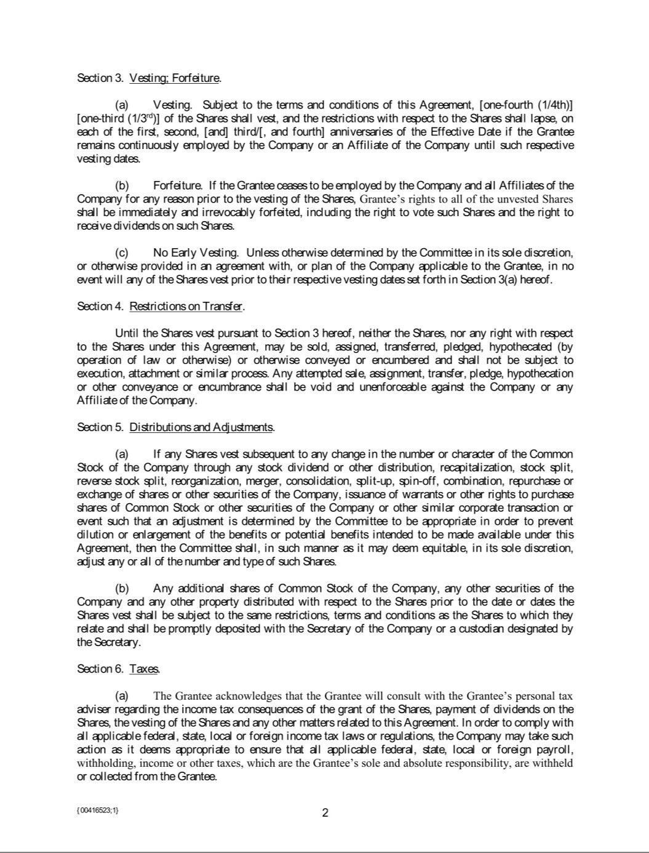

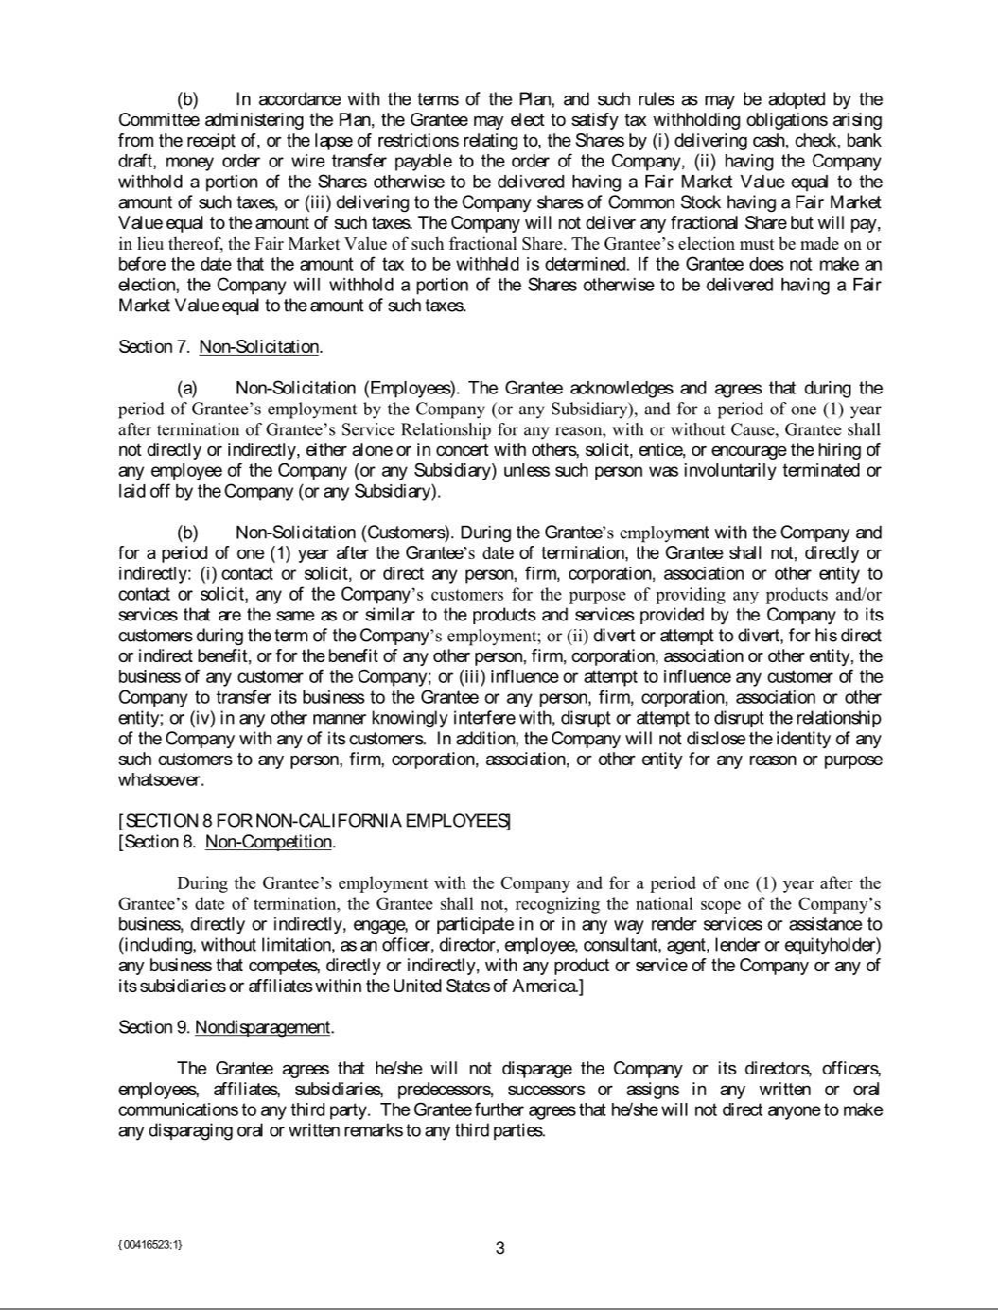

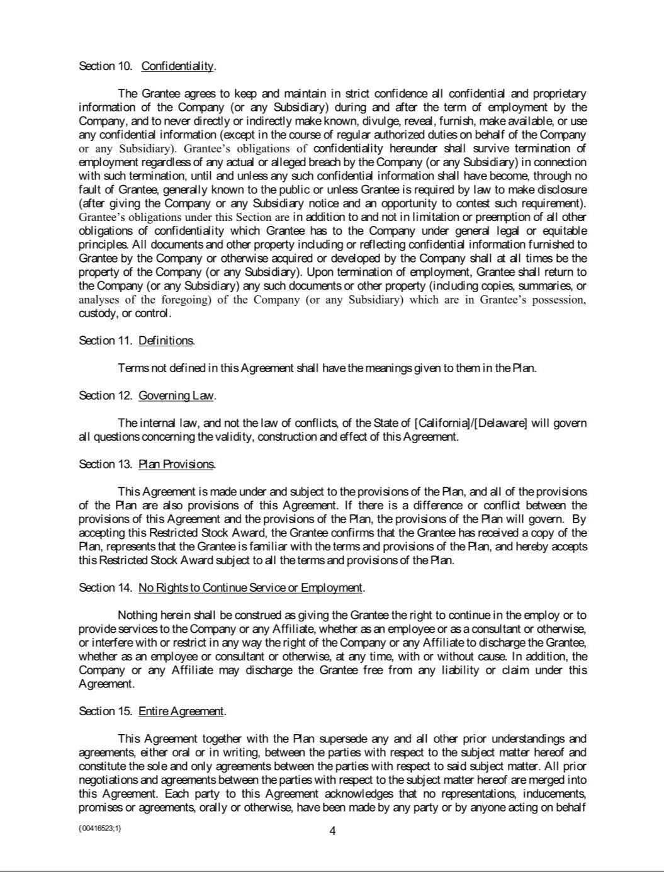

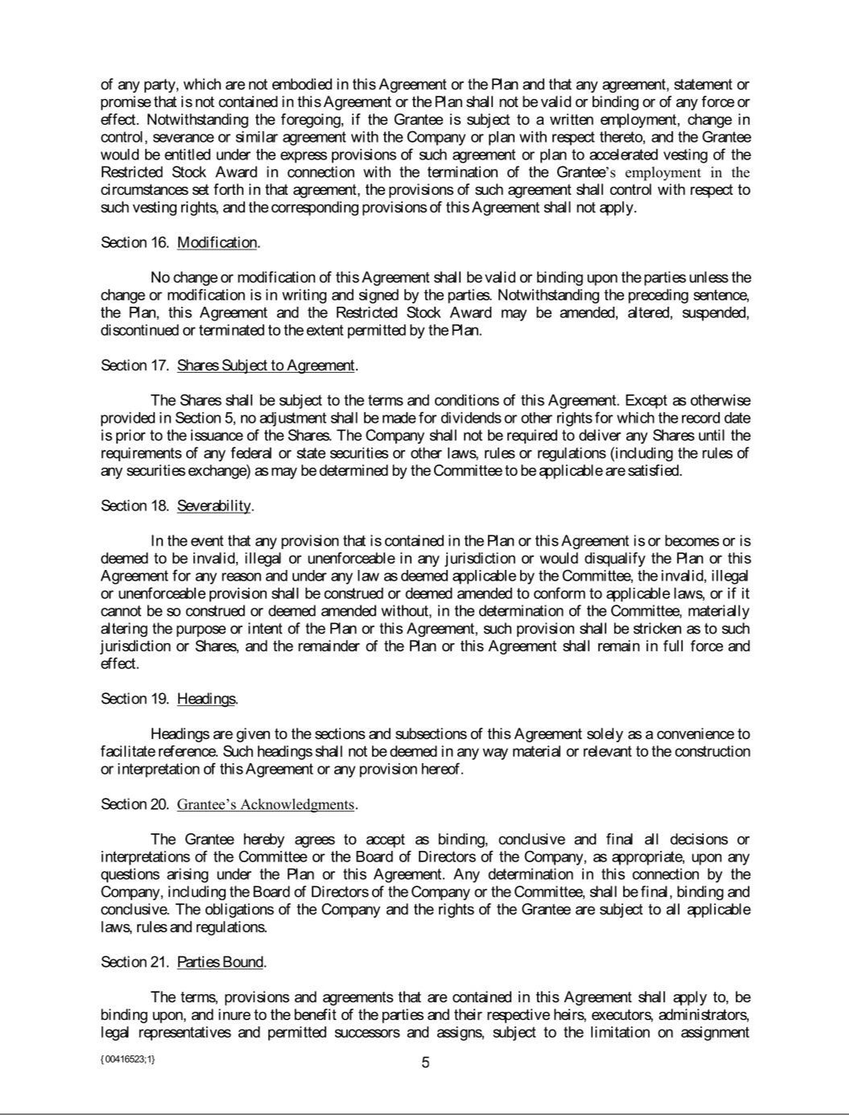

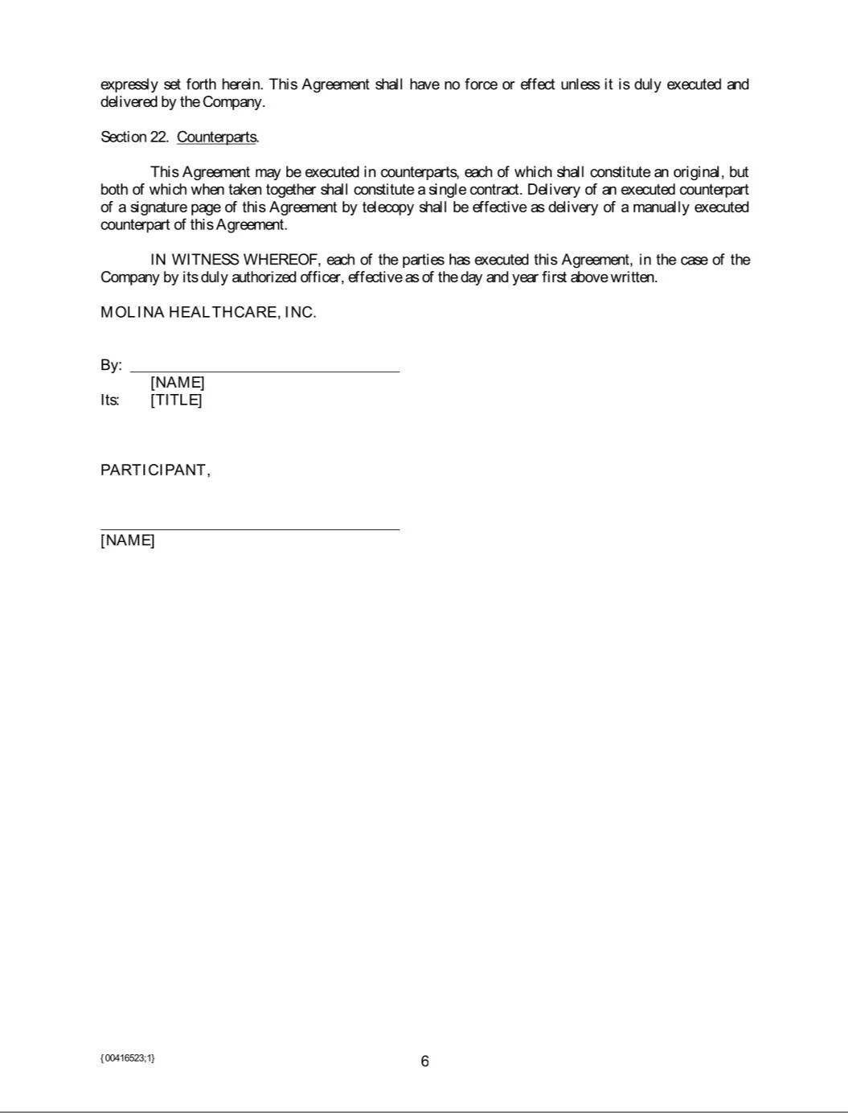

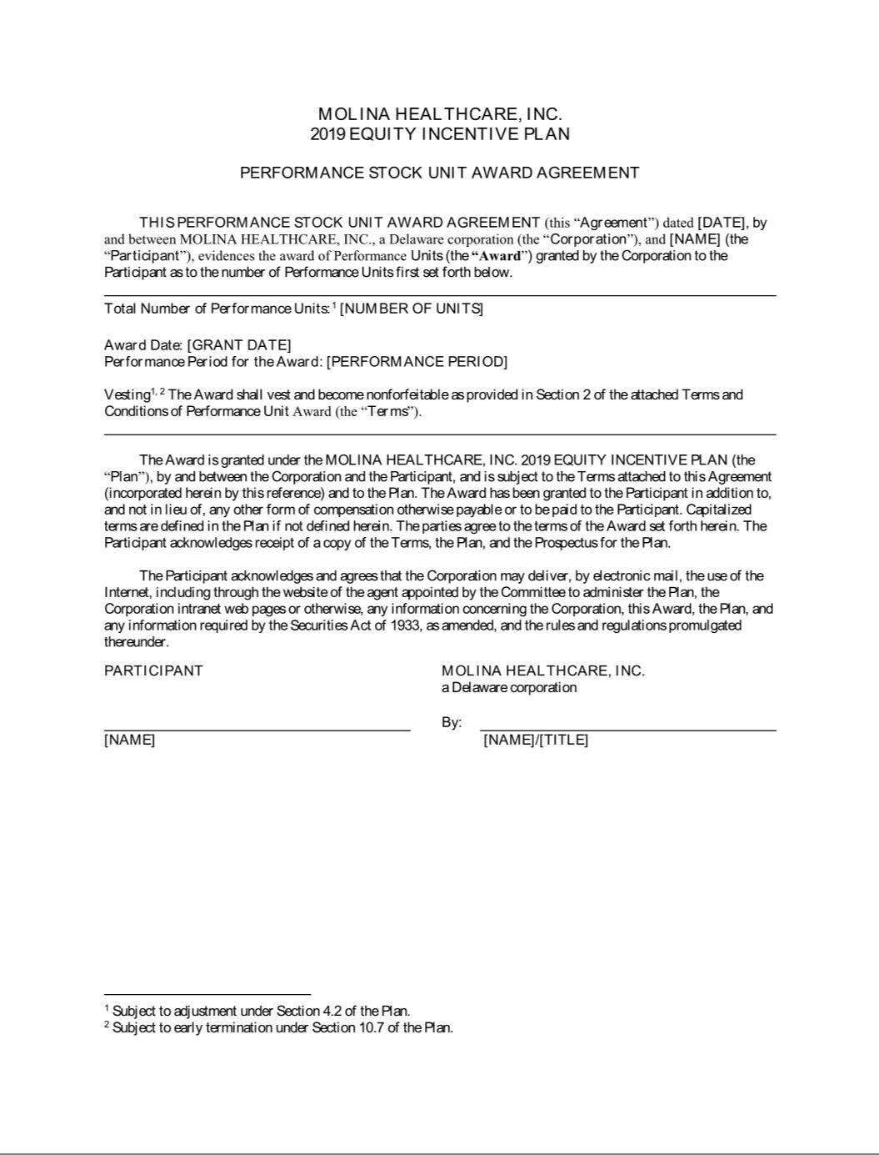

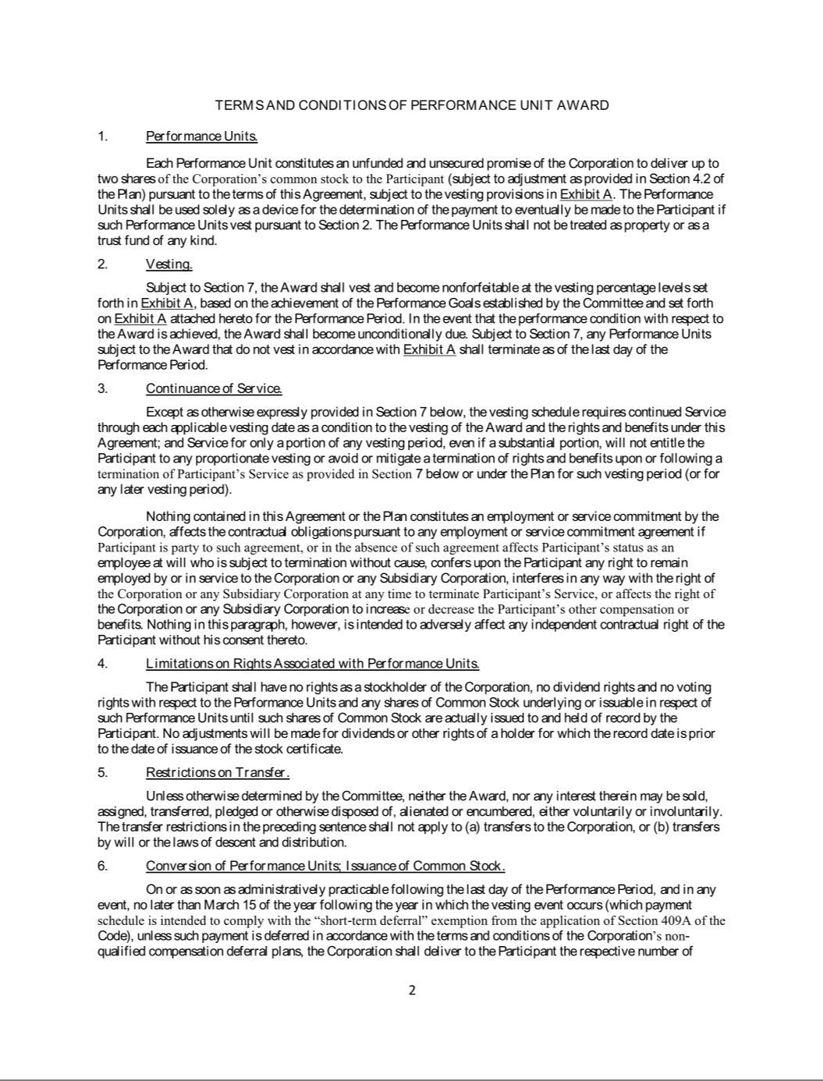

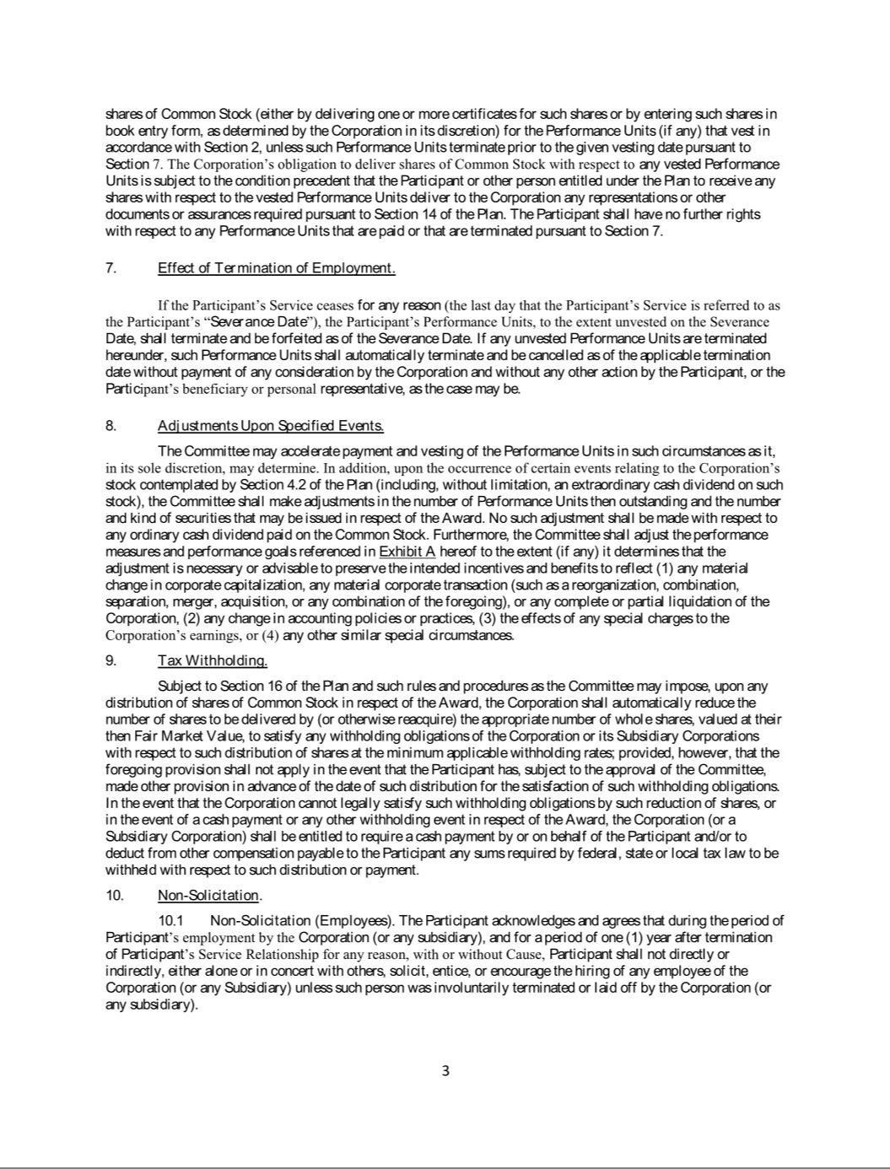

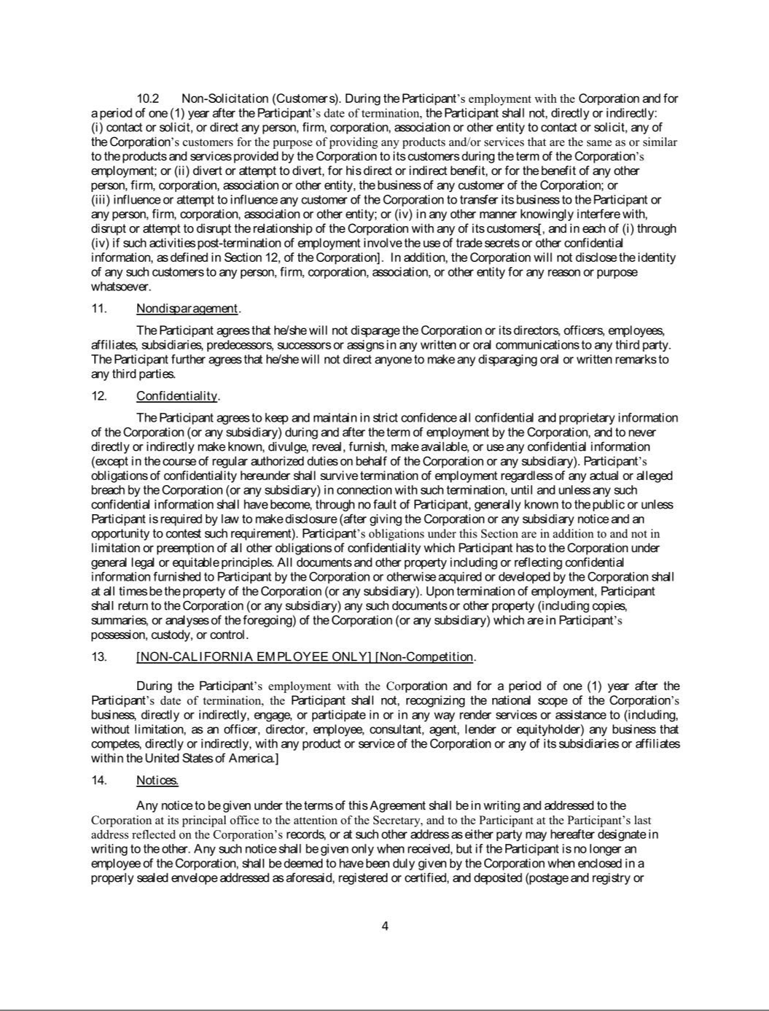

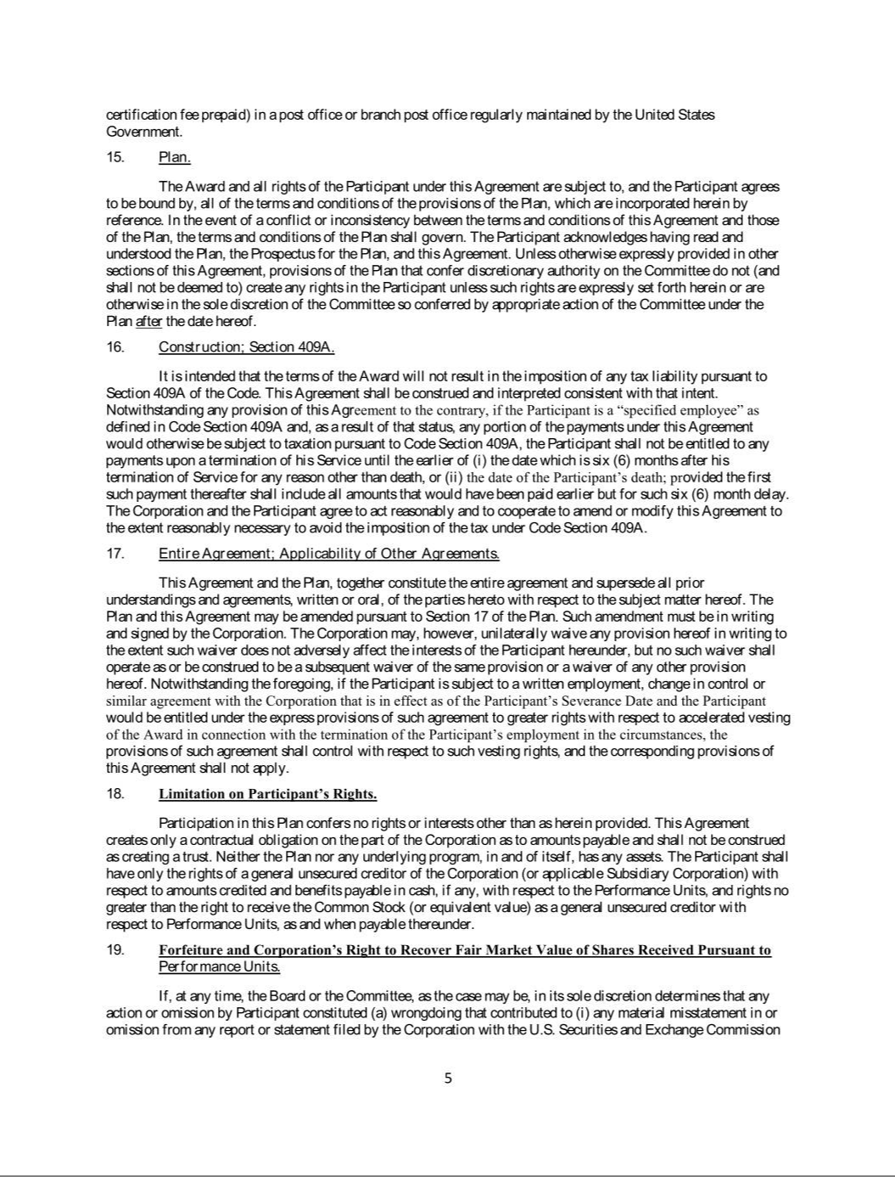

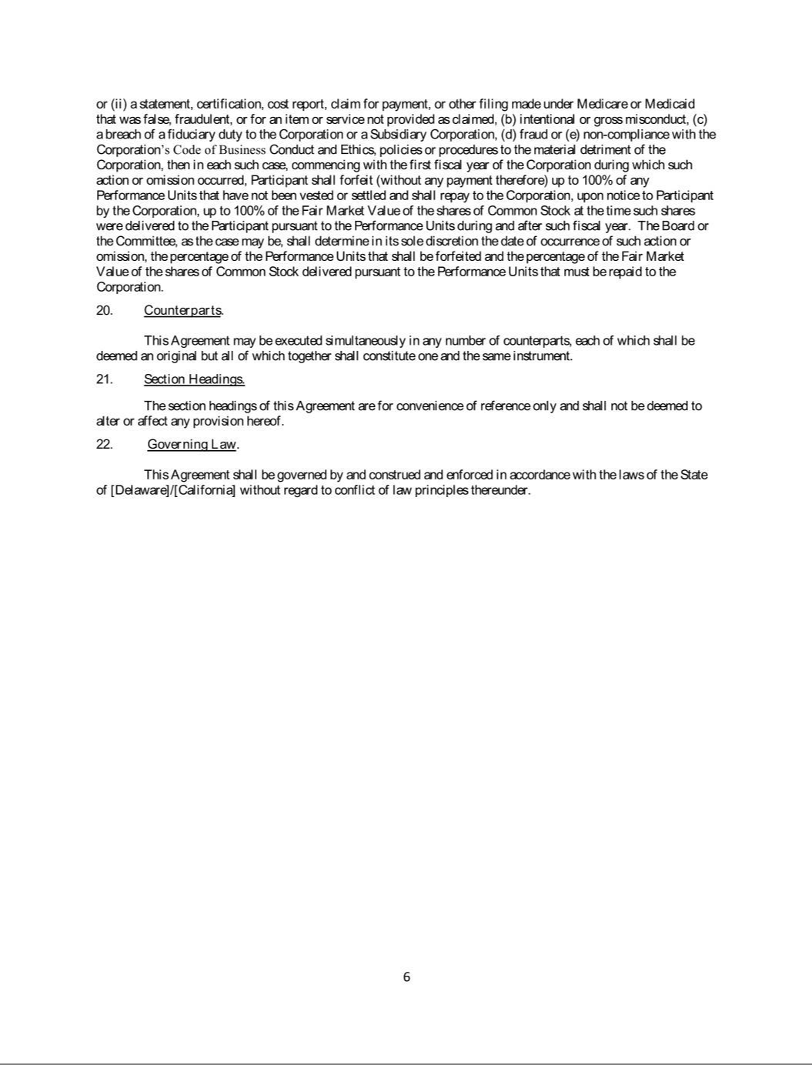



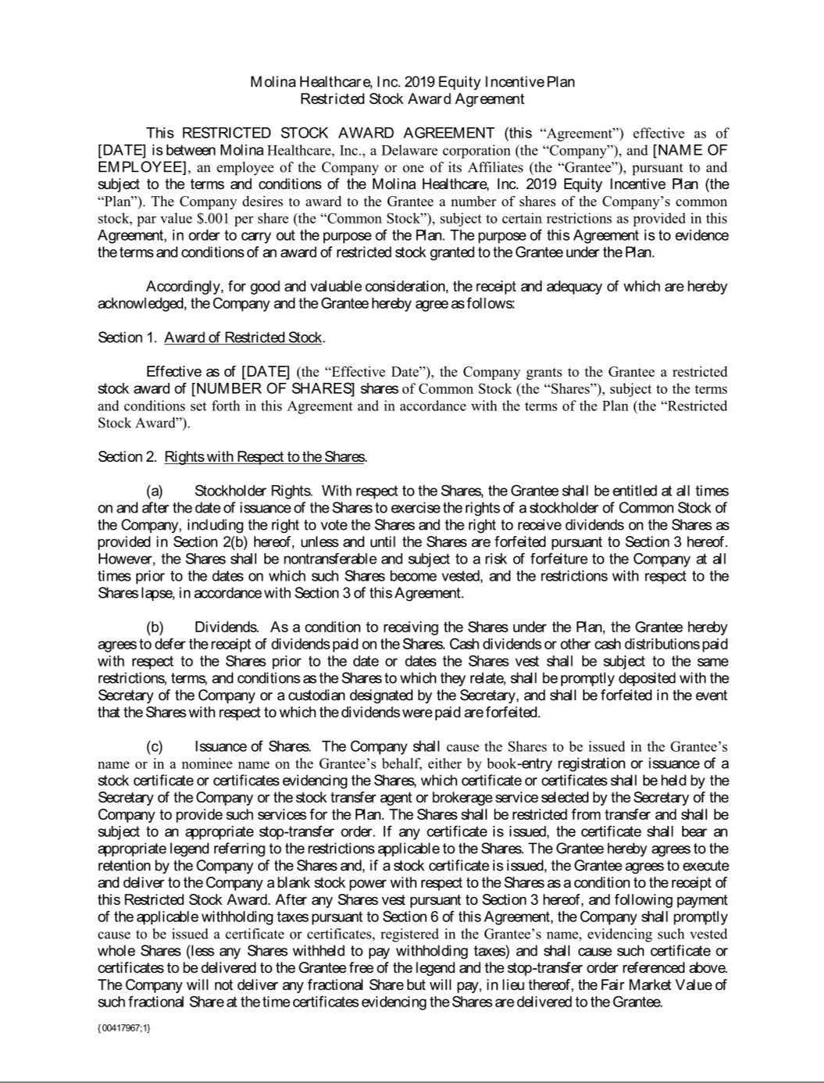

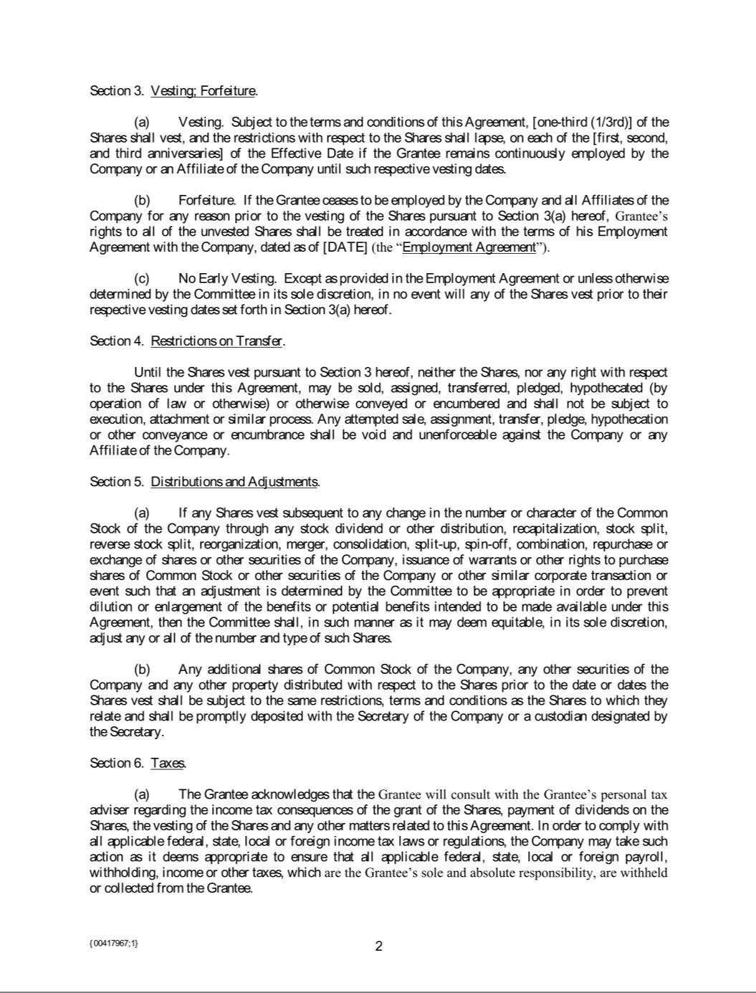

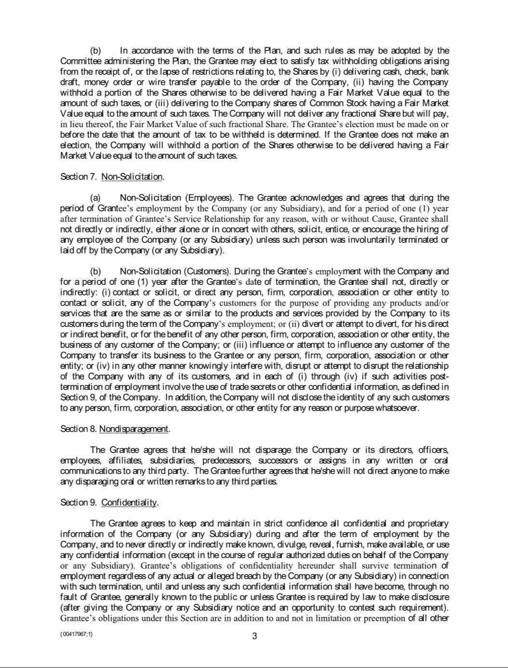

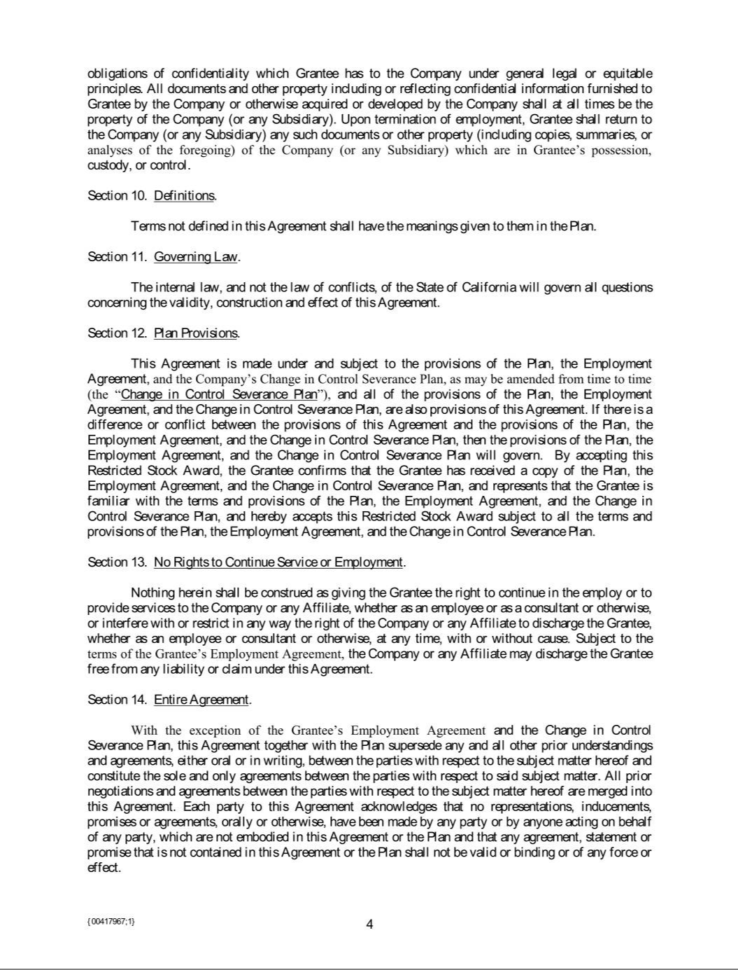

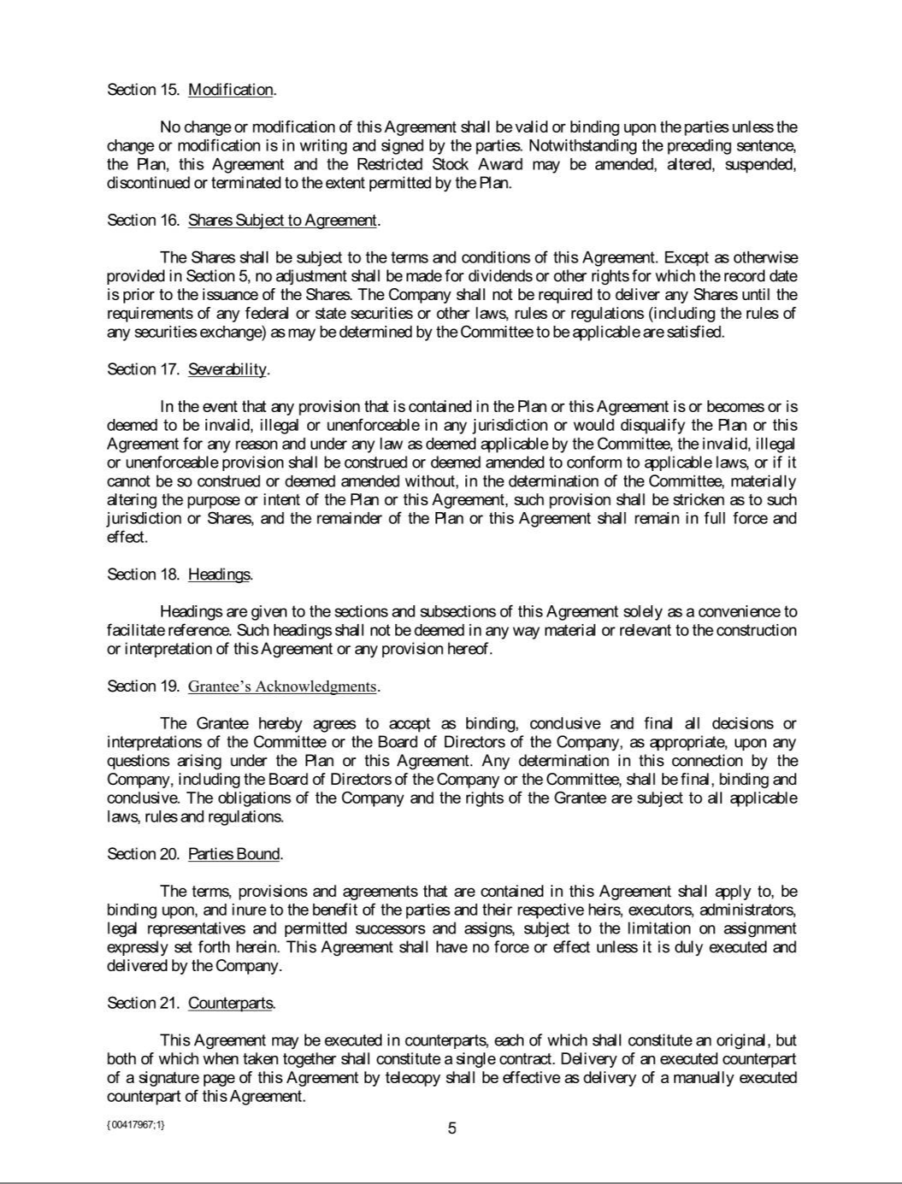



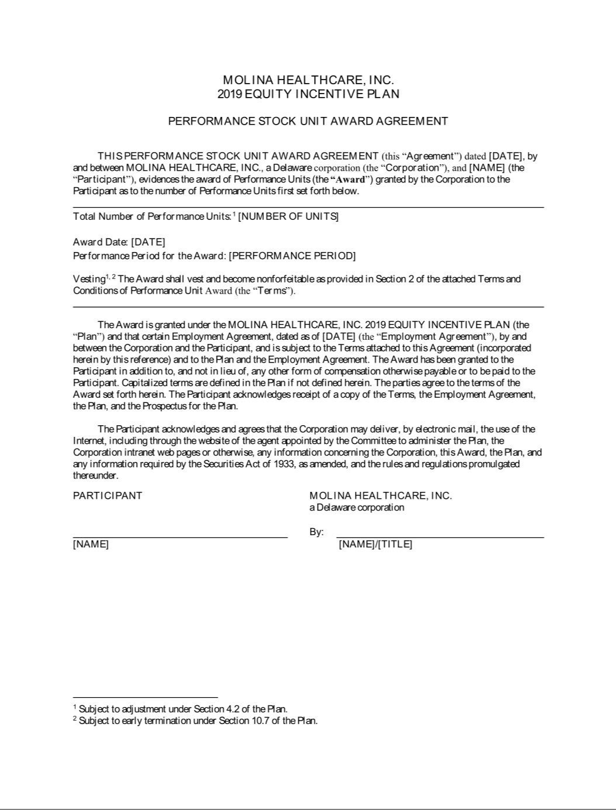

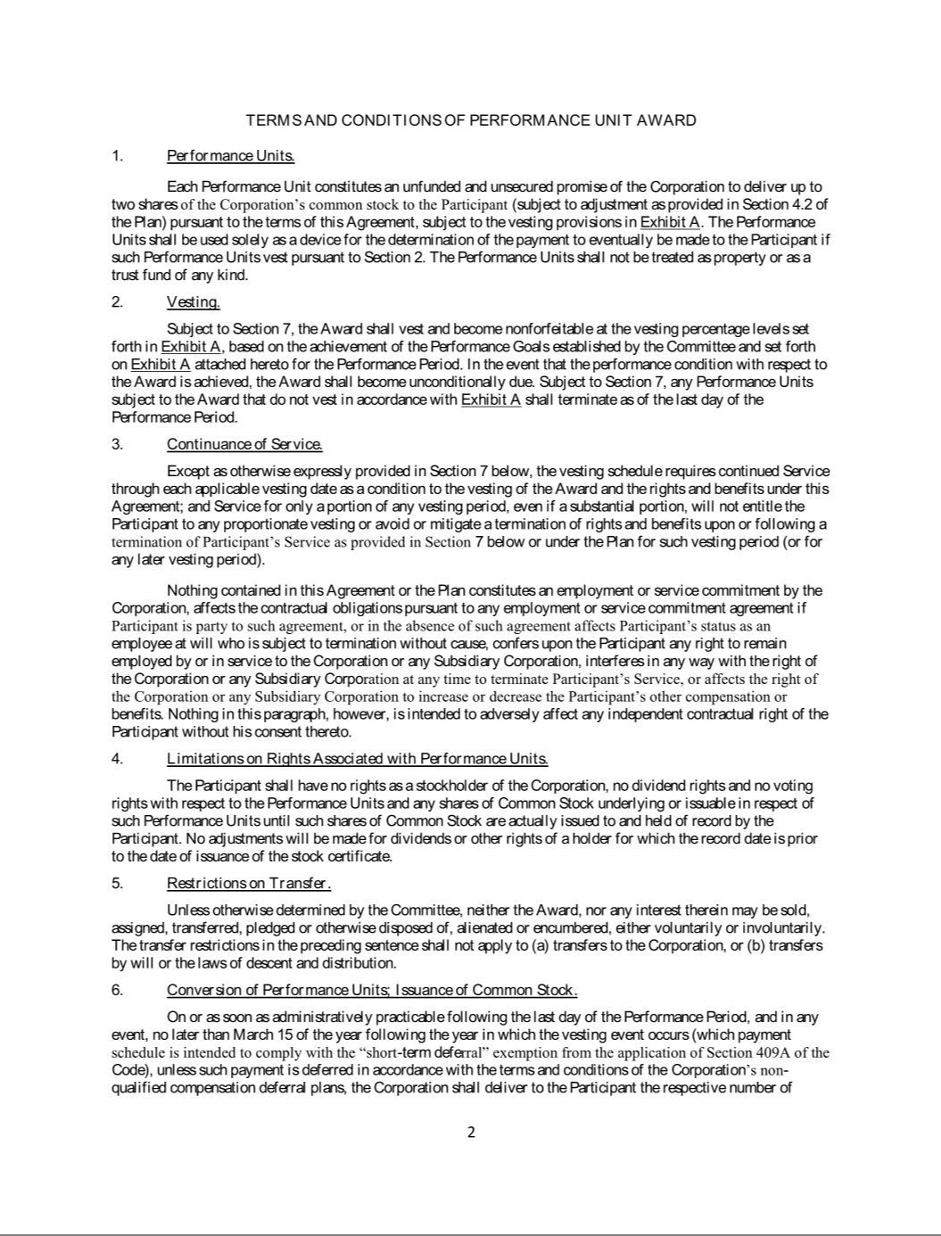

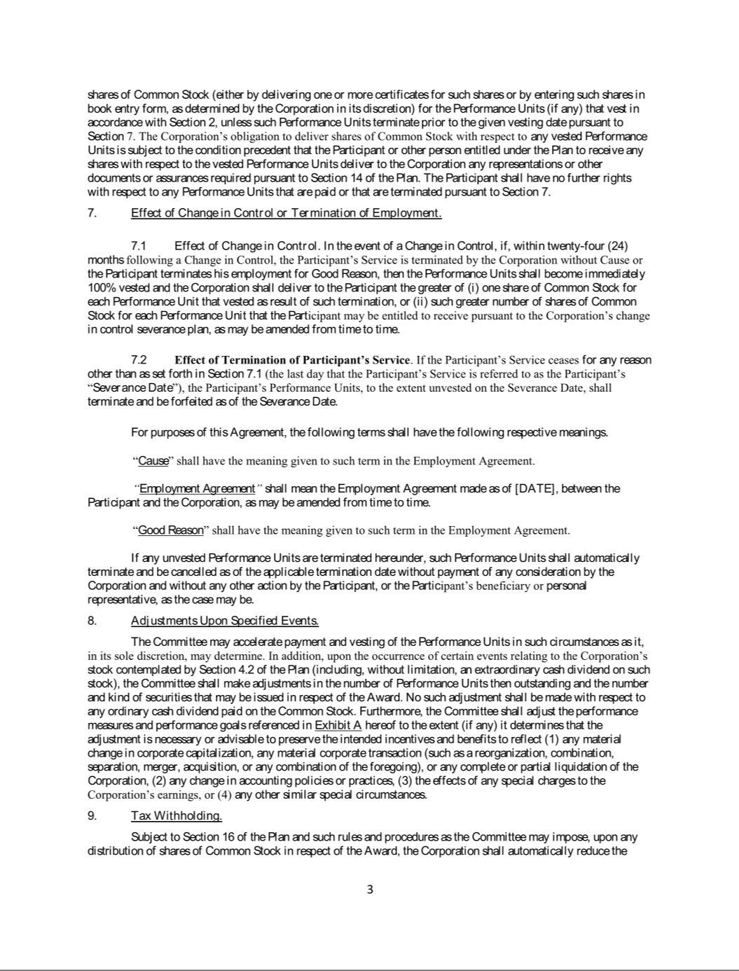

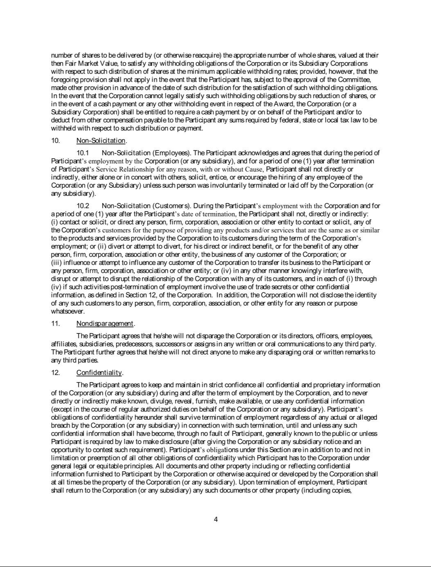

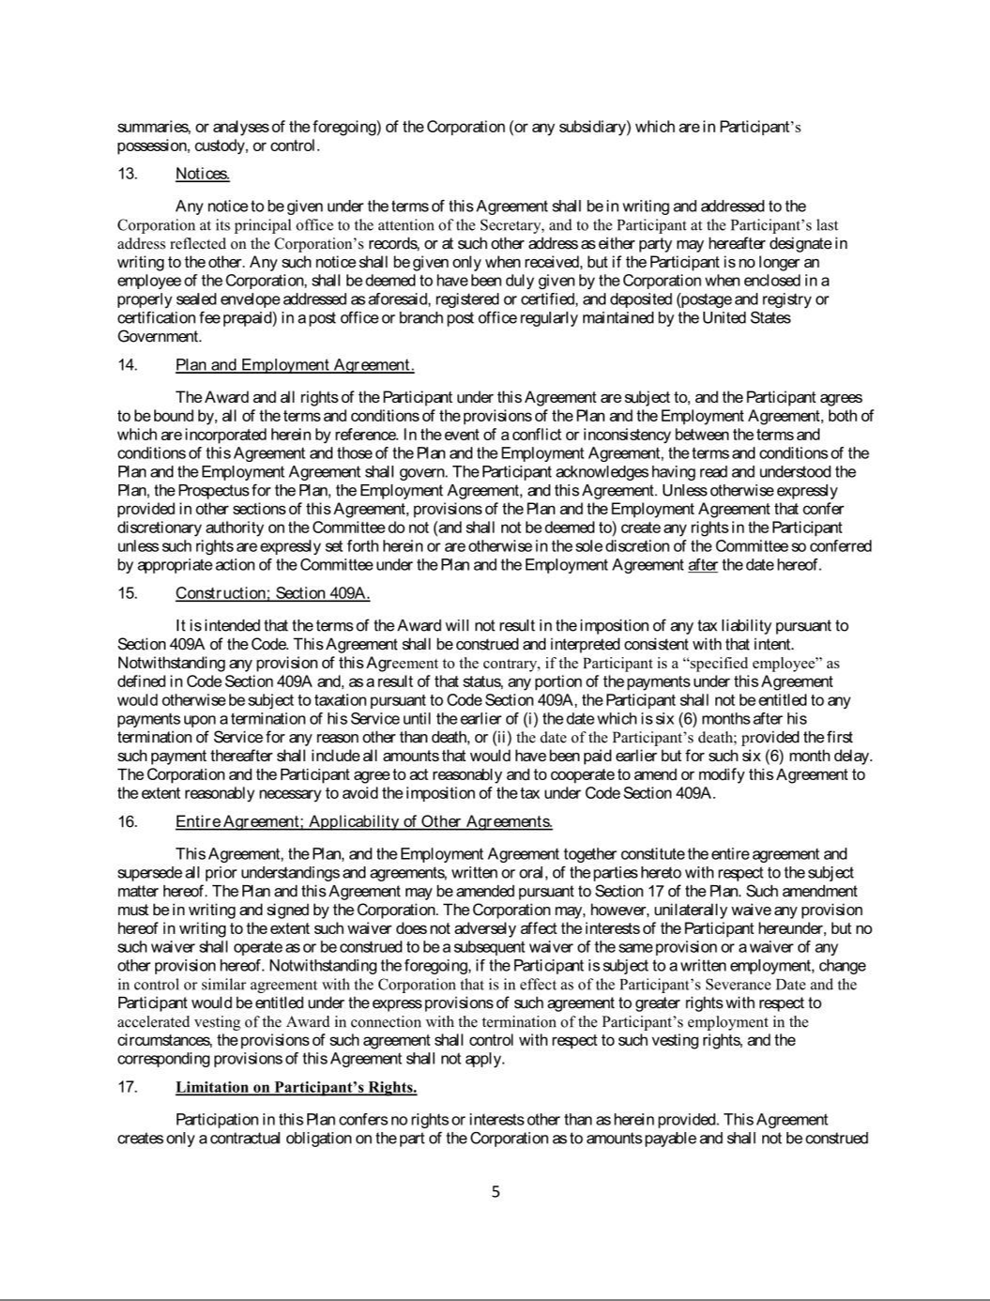

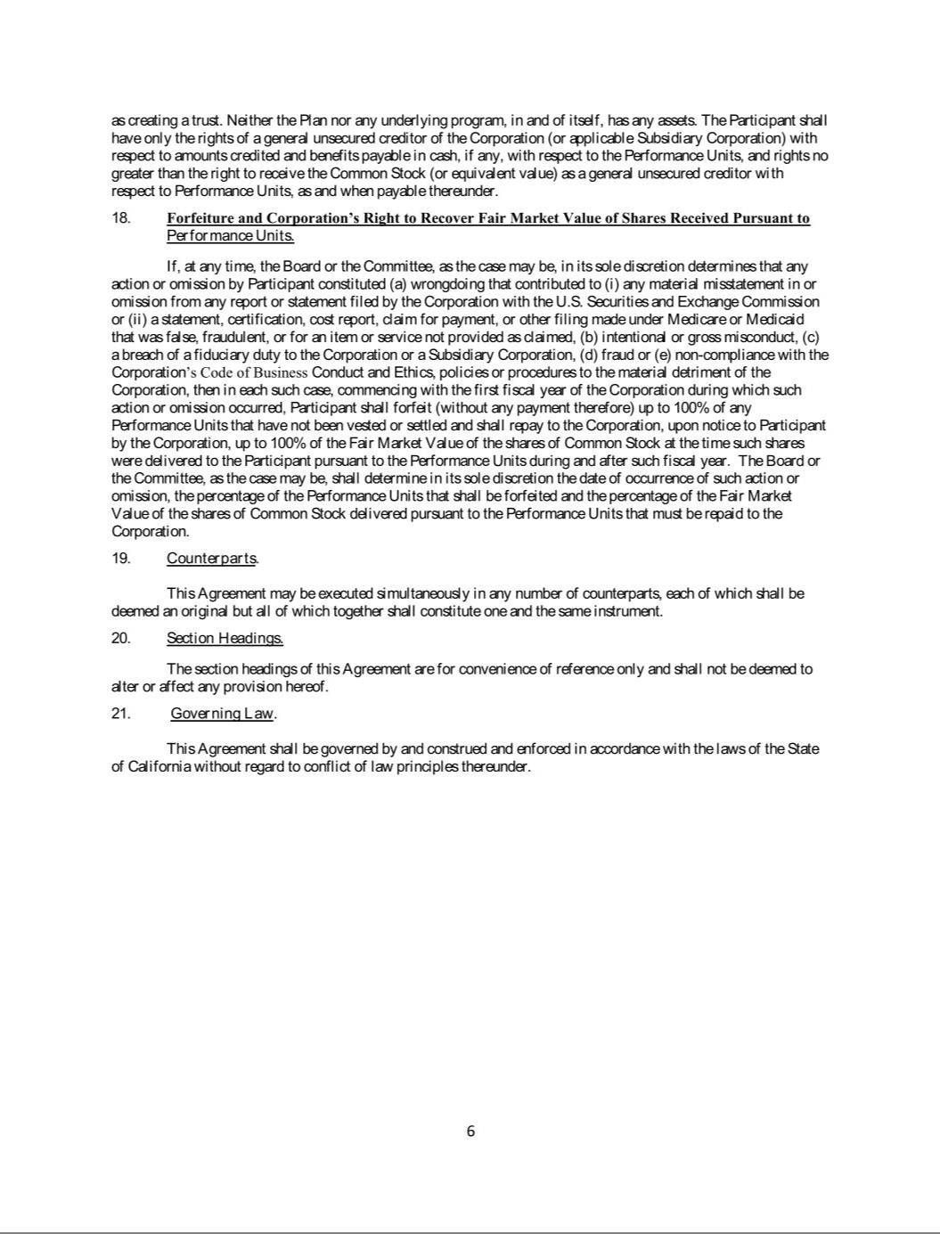



EXHIBIT 31.1

CERTIFICATION PURSUANT TO

RULES 13a-14(a)/15d-14(a)

UNDER THE SECURITIES EXCHANGE

ACT OF 1934, AS AMENDED

I, Joseph M. Zubretsky, certify that:

- I have reviewed the report on Form 10-Q for the period ended June 30, 2019 of Molina Healthcare, Inc.;

- Based on my knowledge, the report does not contain any untrue statement of a material fact or omit to state a material fact necessary in order to make the statements made, in light of the circumstances under which such statements were made, not misleading with respect to the period covered by the report;

- Based on my knowledge, the financial statements, and other financial information included in the report, fairly present in all material respects the financial condition, results of operations and cash flows of the registrant as of, and for, the periods presented in the report;

- The registrant's other certifying officers and I are responsible for establishing and maintaining disclosure controls and procedures (as defined in Rule 13a-15(e) and 15d-15(e) of the Securities Exchange Act of 1934, as amended), and internal control over financial reporting (as defined in Rules 13a-15(f) and 15d-15(f) of the Securities Exchange Act of 1934, as amended), for the registrant and have:

  - Designed such disclosure controls and procedures, or caused such disclosure controls and procedures to be designed under our supervision, to ensure that material information relating to the registrant, including its consolidated subsidiaries, is made known to us by others within those entities, particularly during the period for which this report is being prepared;

  - Designed such internal control over financial reporting, or caused such internal control over financial reporting to be designed under our supervision, to provide reasonable assurance regarding the reliability of financial reporting and the preparation of financial statements for external purposes in accordance with generally accepted accounting principles;

  - Evaluated the effectiveness of the registrant’s disclosure controls and procedures and presented in the report our conclusions about the effectiveness of the disclosure controls and procedures, as of the end of the period covered by the report based on such evaluation; and

  - Disclosed in the report any change in the registrant’s internal control over financial reporting that occurred during the registrant’s most recent fiscal quarter (the registrant’s fourth fiscal quarter in the case of an annual report) that has materially affected, or is reasonably likely to materially affect, the registrant’s internal control over financial reporting; and

- The registrant's other certifying officers and I have disclosed, based on our most recent evaluation of internal control over financial reporting, to the registrant’s auditors and to the audit committee of the registrant’s board of directors (or persons performing the equivalent functions):

  - All significant deficiencies and material weaknesses in the design or operation of internal control over financial reporting which are reasonably likely to adversely affect the registrant’s ability to record, process, summarize and report financial information; and

  - Any fraud, whether or not material, that involves management or other employees who have a significant role in the registrant’s internal control over financial

reporting.

Dated: July 31, 2019 /s/ Joseph M. Zubretsky

Joseph M. Zubretsky

Chief Executive Officer, President and Director

EXHIBIT 31.2

CERTIFICATION PURSUANT TO

RULES 13a-14(a)/15d-14(a)

UNDER THE SECURITIES EXCHANGE

ACT OF 1934, AS AMENDED

I, Thomas L. Tran, certify that:

- I have reviewed the report on Form 10-Q for the period ended June 30, 2019 of Molina Healthcare, Inc.;

- Based on my knowledge, the report does not contain any untrue statement of a material fact or omit to state a material fact necessary in order to make the statements made, in light of the circumstances under which such statements were made, not misleading with respect to the period covered by the report;

- Based on my knowledge, the financial statements, and other financial information included in the report, fairly present in all material respects the financial condition, results of operations and cash flows of the registrant as of, and for, the periods presented in the report;

- The registrant’s other certifying officers and I are responsible for establishing and maintaining disclosure controls and procedures (as defined in Rule 13a-15(e) and 15d-15(e) of the Securities Exchange Act of 1934, as amended), and internal control over financial reporting (as defined in Rules 13a-15(f) and 15d-15(f) of the Securities Exchange Act of 1934, as amended), for the registrant and have:

  - Designed such disclosure controls and procedures, or caused such disclosure controls and procedures to be designed under our supervision, to ensure that material information relating to the registrant, including its consolidated subsidiaries, is made known to us by others within those entities, particularly during the period for which this report is being prepared;

  - Designed such internal control over financial reporting, or caused such internal control over financial reporting to be designed under our supervision, to provide reasonable assurance regarding the reliability of financial reporting and the preparation of financial statements for external purposes in accordance with generally accepted accounting principles;

  - Evaluated the effectiveness of the registrant’s disclosure controls and procedures and presented in the report our conclusions about the effectiveness of the disclosure controls and procedures, as of the end of the period covered by the report based on such evaluation; and

  - Disclosed in the report any change in the registrant’s internal control over financial reporting that occurred during the registrant’s most recent fiscal quarter (the registrant’s fourth fiscal quarter in the case of an annual report) that has materially affected, or is reasonably likely to materially affect, the registrant’s internal control over financial reporting; and

- The registrant’s other certifying officers and I have disclosed, based on our most recent evaluation of internal control over financial reporting, to the registrant’s auditors and to the audit committee of the registrant’s board of directors (or persons performing the equivalent functions):

  - All significant deficiencies and material weaknesses in the design or operation of internal control over financial reporting which are reasonably likely to adversely affect the registrant’s ability to record, process, summarize and report financial information; and

  - Any fraud, whether or not material, that involves management or other employees who have a significant role in the registrant’s internal control over financial

reporting.

Dated: July 31, 2019 /s/ Thomas L. Tran

Thomas L. Tran

Chief Financial Officer and Treasurer

EXHIBIT 32.1

CERTIFICATE PURSUANT TO

18 U.S.C. SECTION 1350,

AS ADOPTED PURSUANT TO

SECTION 906 OF THE SARBANES-OXLEY ACT OF 2002

In connection with the report of Molina Healthcare, Inc. (the “Company”) on Form 10-Q for the period ended June 30, 2019 (the “Report”), I, Joseph M. Zubretsky, Chief Executive Officer of the Company, certify, pursuant to 18 U.S.C. Section 1350, as adopted pursuant to Section 906 of the Sarbanes-Oxley Act of 2002, that:

- The Report fully complies with the requirements of Section 13(a) or 15(d) of the Securities Exchange Act of 1934, as amended; and

- The information contained in the Report fairly presents, in all material respects, the financial condition and results of operations of the Company.

Dated: July 31, 2019 /s/ Joseph M. Zubretsky

Joseph M. Zubretsky

Chief Executive Officer, President and Director

EXHIBIT 32.2

CERTIFICATE PURSUANT TO

18 U.S.C. SECTION 1350,

AS ADOPTED PURSUANT TO

SECTION 906 OF THE SARBANES-OXLEY ACT OF 2002

In connection with the report of Molina Healthcare, Inc. (the “Company”) on Form 10-Q for the period ended June 30, 2019 (the “Report”), I, Thomas L. Tran, Chief Financial Officer of the Company, certify, pursuant to 18 U.S.C. Section 1350, as adopted pursuant to Section 906 of the Sarbanes-Oxley Act of 2002, that:

- The Report fully complies with the requirements of Section 13(a) or 15(d) of the Securities Exchange Act of 1934, as amended; and

- The information contained in the Report fairly presents, in all material respects, the financial condition and results of operations of the Company.

Dated: July 31, 2019 /s/ Thomas L. Tran

Thomas L. Tran

Chief Financial Officer and Treasurer

